Republic of Serbia
PROGRESS REPORT
on recent developments regarding S&T cooperation in/with the WBC
(December 2008 - May 2009)

Policy actions
(e.g. essential changes in the political authorities, administrative bodies, agencies, institutions, personnel, development/launch of new national funding programmes, etc.)
The Ministry has the new structure with seven departments: – (i) Dept. for Basic Research in Natural Sciences and Medicine, (ii) Dept. for Basic Research in Social Sciences and Humanities, (iii) Dept. for Technological Development, (iv) Dept. for Transfer of Technologies and Innovation System, (v) Dept. for Human Resources Development, (vi) Dept. for International Cooperation and European Integrations, and (vii) Dept. for Nuclear and Radiation Safety.

Ministry of Science and Technological Development have participated in the launch meeting Dialogue Forum on ICT Research for the Western Balkan Countries (ICT DF - WBC) which took place on May 21st in the Serbian Chamber of Commerce in Belgrade. Being conceived within the FP7 funded Project WINS-ICT Western Balkan Countries Inco-NET Support in the field of ICT the Dialogue Forum is created in order to link and contribute to the Steering Platform on Research for the Western Balkan Countries specifically as for the ICT research field.

Legislative initiatives - development of the legal and strategic framework
As it was already reported, Ministry of Science and Technological Development has created the Working Groups responsible to define the Bill amending and modifying of the Law on S&R, the Low on Innovation, as well as the Low on Serbian Academy of Science and Arts (SANU). All tree activities are in the stage of finalization.
The Law of Ionizing Radiation Protection and Nuclear Safety is recently approved by the Parliament and it is in force now.

Important events, meetings, training activities, etc.
Events:
Ministerial Conference – Developing a Regional Strategy on Research and Development for the Western Balkans

The Ministers from the Western Balkans responsible for science and research, the EU Commissioner for Science and Research, the Czech Republic Presidency of the Council of the European Union, the RCC Secretary General, representatives of other RCC members from South Eastern Europe, regional and international organizations and other stakeholders met in Sarajevo on 24 April, 2009. The Ministers agreed to launch of an initiative aiming at the development of a Regional Strategy on Research and Development for the Western Balkans in order to foster regional cooperation within the knowledge triangle. The Strategy will improve national research policies through the exchange of experience and good practice and facilitate integration of the region into the European Research Area. A joint statement recorded their determination to place this form of cooperation high on their political agendas and to establish competitive regional centres of excellence – something that will also help integration of the Western Balkans into the EU.
The Ministers recall that the EU perspective is essential for the stability, reconciliation and development of the Western Balkans and that the future of the region lies within the Union.
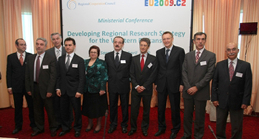

ICT Information and Brokerage Event
The Ministry of Science and Technological Development, Ministry of Telecommunication and Information Society in cooperation with the Serbian Chamber of Commerce have organized ICT Information and Brokerage Event (http://www.ideal-ist.net/events/information-and-brokerage-event-in-serbia ) which took place in Belgrade from the 20 to the 21st of May 2009. The event is supported and co-organized by the European Commission's information Society and Media Directorate-General, within the framework of the FP7 project WBC-INCO.NET.

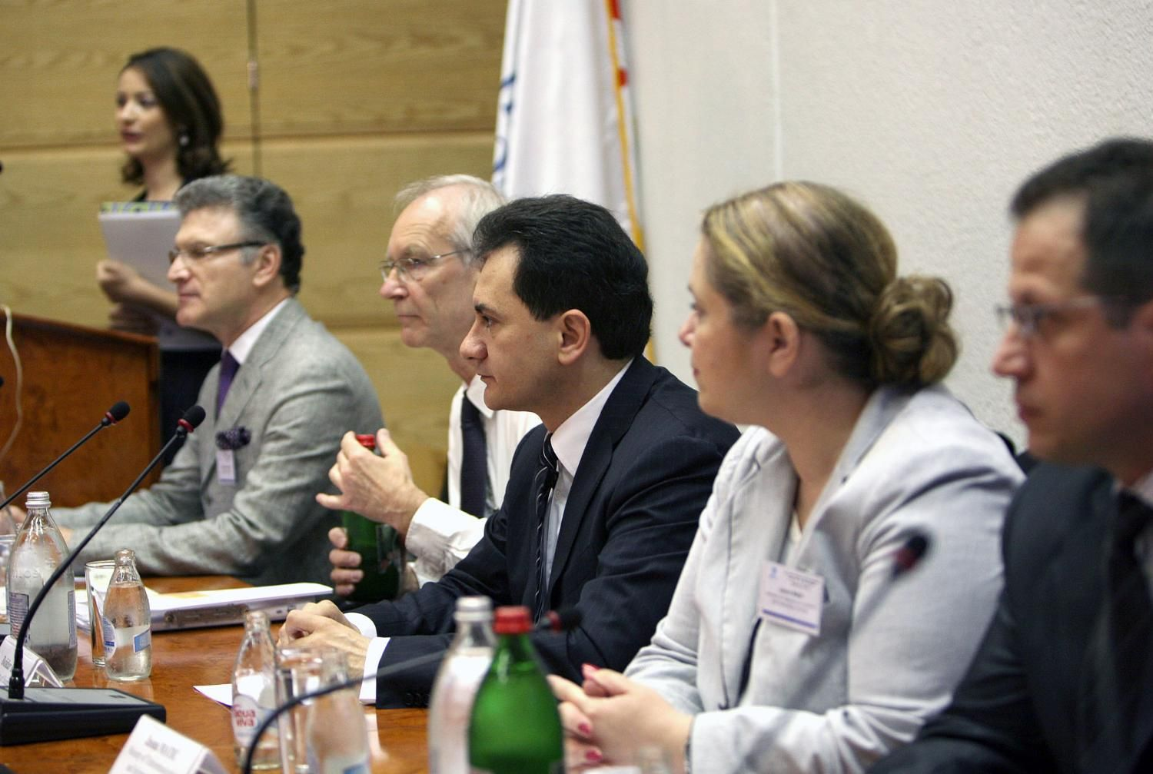 | 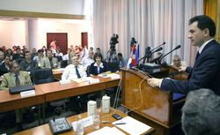

The Event covered topics related to technical and administrative, financial and legal aspects of the FP7-|CT theme, and particularly addressed the objectives and challenges of next Call5 and Call 6. It brought together prominent policy makers from Serbia and other respective Western Balkan and EU countries, and has constituted a brokerage platform enabling ICT researchers network and build consortia. More than 130 participants from R&D institutions, researchers and policy makers from region were present at the Event.

EURAXESS Conference

EURAXESS Conference of 2009 was organized in Potsdam, Germany, 16-18.3.2009. It was dedicated to an in-depth discussion on the implementation of the Partnership for researchers, the future of the EURAXESS Network and many networking opportunities. Conference welcomes around 240 participants, i.e. members of the Network, the Charter and Code Promoters as well as the members of the Steering Group on Human Resources. Representatives of Serbian BHO and Service Centre at University of Belgrade attended the conference and actively participated in various events. Also, in a dedicated session related to Mobility in the Western Balkan Countries, prof. dr Miroslav Trajanović, manager of Serbian BHO, presented a national network and other results, delivered in first 6 months of the FP7 project "SER-MORE: Development of Serbian network of mobility centers".
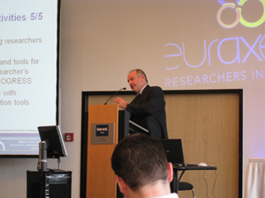

INFO DAYS AND MEETINGS

SME INFO DAYS
Ministry of Science and Technological Development in cooperation with the Ministry of Economy and Regional Development, Serbian Chamber of Commerce and Regional Chambers of commerce Pancevo, Krusevac, Leskovac, Pozarevac, Sombor, Valjevo held introductory info days for SMEs on January 26th and February 6th, March 30th, April 6th, 7th and 23rd 2009, respectively. As the 7th Framework Programme (FP7) supports the enforcement of cooperation between science and technology, the transfer of knowledge and commercializing those innovations, the main goal of these presentations were to introduce Serbian SME representatives to the process of how to apply for FP7 funding possibilities with their own projects. During these info days a total of more than 200 representatives from regional SMEs participated in the events. The most of these events are organized in scope and under the logo of 1st European SME Week ’09.
Main Serbian FP7 SME event in scope of “1st European SME week” was held on February 27, 2009 in Belgrade’s Chamber of commerce. More than 140 representatives from R&D institutions, researchers and economists were present at the meeting.
In cooperation of the Delegation of EC in Belgrade, Ministries of Science and Technological Development and Economy and Regional Development, and in the organization of the EU office of Erste Bank, in the scope of “1st European SME week”, a conference on SME sector in European Programmes – Challenges and Possibilities was held in Belgrade on May 5. More than 50 participants took a part.

Meeting of the South-Eastern Europe Digitization Initiative – SEEDI
Serbian ICT NCPs took a part at the SEEDI Meeting http://www.ncd.matf.bg.ac.yu/seedi/events/SEEDImeetingBelgrade2009/SEEDI_Beograd2009.htm that was held in Belgrade on 16th and 17th April at the Mathematical Institute of the Serbian Academy of Sciences and Arts, under the auspices of the Committee for digitization of the UNESCO commission of Serbia, and presented ongoing Ministry’s support activities in FP7, particularly connected with ICT priority theme.

INFO DAYS, People-EURAXESS
Ministry of Science and Technological Development in collaboration with Serbian Universities organized four INFO days on open calls within the Seventh Framework Program of the European Union (FP7 EU), People – EURAXESS.
Info days People – EURAXESS for researchers and participants from industry were organized in Kragujevac on May 13th, 2009 (27 participants), in Niš May 14th, 2009 (33 participants), in Belgrade May 15th, 2009 (58 participants), and in Novi Sad on May 18th, 2009 (71 participants). The last one was organized in cooperation with the University of Novi Sad as well as Provincial Secretariat for Science and Technological Development of Vojvodina.
TRAININGS
The series of training activities particularly dedicated to young researchers has been organized by the Ministry/Consultative Bureau for international projects:
14-15 April - 2-day training course in Nis on generic research skills
24-25 April - 2-day training course in Novi Sad on generic research skills
7-8 May - 2-day training course in Belgrade on generic research skills
26-27 May - 2-day training course in Belgrade on generic research skills

Training activities inside the project “Competition for the best technology innovation”, 2009 such as:
- business environment and research market held on 10.-15.04.2009.
- business plan: role and importance held on 20.-24.04.2009.

Development of international cooperation and actions on integration into ERA
(e.g. new bilateral/international agreements, memberships, support structures, important international projects, programmes, etc.)
1. China, May 7, 2009: Deputy Prime Minister and Minister of Science and Technological Development Bozidar Djelic and Chinese Minister of Science and Technology Wan Gang signed in Beijing the Agreement on Scientific and Technical Cooperation. Djelic stressed that cooperation with China is very important for Serbia, particularly when it comes to high technologies and biotechnology for the production of food and new materials.
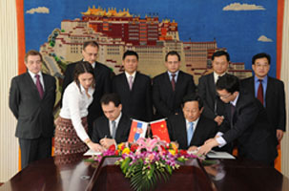
2. Hungary: Bilateral S&T Co-operation Programme between Ministry of Science and Technology Development of the Republic of Serbia and the National Office of Research and Technology of Hungary (NKTH) is launched. The Call for project proposals is ongoing for the years 2010-2011.
3. Austria and Germany: The activities related to the bilateral cooperation with the Republic of Austria and Baden Wittenberg (Germany) are ongoing.
4. Germany/DAAD: Inside the first Call for the project period 2009-2010, published within Bilateral Agreement between Ministry of Science and Technological Development of the Republic of Serbia and DAAD – Germany, 12 joint projects have been accepted and approved for funding. At the moment the second call is open.
5. Croatia: On the basis of the Agreement of scientific and technical cooperation between the Ministry of Science and Technological Development of the Republic of Serbia and Ministry of Science, Education and Sports of the Republic of Croatia, signed in Zagreb on 5th November 2005, the Ministry of Science and Technological Development, on 2nd April 2009 launched second Call for application of bilateral scientific cooperation projects. Deadline for submitting a project proposal is June 1, 2009.
6. In accordance with the Agreement of scientific and technological cooperation between Government of Federal Republic of Yugoslavia and Government of Republic Slovenia about scientific and technological cooperation the Ministry of Science and Technological Development of Republic of Serbia is launching a call For co-funding scientific and technological cooperation between Republic of Serbia and Republic of Slovenia for the period of 2010-2011. Realization of projects – from 1st January 2010 till 31st December 2011. Call is opened until 19th July 2009.
7. Italy: Draft of Cooperation Agreement on Science and Technology between Republic of Serbia and Italy was initiated and sent to Italian side for consideration.
8. Czech Republic: Cooperation Agreement on Science and Technology is in preparation
9. Russian Federation: draft of Cooperation Agreement on Science and Technology is in the preparation stage
10. USA: draft of Cooperation Agreement on Science and Technology is in the preparation stage
11. CERN, May 8: Deputy Prime Minister for EU Integration and Minister of Science and Technological Development Bozidar Djelic said that negotiations concerning Serbia’s accession to the European Organisation for Nuclear Research (CERN) may start next year. Following a meeting with CERN Director General Rolf-Dieter Heuer, Djelic recalled that Serbia first applied for membership last autumn. According to the Minister Serbia submitted its report on science, economy and physics last March, which was the first step towards joining CERN. He noted that this scientific institution should consider Serbia’s application by the end of this year and voiced his belief that negotiations on Serbia’s full membership would start next year. Minister Djelic stressed that Serbia is the first country in the region to be visited by the CERN Director General because Serbia has participated in a scientific experiment costing €6 billion. Djelic added that around 40 Serbian physicists have taken part in the experiment, which has helped Serbia to apply for CERN membership. He also recalled that Yugoslavia was one of the 12 founders of this organisation, set up in 1954, but it withdrew from CERN in 1961.
The CERN Director General said that Serbia submitted an interesting, positive and good application.

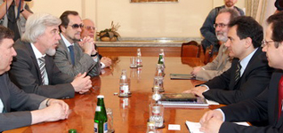

12. DUBNA, May 19: Deputy Prime Minister for EU Integration and Minister of Science and Technological Development Bozidar Djelic met with director of the Dubna Joint Institute for Nuclear Research academician Aleksey Sisakian and Russian Ambassador to Serbia Alexander Konuzin on May 19, 2009. At the meeting they agreed to sign an agreement on cooperation between the Dubna and Vinca nuclear institutes before the year’s end. They also agreed about engaging the Dubna Institute for scientific research in physics as a way of clearing Russia’s outstanding debt to Serbia. For decades Vinca researchers have cooperated with Dubna on scientific and numerous other educational projects. Djelic and Sisakian agreed that Serbia should appoint the scientists and representatives from the Ministry of Science and Technological Development who will take part in the Dubna Institute’s organising and scientific committee, thus raising the agreement on cooperation, signed in 2007, to a higher level.

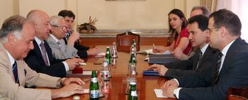

Statistics - major changes / updates of relevant statistical data

Assessment of the developments and outlook on the next 6 months
(Optional personal opinion)

FP7: On 29 of June 2009 the FP7 event in cooperation with DG Research, JRC and COST will be organized in Belgrade. Commissioner Potocnik and Mr. Schenkel, director general of JRC, confirmed the participation.

National: PUBBLIC Call has been launched for submitting project proposal within the Research programme on technological development for a period April 1, 2009 - December 31, 2010. Deadline for submitting a project proposal is end of May 2009.
For the current projects on technological development the annual reports have been submitted which are now in phase of evaluation in order to approve second year of financing.
Public call for legal organizations and registered persons/innovators for innovative project preparation and submission will be publish soon.
The open call “Competition for the best technology innovation 2009“ will be closed in June 2009.

The progress reports are collected in preparation of the meetings of the Steering Platform on Research for the Western Balkan Countries and will be provided for download from the WBC-INCO.Net homepage (www.wbc-inco.net) about one week before the meeting takes place. Therefore please submit your report to heribert.buchbauer@bmwf.gv.at until May 8, 2009.

