Republic of Serbia
PROGRESS REPORT
on recent developments regarding S&T cooperation in/with the WBC
(November 2009 - June 2010)

Policy actions
(e.g. essential changes in the political authorities, administrative bodies, agencies, institutions, personnel, development/launch of new national funding programmes, etc.)
-Civil Servant Regulation Act of the Ministry of Science and Technological Development (MSTD) was adopted by the Government on 23rd March 2010 as part of public administration reform in order to reduce number of civil servant.
-On 23. 5. 2010, MSTD publish national call for project proposals covering all national financed Scientific Program: basic research, technological development and innovation activities and Program of Integral and Interdisciplinary Initiative.
-By the Low of Innovation Activities MSTD published Call for proposal for innovation projects in period 2009/2010 where we have 61 submitted projects, with budget cca 1.2 M€.

Legislative initiatives - development of the legal and strategic framework
-On 24th March 2010, members of Serbian Parliament have completed the first sitting of the regular spring sitting by adopting 37 Bills, including a set of Bills in area of science and intellectual property that have an aim to enhance the scientific system, but also to stop the exodus of most talented people from Serbia.

-Strategy of scientific and technological development of the Republic of Serbia from 2010 to 2015, was adopted by Serbian Government on 25th February 2010.
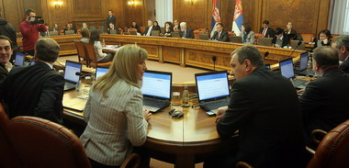
The Bill amending and modifying the Law on Scientific and Research Activities will allow implementation of the Strategy on national priority in the domain of science and technology and rationalization of the network of scientific-research institutes.
The Bill on the Serbian Academy of Sciences and Arts (SANU) has also been approved by the MPs, which defines precisely the property of the Academy, increase the income of the Academic awards, but also allow a better internal organization and increase in the efficiency of the work of the highest scientific and cultural institute in Serbia.
The Bill on Geographical Indications will ensure commercialization of domestic products that come from undeveloped rural areas, but characteristic to Serbia.
MP’s also adopted the following legal acts:
- The Bill amending and modifying the Law on Innovative Activities;
- The Bill on the Confirmation of the Patent Law Treaty;
- The Bill on the Confirmation of the Nice Agreement Concerning the International Classification of Goods and Services for the Purpose of the Registration of Marks of 15 June 1957, as revised in Stockholm on 14 July 1967 and Geneva on 13 May 1977 and as amended on 28 September 1979

-Financial agreement with the European investment bank for a 200 million euro loan that is aimed at revitalizing the scientific infrastructure has also been adopted by the Government.
-Constitution of the National Council for Science, Technological Development
Deputy Prime Minister for EU integration and Minister of Science and Technological Development Bozidar Djelic presented members of the new National Council for Science and Technological Development. The National Council has been constituted on it's first session on Saturday, 22nd of May 2010, whose term of office will be five years.

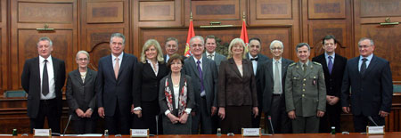

Important events, meetings, training activities, etc.

Council of Europe Development Bank (CEB) Loan

On June 8th 2010, Deputy Prime Minister for European Integration and Minister of Science and Technological Development Bozidar Djelic, after meeting with the Governor of the Council of Europe Development Bank (CEB) Rafael Alomar, announced that this financial institution approved a loan of 200 to 300 million EUR to the Republic of Serbia for the implementation of various projects. He pointed out that in two days the CEB will decide on the first tranches of loans to Serbia from 35 million EUR, 25 million of which is intended for realization of projects in science and ten million for the construction of buildings for scientists.

Scientific community shaping the future of Serbia

The conference "The scientific community shaping the future of Serbia" was held on Sunday, 23rd of May 2010 with an opening speech made by the President of the Republic of Serbia Boris Tadic. During the plenary session, attended by the Prime Minister Mirko Cvetkovic, a number of Ministers, and 2.500 researchers, scientists, representatives of the industry and foreign partners, Head of Delegation of the European Union to Serbia Ambassador Vincent Degert and Vice Prime Minister and Minister of Science and Technological Development Bozidar Djelic addressed the audience.
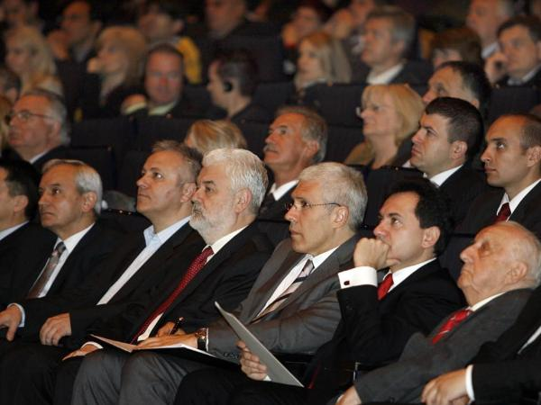

Djelic also signed an Act on the Selection, Assessment and Financing of Programmes for the 2011-2015 Research Cycle, envisaging the beginning of a new stage for science in Serbia and its clear orientation towards a knowledge-based economy.

THE BEST TECHNOLOGICAL INNOVATION COMPETITION – Final competition “The best technological innovation competition 2009” was broadcast by Serbian Radio-Television (RTS) on 23. December 2009 in which occasion the prizes were awarded. Ministry of Science and Technological Development has opened up competition “The best technological innovation competition 2010” in February 2010. The aim of competition for the best technological innovation BTI 2010 (hereinafter referred to competition) is to promote the entrepreneurial climate in Serbia and support to potential and existing high-tech entrepreneurs, who are willing and able to own invention ideas and transform the market valorized innovation. Ministry has provided 20.000.000,00 dinars for support BTI 2010 includes awards and prizes. Apart from possibility of financial support through awards, all participants in this competition will have opportunity to be helped by training and by consultations depending on category in which they will compete.

MSTD together with Serbian Chamber of Commerce was organised two meetings with Rectors of the University Nis and Novi Sad in February and March 2010, with in the project of establishing regional offices in university towns in Serbia with a mission to strengthen the connection of science and industry.

MSTD together with Ministry of Economy and Regional Development (which is in charge in CIP), Ministry of Environment and Spatial Planning, European Enterprise Network-Serbia, Serbian Chamber of Commerce and Belgrade Chamber of Commerce is in the working group for eco-innovation, which is organized on the occasion of publication of the call for eco-innovation under the European Union for Competitiveness and Innovation (CIP), which was open on 13. April 2010.

-In order to foster cooperation between companies and science, Serbian Chamber of Commerce organized meetings with rectors of 4 biggest universities in Serbia – Belgrade (held on 18.03.2010.), Novi Sad (held on 30.03.2010.), Nis (held on 26.02.2010.) and Kragujevac (held on 17.03.2010.). Representatives of Ministry of Science and Technological Development participated in meetings in Nis and Novi Sad.

Development of international cooperation and actions on integration into ERA
(e.g. new bilateral/international agreements, memberships, support structures, important international projects, programmes, etc.)
… Enhanced scientific cooperation with Joint Research Centre

The JRC promotes, as part of its mission, collaboration with organisations and researchers from potential EU candidates. In this context, the JRC has signed a Memorandum of Understanding with the Serbian Ministry of Science and Technological Development. A Serbian delegation, led by the Deputy Prime Minister and Minister of Science, Božidar Đelić, took part today in the signature of the agreement at the JRC headquarters in Brussels.
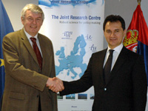
The aim of this collaboration is to co-ordinate as far as possible the research activities in the fields of common interest, such as:
- environment;
- food safety and quality;
- energy;
- agriculture and
- nuclear safety.
To achieve this objective, the EU and Serbian counterparts will exchange information and share results. Serbian research organisations will also be able to request access to large infrastructures and user laboratories at the JRC.
In addition, the JRC welcomes the possibility of hosting of Serbian post-doctoral students to carry out research at the different Institutes, granted by the Serbian Ministry of Science and Technological development. Candidates will be nominated by the Ministry and approved by the JRC.
Text taken from
http://ec.europa.eu/dgs/jrc/index.cfm?id=1410&obj_id=9880&dt_code=NWS&lang=en

Bilateral cooperation:
New bilateral agreements on Science and Technology signed with USA, China, Italy, Spain
Bilateral calls open with France, Chine, Spain

Statistics - major changes / updates of relevant statistical data
…

Assessment of the developments and outlook on the next 6 months
(Optional personal opinion)
…

Appendix: additional data
(Delete if not applicable.)

The progress reports are collected in preparation of the meetings of the Steering Platform on Research for the Western Balkan Countries and will be provided for download from the WBC-INCO.Net homepage (www.wbc-inco.net) about one week before the meeting takes place. Therefore please submit your report to heribert.buchbauer@bmwf.gv.at June 14, 2010.

