REPUBLIC OF SERBIA
PROGRESS REPORT
on recent developments regarding S&T cooperation in/with the WBC
(June 2009 - October 2009)

Policy actions
(e.g. essential changes in the political authorities, administrative bodies, agencies, institutions, personnel, development/launch of new national funding programmes, etc.)

SCIENTIFIC AND TECHNOLOGICAL DEVELOPMENT STRATEGY OF THE REPUBLIC OF SERBIA FOR THE PERIOD 2009 – 2014

The Serbian Ministry of Science and Technological Development has prepared and launched (on June 29, 2009) a draft strategy document for 2009-2014. Immediately after that the public debate started. All main stakeholders at national as well international level has been included in it: the other ministries, public organizations, universities/faculties, companies, diaspora, important international organizations, ministries responsible for science and technological development in many countries, international experts, and so on. During the period of strategy preparation and discussion the pool of high level international experts were included in the process and supported for their work by UNESCO. The debate is closed in October 2009. Many valuable comments will be included in the final strategy version.

FOLLOW-UP MEETING TO THE MINISTERIAL CONFERENCE ON REGIONAL STRATEGY

Developing Regional Strategy for Research and Development for the Western Balkans follow-up meeting was held in Sarajevo on 7th September 2009. This meeting co-organized by the RCC and the Czech Republic gathered experts from the respective Ministries for science and research of the RCC members from South East Europe, as well as members of the scientific institutions from the region, and representatives of relevant international organisations and respective stakeholders. The aim of the Follow-up Meeting was to assess the current status of the realization of the project and raised discussion on the future steps and best modalities for development of the Regional Strategy for Research and Development.
The meeting participants also agreed that Coordination Body for the continuation of all activities related to Regional Research Strategy needs to be established and that the role of the Chair of the Coordination Body will be given to RCC. All RCC Members will inform RCC of two members of their delegation to participate in the work of the Coordination Body, one being from the relevant Ministry. In the mean time Ministry of Science and Technological Development of republic of Serbia proposed Prof. Viktor Nedović and Prof. Đuro Kutlača as Serbian members of Coordination Body.

Legislative initiatives - development of the legal and strategic framework
The Low on Serbian Academy of Science and Arts (SANU) is prepared. The new Law on Innovation and modified Law on S&R are in the last stage of the preparation. The next step is public debate.

In July 2009, new “Act of financing the projects within EUREKA program” was adopted, giving the opportunities for supporting not only scientific organizations: universities and institutes, but also, “innovative organizations” with 50% of projects costs financed from the public fund.

Important events, meetings, training activities, etc.

FP7 INFORMATION EVENT IN SERBIA

On 29 June 2009 the JRC, the Commission's Research Directorate General and the Serbian Ministry of Science and Technological Development jointly organized a high-level conference in Belgrade entitled "Towards Serbia's Integration into the European Research Area". The main purpose of the event was to present and discuss a wide spectrum of research-cooperation opportunities in FP7, with a view to identifying specific areas and topics that would need special attention or support.
More than 400 experts attended the conference which featured 36 speakers from both the EU and Serbian side, including Ministers, Secretaries of States, Deans of Universities, Directors of Institutes as well as major media outlets. The conference was opened by Mr Božidar Đelić, Deputy Prime Minister for EU Integration and Minister of Science and Technological Development, and by the European Commissioner for Science and Research Janez Potočnik. Deputy Prime Minister Đelić presented the draft version of Serbian S&TD strategy and announced that Serbia plans to boost its research spending from the present level of 0.3% of GDP to 1.0% by 2014 and, moreover, that negotiations are underway with the European Investment Bank for an additional 150 M€ investment in research infrastructure. Commissioner Potočnik commended Serbia's good results in its first two years of association to FP7 and praised the assistance that the JRC is providing to the potential candidate countries in their preparation for the uptake of complex S&T-based EU legislation.
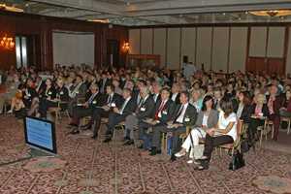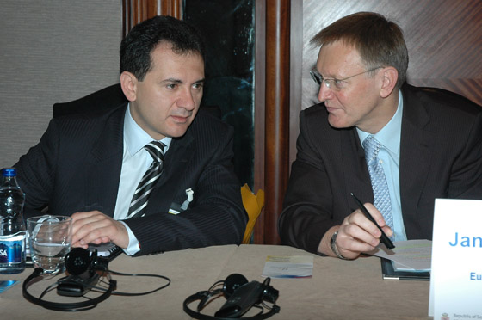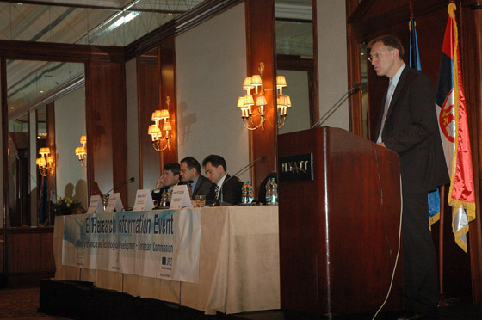

Mr. Djelic, Mr. Potocnik and audience at the information event in Serbia

Prof. Francesco Fedi, President of COST, confirmed the excellent performance of the Serbian scientific community that in a short period of time joined over 60 pan-European research networks. Prof. Viktor Nedovic, Assistant Minister for International Cooperation and Serbia's representative in the JRC Board of Governors, underlined the important role of the JRC in support to Serbia's approximation of the EU body of law. As a measure to focus future collaboration between the JRC and the relevant Serbian organisations, Prof. Nedovic proposed signing a Memorandum of Understanding (JRC - Ministry Science and Technological Development) specifying priority areas and available instruments, including new positions for Serbian grantholders at JRC Institutes. He also presented the main results of Serbian institutions in FP7, and underlined the areas where the remarkable results are achieved, but also the areas in which further improvements are needed.
Deputy Prime Minister Đelić recognised the conference as the most important event that took place in Serbia in the field of research since its association to FP7. The topics and themes of the conference had been chosen based on specific interest expressed by Serbia (ICT, Energy, Food and Health), areas in which Serbia should pay more attention given its integration process into the EU, or topics which are new (presentation on FP7 Euratom and, for the first time, the specific programme "Ideas") or in which Serbia is underrepresented (FP7 "People" programme). Other participating Commission services included the Directorate General Information Society as well as Enlargement who presented the Pre-Accession Instrument (IPA) and how it relates to research capacity.

Additional cooperation protocol signed by Serbia, IAEA

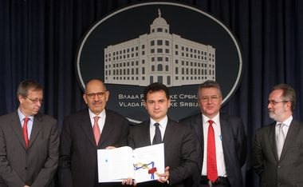
Serbian Deputy Prime Minister for EU integration and Minister of Science and Technological Development Bozidar Djelic and Director General of the International Atomic Energy Agency (IAEA) Mohamed El Baradei signed an additional protocol to the agreement on the non-proliferation of nuclear weapons on 3rd July 2009.
Speaking at a press conference Djelic said that once the Serbian Parliament ratifies the protocol the IAEA will carry out detailed inspections across Serbia, similar to the ones that were made at Vinca nuclear institute. He said that by signing the protocol Serbia has shown that it is part of the international efforts for controlling the proliferation of nuclear weapons.
One of the important subjects discussed with El Baradei was the transfer of used nuclear fuel from the reactor at Vinca. Minister said that $23 million out of $25 million necessary for the transfer of used nuclear fuel from the Vinca Institute of Nuclear Sciences have already been provided, adding that nuclear waste is expected to be imported in Russia by the end of 2010.
Djelic and ElBaradei also discussed the possibility of using nuclear technologies for the development of science, agriculture and the protection of cultural heritage.
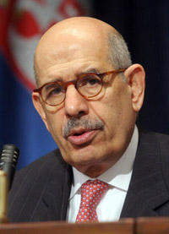
ElBaradei voiced his satisfaction with cooperation between Serbia and the IAEA and congratulated Minister Djelic on his persistency and determination.
He noted that the Vinca Institute has been posing a security threat for a while and therefore used nuclear fuel must be transferred to Russia as soon as possible.
ElBaradei pointed to the importance of the usage of nuclear energy in medical diagnostics and therapy, particularly when it comes to cardiology and oncology, announcing that the IAEA will soon send an expert team to Serbia to estimate Serbia’s needs concerning nuclear medicine.

COST REGIONAL INFO- DAY IN SERBIA

On 2 September 2009 COST and the Serbian Ministry of Science and Technological Development jointly organised the regional COST information day in Belgrade which featured 12 speakers from COST, Serbia, as well as the national COST coordinators from the Balkan region.The main purpose of the event was to present and discuss cooperation opportunities offered by the COST network with a view to stimulate many new proposals for COST Actions from the region.
More than 120 experts attended the conference hosted by the Faculty of Civil Engineering University of Belgrade under sponsorship of Ministry for Science and Technological Development of the Republic Serbia. The welcome address was given by State secretary MSTD Prof. Miloš Nedeljković, Rector of the Belgrade University Prof. Branko Kovačević, Assistent Minister for international cooperation MSTD Prof. Viktor Nedović, and COST national coordinator Prof. Biljana Stojanović. After the welcome address to the audience Prof. V.Nedović presented the International S&T Cooperation in Serbia.
The COST delegation to Belgrade was headed by Prof. J. Bartzis, Vice-President of the COST Committee of Senior Officials, who presented the “ Past, Present and Future of COST”. Talking about the COST history Prof. Bartzis reminded that Yugoslavia was one of the funding countries of COST. He illustrated the opportunities offered by COST, this European intergovernmental network for coordination of nationall- funded research activities, one of the longest-running European instruments supporting co-operation among scientists and researchers across Europe and confirmed the ever-growing interest in COST from the non-COST countries all over the world. The COST Office was represented by 3 delegates. Dr Kalliopi Kostelidou (Senior Science Office Life Science Cluster), explained “Open Call and assessment procedures in COST”. The participants picked up valuable Information for the next collection dates of the COST Continuous Open Call. Dr Albino Maggio (Science Officer Food and Agriculture), presented “Food and Agriculture – examples for the activities in one COST Domain”, demonstrating the vital societal and economic importance of some COST Actions of the Domain. Svetlana Voinova (coordinator for Balkan related COST activities) provided examples of specific COST Schemes as well as practical aspects of participation in COST of neighbouring and non-COST countries.
The afternoon session was devoted to the presentations by the national COST coordinators from the Balkan region of their experience in the participation in COST Actions followed by questions and answers with the Serbian scientific community. Presentations were given by prof. Biljana Stojanovic (Serbia), Damir Jeličić (Croatia), Orsolya Toth (Hungary), Silvia Gergely (Romania), Milena Glavcheva (Bulgaria) and Ammar Mirascija (Bosnia and Herzegovina), all of them giving examples of COST experience in their countries and providing information on national supporting tools.
In her presentation Prof. Stojanovic confirmed the excellent performance of the Serbian scientific community that in a short period of time joined over 85 COST Actions run in 9 COST scientific Domains.
'The Regional COST info-day has illustrated the experience of the international programmes on regional level and showed that future cooperation with countries in the region could strenghten. As Serbia disposes of the significant research potential ready to start up the new projects, the conclusions of regional COST info-day clearly declare that cooperation could be intensified and the number of COST Actions increased’, said professor Stojanovic.
At the end of the COST Information Day Professor Stojanovic congratulated the participants with the success of the event and encouraged the Serbian scientific community to maintain and possibly increase the fruitful participation in COST activities.

THE BEST TECHNOLOGICAL INNOVATION COMPETITION

Ministry of Science and Technological Development is organizing “The best technological innovation competition 2009”. The objective of this competition is to promote enterprising spirit among researchers, students and innovators, creative individuals, economic societies as well as the whole interested public. Ministry has provided 20.000.000 dinars for awards and prizes. Apart from possibility of financial support through awards, all participants in this competition will have opportunity to be helped by training and by consultations depending on category in which they will compete. In Serbian Radio-Television (RTS) on 12. October 2009 were promoted 50 best teems, from which 36 were chosen to go further to the semi final of the competition. Final competition will be broadcasted by Serbian Radio-Television (RTS) on 23. December 2009 by which occasion the mentioned prizes will be awarded.

SME INFO DAY - Ministry of Science and Technological Development in cooperation with the Serbian Chamber of Commerce held info day for SMEs on 13th October 2009. As the 7th Framework Programme (FP7) supports the enforcement of cooperation between science and technology, the transfer of knowledge and commercializing those innovations, the main goal of this presentation was to introduce representatives from innovative SMEs to the process of how to apply for FP7 funding possibilities with their own projects. During these info day 30 representatives from SMEs which are registered in the Ministry data base, participated in the event.
DEVELOPMENT OF SMEs SUPPORT STRUCTURES - Serbian Chamber of Commerce in cooperation with Ministry of Science and Technological Development initiated project of establishing regional offices for supporting SMEs participation in FP7. Regional offices are settled within chambers of commerce in the biggest university cities in Serbia – Belgrade, Novi Sad, Nis and Kragujevac and provide following services:
- information on open calls and requirements for participation,
- FP7 participation training for SMEs,
- assistance to SMEs in partner search,
- connecting companies with domestic and foreign scientific organizations,
Assistance to SMEs in drafting project proposals will be developed. All services are free of charge.

TRAININGS:

Ministry of Science and Technological Development has organised meeting with the researchers in the RT-RK group in Novi Sad on 14th September 2009.

August 27, 2009, University of Novi Sad, Faculty of Sciences - a smaller scale, general info session on possibilities within the specific programme PEOPLE, with a special accent on Marie Curie actions. University of Novi Sad, Faculty of Sciences hosted Dr Dagmar M. Meyer – National Contact Point for the Marie Curie Programme (from the Irish Universities Association, The Irish Marie Curie Office (IMCO)). The overall objective of the info session was to provide general information on how to utilize Marie Curie actions to support the career-development of researchers, with a view to the successful creation of the European Research Area.

A further 200 Serbian scientists, mainly PhD students, were trained in generic research skills by the Ministry/Consultative Bureau for International Projects:
3-4 June - 2-day training course in Novi Sad
24-25 June - 2-day training course in Belgrade
27-28 September - 2-day training course in Belgrade
2 October - 1-day training course in Belgrade

Info session Regpot:
31.7.2009. Institute of Meat hygiene and Technology
6.8.2009. Institute of Chemistry, Technology and Metallurgy
10.8.2009. Institute of Economic Sciences
15.9.2009. Institute of Chemistry, Technology and Metallurgy
21.9.2009. Institute for Multidisciplinary Research-IMSI
25.9.2009. Institute for Technology of Nuclear and Other Raw Materials

The Ministry/Consultative Bureau for International Projects prepared a detailed guide for applicants for REGPOT projects to help Serbian scientists understand the philosophy needed to write and submit successful REGPOT proposals.

Development of international cooperation and actions on integration into ERA
Bilateral cooperation:
SLOVAKIA
On the basis of the Agreement between the Federal Government of the Federal Republic of Yugoslavia and the Government of the Slovak Republic, signed in Bratislava on the 26 February 2001, Ministry of Science and Technological Development of Republic of Serbia launching the call for co-funding scientific and technological cooperation for the period of 2010-2011. Call was opened until 14th October 2009.

FRANCE
Bilateral scientific cooperation with CNRS
On the basis of the Agreement of scientific and technical cooperation between the Ministry of Science and Technological Development and National Center for scientific Research (Centre National de la Recherche Scientifique – CNRS), signed in Paris on 25th October 2005, the Ministry of Science and Technological Development, in October 2008 launched a Call for application of bilateral scientific cooperation projects. In accordance of scientific expertise in Serbia and France on the occasion of the Second Session of French-Serbian Mixed Committee for projects selection, it was decided to approve funding of 12 project proposals.

JAPAN
Draft of Cooperation Agreement on Science and Technology between Republic of Serbia and Japan was sent to Japanese side.

RUSSIA
Negotiations on Cooperation Agreement on Science and Technology between Republic of Serbia and Russian Federation are finalized. The draft text is discussed on September 28-30 in Moscow on expert’s level and accepted afterwards by both sides. The next step is singing of the document.

USA
The process of negotiation on S&T Cooperation Agreement is in the last stage and should be finished soon.

PORTUGAL and SPAIN
The processes of negotiation on S&T Cooperation Programmes are in the last stage and should be finished soon.

Statistics - major changes / updates of relevant statistical data
EUREKA – In the second part of the year, 6 new Eureka projects were started, 3 projects among them, are co-financed from the public budget.

Assessment of the developments and outlook on the next 6 months
(Optional personal opinion)
Suggestions to the Commission:
EU level:
- based on the evaluation of the quality of the RegPot proposals and success rate in 2008 and 2009: If the Commission really wants to help raise the competitiveness of WBC scientists in general, then requiring large scale proposals with a budget of up to €2 million per proposal is not the most effective way of doing this for the large majority of the good quality WBC scientists.
- After priority settings in several important areas that was done inside the frame of WBC INCO NET project it is expected from the Commission to pay more attention to those results and consider possibilities to open regional calls and funds for WBCs in the specific fields.

National level:
- Action plan based on the final approved S&T strategy version should be prepared as the next step
- The laws on Serbian Academy of Science and Arts (SANU), on Innovation and modified on S&R should be approved by the Government before the end of the year.

Appendix: additional data
(Delete if not applicable.)
…

