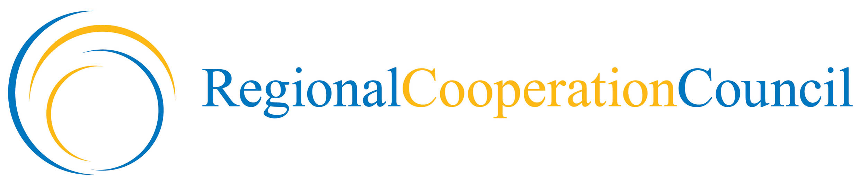
Building Human Capital and Cross-Cutting Issues Unit

No. Sarajevo, 16 November 2009

Report on the Sarajevo Conference on Higher Education -
“Building Capacity for Change in the Western Balkans”,
RCC Secretariat premises, 30-31 October 2009

A two-day conference on higher education - “Building Capacity for Change in the Western Balkans” has been held in Sarajevo, on 30-31 October 2009. The event has been organized by the RCC Secretariat, in cooperation with the Universities of Novi Sad, Sarajevo and Zagreb. It was the third in the series of biannual conferences devoted to institutional reform and cooperation in higher education, a follow up of the Novi Sad Initiative, 28 - 30 October 2005, and Dubrovnik Conference on Higher Education, 29 - 31 October 2007.

The conference gathered a range of constituencies from the Western Balkans region, along with representatives of international organizations, European and regional experts involved in the creation of respective policies on higher education. The event was opened by Hido Biščević, the RCC Secretary General. Introductory remarks were delivered by Aleksa Bjeliš, Rector of the University of Zagreb, Faruk Čaklovica, Rector of the University of Sarajevo, and Miroslav Vesković, Rector of the University of Novi Sad. Head of the RCC Building Human Capital Unit chaired the meeting.

The aim of the meeting was to support institutional reform in the Western Balkans by sharing the experiences of the higher education sector within the region and beyond. The participants focused on finding ways to accelerate the convergence of the region towards European Higher Education Area and EU policy in higher education through a number of EU platforms. Ministries of the RCC members from the Western Balkans provided a keynote speech on macro structure of their higher education sector, with special emphases on the institutional issues and provided evidences on the evolution of the higher education system in the last ten years.

Wide-ranging discussions together with excellent, informative presentations raised fundamental questions about the higher education systems participants of the conference want to see, on the systems as they are now and how positive changes can be achieved. Participants from the EU countries (Sweeden, Austria, Irelan) provided detailed information about developments around Europe.

Representatives of the Western Balkans institutions highlighted positive developments and argued that the region can develop very good education systems. It was heard that the region shouldn’t be blindly following a European policy agenda, but fully participating in its development, which is not yet the case.

Major challenges have also been discussed, as the nature of EHEA (inclusive or two-track), funding of higher education, inclusion/participation, concepts of autonomy, quality etc. Participants emphasised importance of investing in higher education and making system changes to improve quality/equality of opportunity self evident, and stressed the need for genuine and wide societal debate about some aspects of higher education that are taken for granted. Bologna reforms have often been implemented cosmetically without understanding of purpose; old, introverted practices perpetuate; laws are still being written the traditional way etc. It was concluded that the issues of financing and autonomy of Universities should be subject of regional debate – since the same practice exists across the region. Another common concern is how to ensure student participation in decision-making at all levels, including quality assurance development. Novi Sad Initiative should set an example and secure that no more meetings are held without student representation.

Mobility of students and academic staff was mentioned as an important challenge for the region because it has been so closed/isolated in the last period. Participants agreed that brain drain is a short-term danger and expressed the need to establish diaspora contacts in academic community, and create conditions whereby people may wish to return. Need for holistic approach on education systems has been stressed, not just in regard to higher education but to vocational education and school system, too. National Qualification Frameworks can help if developed for the right reasons and in the right way.

It was concluded that key actions are now needed, especially filling administrative gaps through training of the ministerial staff, agencies’ staff dealing with quality assurance and diploma recognition, administrators within higher education bodies – structures and professionalization of national university associations. Participants of Sarajevo conference welcomed the proposal that that these goals could be addressed at regional level, within a Tempus project, under umbrella of the RCC.

Mladen Dragašević
Head of Unit

