CONCEPT NOTE

Title of the suggested Action: DEVELOPMENT OF A VIRTUAL LABORATORY FOR ACTION RESEARCH, INNOVATION AND ENTREPRENEURSHIP (VLARIE)

Subtitle (or short description in one sentence): Development of operational partnership between the academia and businesses

Description of the Action (approx. 1 page):
In Western Balkan countries (WBC) economy, SMEs are predominantly business entities that lack resources (financial, human, and technological) for conducting innovation development and starting new intrapreneurial ventures. Having this in mind, the idea of development of VLARIE is based on the need for establishing a holistic integration of developmental potentials of academic institutions and business organizations in order to improve and accelerate innovations and entrepreneurial ventures in WBC. The concept of VLARIE is developing relationships, practices and cultures, both at academic institutions and business organizations that will lead to a sustainable virtual organization for long term support of innovations and entrepreneurship in WBC. During the first, developmental phase, this endeavor will go though the following steps:

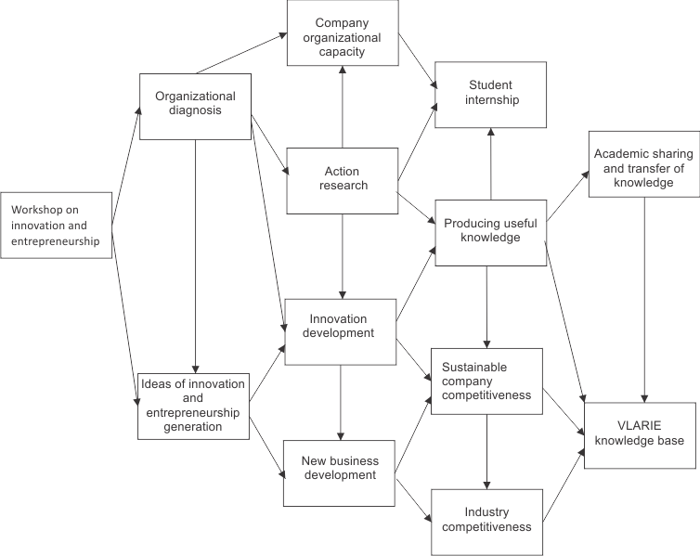

Step 1: Inception. Outcomes: Action plan developed; consortium contract signed and initial staffing of the VLARIE conducted; governing bodies established; first pilot public awareness workshops conducted (first year).
Step 2: Diagnostics. Outcomes: Pilot companies selected and diagnosing workshops conducted (end of first year; diagnostic activities continue until end of third year).
Step 3: Piloting. Outcomes: Developmental needs defined in the selected companies, minimum one action research and one entrepreneurial endeavor conducted; minimum 10 new businesses established and supported at the VLARIE business incubator; knowledge base designed and tested; regular video conference conducted (second year).
Step 4: Solution Development. Outcomes: Evaluated and promoted relevant number of good practices for: innovative organizations, entrepreneurial organizations, learning organizations, selected from different branches; reasonable percentage of established new business become independent from further incubator support and become competitive; action research for each organization intervention conducted (third, fourth and fifth year); First regional conference conducted at beginning of fourth year.
Step 5: Dissemination. Outcomes: Expanding number of new partnerships both with academic institutions and business organizations; Presentation of findings and good practices at conferences and business associations (fourth and fifth year).
Step 6: Closing of first, developmental phase. Outcomes: Final Report prepared and printed in English and WBC languages; Final conference conducted (fifth year).

References to running activities, lessons learned from other regions, etc. (one paragraph):
Large international companies have different innovative laboratories. These forms of developmental activities are generators of new products and new processes development. Business incubators in many, especially developing countries, are main form for support of self-employment and entrepreneurship development. Some universities have established action research laboratories as a platform for student involvement in developmental activities. All of the above mentioned practices are useful lessons and practices that can be transferred to our idea of VLARIE.

Actors to be involved in the implementation and their roles (max. half a page):
One academic institution from each WBC and an appropriate number of partnering companies will form the initial core of VLARIE.
The overall project methodology to be applied by the VLARIE will present a blend of the following:
- Interactive training workshops for awareness raising and developing the competencies for innovative and entrepreneurial projects in the development of the company and sector competitiveness;
- Facilitating company teams for organizational diagnosis and generating innovative entrepreneurial ideas;
- Action research implemented by mixed teams (staff and management from companies, teachers and students from tertiary education);
- Lab development of new products, services and business processes by expert teams from VLARIE, with participation from experts from interested companies;
- Mentored student practice in partnering companies.

Expected impact (one paragraph):
Improvement of company competitiveness of WBC companies, development of a new culture of experience and knowledge sharing and building supportive climate for student internship at involved companies.

Relevance to the WBC region (one paragraph):
Building coalition of existing academic and company capacities for joint projects on collecting, storing and selection of innovative ideas, start-up business ideas and conducting action research that will accompany business development innovation .

Author: Prof. Cvetko Smilevski,Ph.D; Business Academy Smilevski, 1000 Skopje, bul. AVNOJ 74a Macedonia

