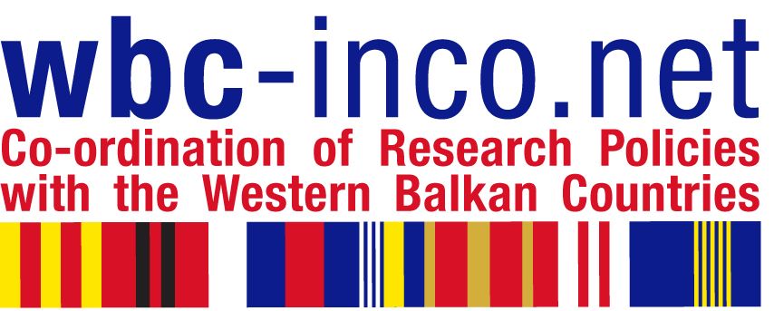

PRACTICAL INFORMATION

Steering Platform on Research for
Western Balkan Countries
Meetings in Tirana

11 – 15 June 2012

Meeting series
June 11: Executive Steering Board meeting of the WBC-INCO.NET project
June 12: Meeting of the Steering Platform on Research for WBC
June 13: Innovation Dialogue Meeting organized by WBC-INCO.NET
June 14: Short preparatory meeting for the next meeting series for organizational team
Separate agenda and individual invitations are circulated for each of these meetings.

Registration of delegations / participants

Participants are kindly requested to register by filling out Central Registration Form and send it to rajna.spaho@akti.gov.al and edmond.agolli@akti.gov.al
If you have any question regarding the registration please send an e-mail to the above mentioned addresses.

Meeting Venue

Hotel TIRANA INTERNATIONAL, Scanderbeg Square, No. 8, Tirana, Albania www.tiranainternational.com ; e-mail: reservation@hoteltirana.com.al ;
Tel. +355 42 234185; Fax +355 42 232521

Accommodation

It is recommended that participants book their rooms in the Hotel Tirana International which have been reserved especially for participants of the meetings. You will find the reservation form attached. Please send the reservation form at rajna.spaho@akti.gov.al and reservation@hoteltirana.com.al .

Rates for rooms are as below:
- Deluxe Single Room- (99 Euro)
- Deluxe Double Room- (108 Euro)
- Standard Single Room- (87 Euro)
- Standard Double Room- (94 Euro)

These rates are especially for participant in Steering Platform Meeting (room/night), including 20% VAT, 5% City Tax and rich breakfast buffet.

Other special services included in the room rate:

- Free use of SPA Center (Indoor Swimming Pool, Sauna& Fitness Center);
- Free Internet access in room, at the Lobby & also in all Conference Room Areas;
- Free parking area for guests who are accommodated in the Hotel.

Transport from the airport to hotel
By Taxi
The fastest way to get to the Hotel is by taxi. The journey from the airport to Tirana takes 20–25 minutes, depending on traffic, and costs about 2,500 Leke (18 EUR) one way. For full details download TAXI Offer by Hour
Tirana Airport taxi service is provided by ATEX shpk. www.atex.al is the website that offers to all passengers the ability to reserve taxis in advance, online. They specialize in transfers between Tirana Airport and all Albanian cities for both individuals and groups. The service is professional, courteous and personal, and at affordable prices, 24 hours a day, seven days a week.
We would recommend using only licensed taxis, which are yellow with a red ATEX logo and the airport logo on both sides of the vehicle. At the airport, these taxis park in front of the terminal and also at the pick up area of the terminal.
Phone: 00355 4 2222 122
Mobile: 00355 66 20 80191, 00355 66 20 08873

By Bus
Rinas Express operates 12 hours (6 am to 6 pm) as an hourly bus service between the Airport and the National Museum in the centre of Tirana. The single fare is 250 Albanian Lek.

Currency
The local currency name is LEK. 1 Euro = 139.99 Lek

Emergency and other phones

Medical Emergency (04) 34937
Police 129
Airport 00355 4 2381 600
Country Code 042
Albania Area code 00355

