 | Faculty of Mechanical Engineering - University of Zenica (B&H)  in cooperation with
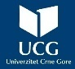 | Faculty of Martime Kotor - University of Montenegro (Montenegro) | 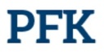
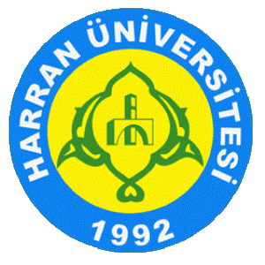 | Faculty of Engineering, Harran University, Şanlıurfa (Turkiye) | 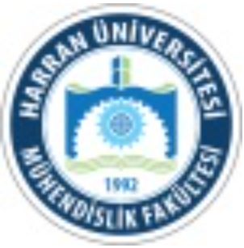
 | Faculty of Mechanical Engineering - University of Maribor (Slovenia) | 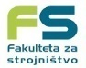
 | Faculty of Technical Sciences - University of Novi Sad (Serbia) | 
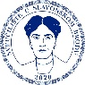 | Mechanical Engineering Faculty – University of Slavonski Brod (Croatia) | 

7th CONFERENCE „MAINTENANCE 2022”
Budva (Montenegro), September 12 – 16, 2022

This box is not to be filled:

REGISTRATION FORM

Please, fill the form below:
Title of the paper:
Authors:  Note:  Please, bold or highlight the corresponding author |  | Name |  | Surname | Institution |  | e-mail address
 | 1.
 | 2.
 | 3.
 | …
Abstract:

Abstract: | Keywords:
TOPIC:  Please, write down No of topic to put your paper in. | TOPIC  1. Technology maintenance  2. Reliability and maintenance  3. Logistics in the maintenance  4. Quality and maintenance  5. Monitoring and Diagnostics  6. Management and maintenance  7. Information systems maintenance  8. New technologies in the maintenance  9. Education Maintenance  10. Human resources in maintaining |  |  |  |  | 11. Asset management  12. Facility Management  13. Outsourcing  14. Risk Management  15. Ecology and Maintenance  16. Inventory Management  17. Cost of maintenance  18. Safety at work and Fire Protection  19. Performance indicators of maintenance  20. Trends in Maintenance

Please, send filled form to the following e-mails: fuad.hadzikadunic@unze.ba; darko.petkovic@unze.ba; emir.djulic@unze.ba !!!!!!

