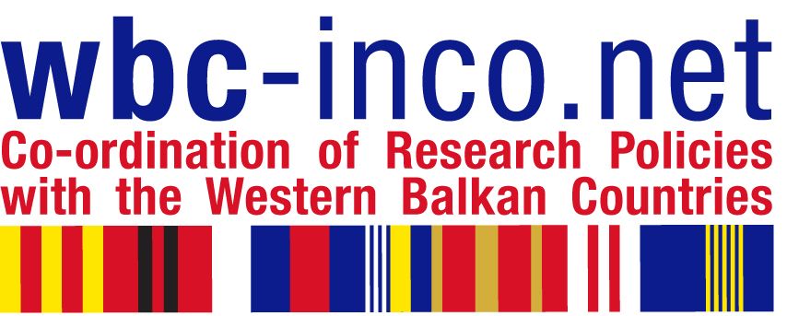
WBC-INCO.NET and
Steering Platform
Meetings in Montenegro
8 – 12 November 2010

REGISTRATION FORM
Becici (Budva), Montenegro

REGISTRATION FORM
Please fill out this form and send it to siller@zsi.at and milena.milonjic@gov.me within October 25, 2010

Name and Surname
Institution
Tel/Fax/Mobile
E-mail

Series of Meetings
In order to keep an overview, please inform us for which of the meetings you are registered / invited:
8. 11. 2010. Innovation Dialogue Forum (13 – 17.00h)
9. 11. 2010. Innovation Dialogue Forum (cont. 9 – 16.00h)
10. 11. 2010. Regional Dialogue Meeting (9 – 13 h)
10. 11. 2010. WBC-INCO.NET Executive Steering Board - for ESB members (14 - 17h)
11. 11. 2010. Steering Platform Meeting – for nominated delegates (2 per country)
12. 11. 2010. WBC-INCO.NET General Assembly and Enhanced Kick Off ( 9 – 13h )
12. 11. 2010. WBC-INCO.NET Preparatory Meeting for the next SP (14 – 17h)

DETAILS ON ARRIVAL if applicable
Arrival Date: | Time: | Airport: | Number of nights:
Departure Date: | Time: | Airport: | Number of nights:

DINNER or other EXTRAS
Special dinner Thursday evening (Steering Platform participants) and the exact venue will be communicated separately.

INFORMATION ON THE VENUE

VENUE: The meetings will take place at Hotel ‘Queen of Montenegro’, Becici (Budva), Montenegro

Reservations are to be made through agency CONGRESS TRAVEL (see separate hotel registration form)
Džordža Vašingtona 45 tel/fax:
81000 Podgorica, Crna Gora
e-mail: office@congresstravel.me
tel/fax: + 382 20 229 550
+ 382 20 229 55
tel/fax: + 382 20 228 410

