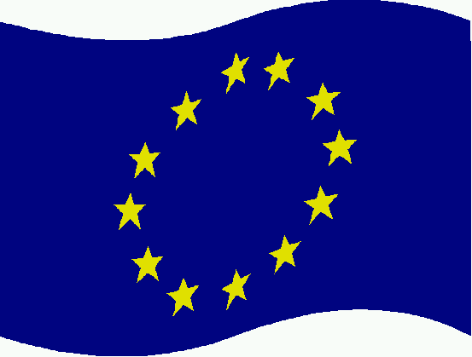 | 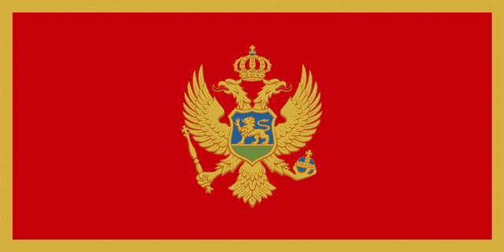 | 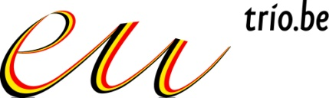
EUROPEAN COMMISSION RESEARCH DIRECTORATE-GENERAL | MINISTRY  OF EDUCATION AND SCIENCE OF MONTENEGRO | BELGIAN PRESIDENCY

DRAFT AGENDA

Meeting of Steering Platform on Research for Western Balkan Countries

November 11, 2010

Meeting in Becici (Budva), Montenegro

9.00 - 9.30 | Opening Statements by:  - Belgian Presidency (including presentation of Presidency activities);  - European Commission;  - Representative from Montenegro: Igor Radusinovic, Deputy Minister for Science, Research and Technological Development.
9.30 - 9.45 | Approval of the Agenda.  Approval of the Minutes of the last Steering Platform Meeting (Belgrade, 24 June 2010).
9.45 - 11.15 | What has been done since June 2010:  Stocktaking on implementation Conclusions Steering Platform meeting in Belgrade (WBC-INCO.NET).  Presentation of recent developments regarding S&T cooperation in/with the WBCs (see Information sheets for more details) by:  - European Commission (DG RTD and JRC);  - Western Balkan countries;  - Steering Platform members: EU Member States and countries associated to FP7;  - Representatives from WBC-INCO.NET, SEE-ERA.NET PLUS, COST, RCC and EUREKA.
11. 15 – 11.30  11. 30 - 12.30 | Family photo  Coffee break  Involving private sector/SMEs in research cooperation:  General presentation by representative from UEAPME, Christian Lister, Communications Director of The Genesis Initiative in the UK: Why should SMEs invest in research? How to attract SMEs into research and how to cooperate with FP7 and other instruments?
12.45 - 14.00 | Lunch
14.00 – 15.15 | Research for the benefit of SMEs:  - Presentation of specific SME Programme and statistics and best practices (Mr Bernd Reichert, DG RTD/T.3);  - Presentation of Eurostars Programme (Mr S. Halada, Eureka secretariat);  - Role of European Technology Platforms (Ms Patricia Postigo-Mclaughlin DG RTD/C.2) and presentation of National Competence and Technology sector and national programme for SMEs (Platform member to volunteer).
15.15 – 15.30 | Coffee break
15:30 – 16:45 | From Research to Innovation:  - Report of WBC-INCO.NET-Enhanced: debriefing on 1st Innovation Dialogue Forum;  - Presentation of European Innovation Scoreboard;  - Competitiveness programme (CIP): presentation of programme (DG Entr.) and of project NUMIX on Eco-Innovation by Ms Ivana Glisevic (local project manager);  - Central European Initiative (CEI): past experiences, current financial instruments and a strategic project for the future” by Mr. Giorgio Rosso Cicogna, Alternate Secretary General.
16.45 – 17.30 | Concluding Remarks  - Presentation and adoption of conclusions including recommendations on future actions and work.  AOB  Announcement of the next Steering Platform Meeting
19.00 – | Social event

