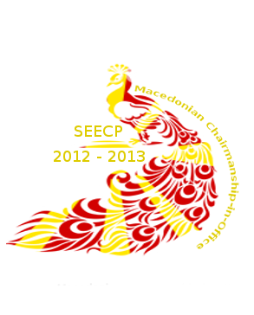
“Solidarity in action”

Macedonian Chairmanship in Office

Delegate Handbook

Summit of the SEECP Heads of State/Government
Ohrid, 1 June 2013

Meeting of the SEECP Ministers for Foreign Affairs
Ohrid, 31 May 2013

RCC Annual Meeting
Ohrid, 30 May 2013

Meeting of the SEECP Political Directors
Ohrid, 29 May 2013

SUMMIT
of Heads of State and Government of the Participating Countries of the South-East European Cooperation Process
and
11th FORUM
of the Dialogue among Civilizations

FRIDAY, 31 MAY 2013
 | Arrival of Heads of State and Government of the participating countries of the SEECP and the Forum of the Dialogue among Civilizations
 | Possibility for bilateral meetings
20:00 | Informal dinner for the Heads of State and Government  Venue: Villa “Biljana”  Format: 1+1

SATURDAY, 1 JUNE 2013
09:00 - 10:45 | Possibility for bilateral meetings  Venue: Hotel “Inex - Gorica”
10:45 | Gathering of the Heads of State and Government  Venue: Balcony of Hotel “Inex - Gorica”
10:55 | Family photo
11:00 – 13:00 | Official opening of the Summit of SEECP Heads of State and Government  - Introductory remarks by the SEECP Chair-in-Office, the President of the Republic of Macedonia, H.E. Dr. Gjorge Ivanov,  - Welcoming statement by the President of the Government of the Republic of Macedonia, H.E. Mr. Nikola Gruevski,  - Adoption of the Agenda,  - Remarks by Heads of State and Government (7 min. max),  - Remarks by special guests attending the Summit (5 min. max),  - Endorsement of the Annual Report of the RCC Secretary General on the regional cooperation in South-East Europe for 2012-2013  - Endorsement of the “RCC Strategy and Work Programme 2014-2016”  - Endorsement of the Chairmanship-in-Office of the SEECP for the term 2013-2014  - Adoption of the SEECP Ohrid Declaration and “Solidarity in Action” Joint Statement,  - Miscellaneous  Venue: Conference hall of Hotel “Inex-Gorica”
13:00 – 13:30 | Press conference of the Troika
14:00 | Departure for the complex “St. Naum of Ohrid” (by boat)
15:00 | Arrival
15:00 – 17:00 | - Sight-seeing of the complex  - Lunch hosted by President Ivanov for the SEECP Heads of State and Government and special guests
17:00 | Departure for the Neolithic settlement “Bay of Bones” and the Museum on Water
17:30 – 18:00 | Arrival and sight-seeing
18:15 | Transfer to Hotel “Inex-Gorica” by vehicles
18:30 – 21:00 | Possibility for bilateral meetings  Venue: Hotel “Inex - Gorica”
21:00 | Gala dinner  Venue: Hotel “Inex-Gorica”

SUNDAY, 2 JUNE 2013
 | Departure to the port of Ohrid (by vehicles)
09:00 – 09:45 | Working breakfast of the Heads of State and Government and Special Guests in the Fish Restaurant – Ohrid
09:45 – 10:30 | Sight-seeing of Ohrid and visit of St. Sofia Church
10:40 | Departure for Hotel “Biser”, Kalishta, Struga (by bus)
11:15 | Arrival
11:30 – 12:30 | Official opening of the 11th Forum of the Dialogue among Civilizations  First plenary session  - Introductory remarks by the host, President Ivanov,  - Remarks UNESCO Director-General,  - Remarks by special guests (5 min. each),  - Remarks of Heads of State and Government (5 min. each),  Venue: Hotel “Biser”, Kalishta
12:30 – 12:45 | Coffee break
12:45 – 13:45 | Second plenary session  - Presentation by Ivanov School for Leaders Alumni Association - ISLAA  - Presentation and adoption of the Forum Declaration,  - Miscellaneous,  - Final remarks by:  - UNESCO Director General,  - President Ivanov.
13:45 – 14:00 | Family photo
14:00 – 14:30 | Press conference of the President Ivanov and the forthcoming host
14:30 – 16:00 | Lunch hosted by President Ivanov for the participants of the Forum of the Dialogue among Civilizations  Venue: Complex Kalishta
16:15 – 17:00 | Departure of delegations by boat to the port of Ohrid
17:00 | Departure of the participants

GENERAL INFORMATION

- VENUE

1.1. The Summit of Heads of State and Government of the Southeast European Cooperation Process participating countries (SEECP) will be held in Ohrid, Republic of Macedonia, on June 1st, 2013 (Saturday), in the Inex Gorica Hotel.

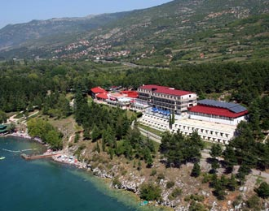
The Inex Gorica Hotel is part of the world renowned LUXURY GROUP

1.2. The 11th Forum of the Dialogue among Civilizations will be held in Struga, Republic of Macedonia, on June 2nd, 2013 (Sunday) in the Kalishta Complex.

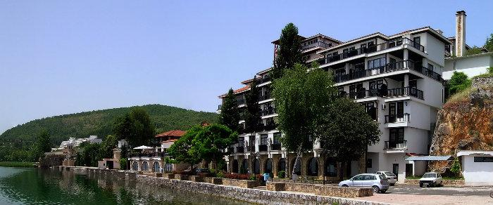
Kalishta

- AGENDA

The Summit will begin with an informal dinner for the Heads of State or Government hosted by the President of the Republic of Macedonia in Villa Biljana - Ohrid (summer residence), on May 31st, 2013 at 8 pm.

The official opening of the Summit followed by the plenary session will be held on June 1st, 2013 (Saturday) in the Inex Gorica Hotel – Ohrid.

The official opening of the Forum followed by the plenary session will be held on June 2nd, 2013 (Sunday) in the Kalishta Complex – Struga.

The latest updated version of the agendas for both the Summit and the Forum are enclosed to this Information paper.

- DELEGATIONS

3.1. Official participation format for the Summit and the Forum is 1+4

- this format will be valid for all plenary sessions, meals and side events
3.2. Registration and Accreditation Badges
- Delegations are kindly requested to fill in the enclosed application forms and return them by May 10, 2013 at the latest to the e-mail address of their liaison officer.

- All delegates and other participants attending the Summit / Forum must be accredited in advance. The host will provide badges for heads of delegations, special guests, members of delegations, as well as for media representatives. Badges are mandatory and must be clearly visible at all times.

NB: Accreditation badges and information packages will be distributed by the liaison officers upon arrival.

- SESSIONS AND ORDER OF SPEAKERS
4.1. The SEECP Summit will be divided into two working sessions (morning and afternoon).
The order of speakers will be established according to the SEECP practice, i.e. in alphabetical order of the names of participating countries.
The expected length of addresses shall be up to 7 min. for Heads of State or Government and up to 5 min. for special guests.
The session will finish by adoption of the Final Document.
4.2. The Forum will take place in a single session.
The order of speakers will be established according to the Forum’s practice, i.e. in alphabetical order of the names of participating countries.
The expected length of addresses shall be up to 5 min. for Heads of State or Special Guests
The session will finish by adoption of the Forum Declaration.
4.3. The end of the SEECP Summit will be followed by a joint press conference of the troika (previous, current and future presidency)
The end of the Forum will be followed by a joint press conference of the current and future presidency.
- WORKING LANGUAGE / INTERPRETATION

The working language of the SEECP Summit and the Forum of the Dialogue among Civilizations is English. Simultaneous interpretation will be provided.

Delegates who wish to speak in their mother tongue are kindly requested to bring their own interpreters and inform their liaison officers (see other accompanying staff section of the registration form).

- BILATERAL MEETING ROOMS

In function of organizing bilateral meetings between participants, every delegation will have a special bilateral meeting room at its disposal.
Delegations are kindly invited to submit any bilateral meeting requests to their liaison officers in order to draft the schedule.

- DRESS CODE

Dress code during the Summit and Forum will be business attire for the official part of the programme and smart casual for the informal part.

- ARRIVAL / DEPARTURE OF DELEGATIONS

Arrival of delegations is expected on May 31st, 2013 (Friday), whereas departure is expected on June 2nd 2013 (Sunday) or June 3rd 2013 (Monday).

Delegations will be welcomed by representatives of the State Protocol of the Republic of Macedonia, at the airports Alexander the Great – Skopje and St. Paul the Apostle – Ohrid, as well as at the border crossings, depending on the itineraries.

NB: Delegations traveling by special flights are encouraged to choose Ohrid Airport.

VIP Lounge at airports will be arranged for all delegation members upon arrival / departure.

NB: An expedited passport and customs control procedure will take place for all delegations upon arrival / departure. Therefore, delegations are kindly requested to designate a person in charge of such formalities (passport and luggage) and submit this information to their respective liaison officers. Preferably, baggage should be visibly tagged.

- TRANSPORTATION

The organizer will provide transport from the airports in Skopje and Ohrid to the respective hotels and vice versa for all Heads of Delegation and Special Guests.

Transport will also be provided for all other members of delegations as part of a standard motorcade.

- VISA REQUIREMENTS

Members of delegations requiring entry visas for Republic of Macedonia are requested to acquire the visas prior to entry at the diplomatic representations of Republic of Macedonia in their countries. Further information regarding the visa regime can be found on http://www.mfa.gov.mk/?q=node/270

- HOTEL ACCOMMODATION

Delegations will be accommodated in the following hotels|: Inex Gorica, Metropol, Bellevue, Granit and Belvedere.
Accommodation costs for 3 nights will be covered by the host country for the 1+4 format.
Costs for additional delegation members outside of the abovementioned format are to be covered by each delegation individually.

- SECURITY

The Ministry of Interior of the Republic of Macedonia will be in charge of security during the Summit / Forum.
Delegations are kindly requested to submit information on the type of weapon, ammunition, communication frequency and blood type of their security officers.
A VIP vehicle and police escort will be provided for all Heads of Delegation.

- MEDICAL ASSISTANCE

Medical services will be provided during the Summit / Forum. Delegations are kindly requested to provide information regarding eventual special medical needs (restrictions of any type or special dietary preferences).

- PRESS CENTER AND TECHNICAL SECRETARIAT

The Offices of the Press Center and Technical Secretariat in Ohrid and Struga will be equipped with telephone line, internet access, computers, printer, fax machine and photocopier.
For any additional information, please contact your assigned liaison officer.

- LIAISON OFFICERS

A liaison officer has been assigned for every delegation individually.
Liaison officers will be met and presented to the advance teams at their meeting.

Please find below the complete list of liaison officers and their contact details.
Delegations without an assigned liaison officer are advised to contact the Protocol Office of the Ministry of Foreign Affairs of the Republic of Macedonia.

REGISTRATION FORM

To be filled in and returned to the respective liaison officers by April 10, 2013
Please have in mind that the arrangements shall be made at a first come – first served basis
NB: Advance teams are invited at a coordination meeting scheduled for May 10-11, 2013. Please contact your assigned liaison officer in order to register for the coordination meeting.

Format: 1+4

HEAD OF DELEGATION

Name:
Surname:

Date of Birth:
Passport number:
Blood type:
Photo in .jpg format: to be sent to the e-mail address of your respective liaison officer

Date and Time of Arrival:
Means of transport:

- Commercial flight:
- Special flight:
- Car:

If traveling by special flight, please specify the airport of arrival (Ohrid airport recommended)
If traveling by car, please specify the border crossing of arrival

Date and Time of Departure:
- Commercial flight:
- Special flight:

If traveling by special flight, please specify the airport of departure (Ohrid airport recommended)
If traveling by car, please specify the border crossing of departure

Special dietary requirements:
Other remarks:

Delegation member 1

Name:
Surname:
Title:
Photo in .jpg format: to be sent to the e-mail address of your respective liaison officer
Date of Birth:
Passport number:
Date and Time of Arrival:
Date and Time of Departure:
Means of transport:

- Commercial flight:
- Special flight:
- Car:

Please specify if the delegation member will travel in the same manner as the Head of Delegation

Delegation member 2

Name:
Surname:
Title:
Photo in .jpg format: to be sent to the e-mail address of your respective liaison officer
Date of Birth:
Passport number:
Date and Time of Arrival:
Date and Time of Departure:
Means of transport:

- Commercial flight:
- Special flight:
- Car:

Please specify if the delegation member will travel in the same manner as the Head of Delegation

Delegation member 3

Name:
Surname:
Title:
Photo in .jpg format: to be sent to the e-mail address of your respective liaison officer
Date of Birth:
Passport number:
Date and Time of Arrival:
Date and Time of Departure:
Means of transport:

- Commercial flight:
- Special flight:
- Car:

Please specify if the delegation member will travel in the same manner as the Head of Delegation

Delegation member 4

Name:
Surname:
Title:
Photo in .jpg format: to be sent to the e-mail address of your respective liaison officer
Date of Birth:
Passport number:
Date and Time of Arrival:
Date and Time of Departure:
Means of transport:

- Commercial flight:
- Special flight:
- Car:

Please specify if the delegation member will travel in the same manner as the Head of Delegation

Security Officers

Name:
Surname:
Photo in .jpg format: to be sent to the e-mail address of your respective liaison officer

Date of Birth:
Passport number:
Blood type:
Date and Time of Arrival:
Date and Time of Departure:

Means of transport:

- Commercial flight:
- Special flight:
- Car:

Type of weapon (if armed):
Request for frequency (if necessary):

Please specify if the security officer will travel in the same manner as the Head of Delegation

Other accompanying staff

Name:
Surname:
Title:
Photo in .jpg format: to be sent to the e-mail address of your respective liaison officer
Date of Birth:
Passport number:
Date and Time of Arrival:
Date and Time of Departure:
Means of transport:

- Commercial flight:
- Special flight:
- Car:

Please specify if the delegation member will travel in the same manner as the Head of Delegation

Media representatives

Name:
Surname:
Media:
Photo in .jpg format: to be sent to the e-mail address of your respective liaison officer
Date of Birth:
Passport number:
Date and Time of Arrival:
Date and Time of Departure:
Means of transport:

- Commercial flight:
- Special flight:
- Car:

*For each media representative, kindly send the above information to the e-mail address of your assigned liaison officer

Please report to your assigned liaison officer any other information regarding:
- specific requirements of any kind
- composition, date and time of arrival of the advance team (if any)
- contact person from the delegation

LIST OF LIAISON OFFICERS FOR SUMMIT AND FORUM
COUNTRY | NAME | Cell  Phone | PHONE  +389 2 3110 333 | E-MAIL ADDRESS
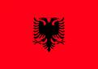 | Femije Shahini | 075 276 416 | ext.419 | femije.shahini@mfa.gov.mk
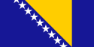 | Ivan Ivanovski | 071 232-815 | ext.158 / 154 | ivanovski.i@mfa.gov.mk
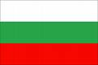 | Srgjan Hadji-Nikolov | 075 268 741 | ext.274 | srgjan.hadji-nikolov@mfa.gov.mk
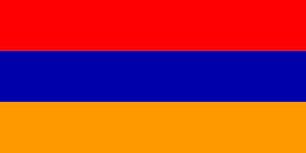  Republic of Armenia | Srgjan Hadji-Nikolov | 075 268 741 | ext.274 | srgjan.hadji-nikolov@mfa.gov.mk
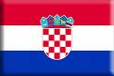 | Katerina Bojoska | 075 364 727 | ext.158 / 154 | katerina.bojoska@mfa.gov.mk
  OSCE | Katerina Bojoska | 075 364 727 | ext.158 / 154 | katerina.bojoska@mfa.gov.mk
 | Atina Nichoska | 075 446 608 | ext.258 | atina.nichoska@mfa.gov.mk
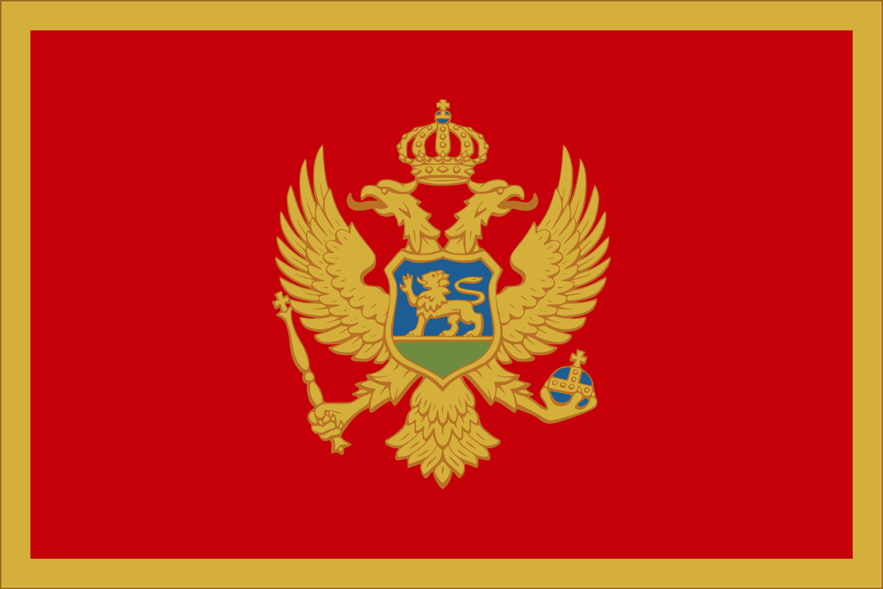 | Blerta Sali | 075 321 470 | ext.120 | blerta.sali@mfa.gov.mk
 | Ivica Jovanovski | 075 402 541 | ext.126 | ivica.jovanovski@mfa.gov.mk
 | Arta Bojku | 075 279 372 | ext.627 | arta.bojku@mfa.gov.mk
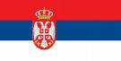 | Dragana Kemera | 076 445 149 | ext.111 / 106 | dragana.kemera@mfa.gov.mk
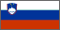 | Boris Mirchevski | 072 239 045 | ext.184 | boris.mircevski@mfa.gov.mk
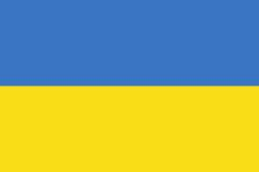  Ukraine | Boris Mirchevski | 072 239 045 | ext.184 | boris.mircevski@mfa.gov.mk
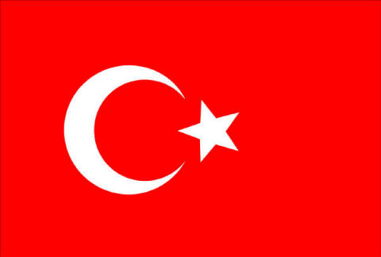 | Semra Ramadani | 075 358 397 | ext.158 / 154 | semra.ramadani@mfa.gov.mk
 | Sherif Aliu | 075/327094 | ext.111 | sherif.aliu@mfa.gov.mk
  Central European Initiative | Semra Ramadani | 075 358 397 | ext.158 / 154 | semra.ramadani@mfa.gov.mk
  United Nations | Dragan Zeroski | 075 446 609 | ext.212 | dragan.zeroski@mfa.gov.mk
  European Union  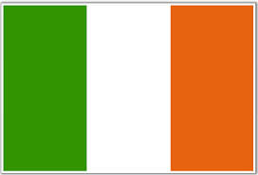  Irish Presidency | Dimitar Mitrevski | 075 230 872 | ext.209 | dimitar.mitrevski@mfa.gov.mk
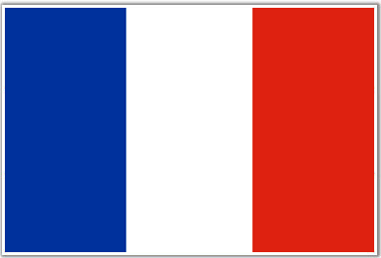  Republic of France | Afrim Jashari | 072 239 052 | ext. 111 | afrim.jashari@mfa.gov.mk
  Organisation internationale de la Francophonie | Afrim Jashari | 072 239 052 | ext. 111 | afrim.jashari@mfa.gov.mk
  Council of Europe | Nikola Koleski | 072 239 053 | ext. 839 | nikola.koleski@mfa.gov.mk
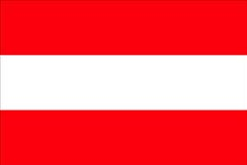  Republic of Austria | Abdilxhemil Saiti | 072239076 | ext. 163 | abdilxhemil.saiti@mfa.gov.mk
  UNESCO | Dana Nikolov | 075 237 176 | ext. 283 | dana.nikolov@mfa.gov.mk
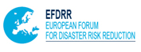  European Forum for Disaster Risk Reduction | Borjan Naumovski | 075 402 898 | ext. 680 | borjan.naumovski@mfa.gov.mk
  USA | Muarem Mexhiti | 075 268 734 | ext. 283 | muarem.mexhiti@mfa.gov.mk
  JICA | Suzana Tuneva | 072 239 075 | ext. 220 | suzana.tuneva@mfa.gov.mk
  Republic of Lithvania | Suzana Tuneva | 072 239 075 | ext. 220 | suzana.tuneva@mfa.gov.mk
  Intergovernmental Panel on Climate Change | Nenad Sundovski | 072 239 077 | ext. 115 | nenad.sundovski@mfa.gov.mk
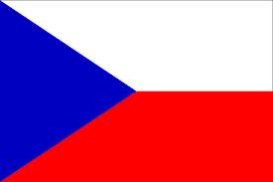  Czech Republic | Valentina Stojkoska |  | ext.172 | volonter.vez1@mfa.gov.mk

FORMAL MEETING
of the SEECP Ministers for Foreign Affairs
31 May 2013, Ohrid

Venue: Hotel Inex Gorica, Ohrid

Programme
Thursday, 30 May 2013

Arrival and Accommodation of the Delegations

20:00 Welcome Cocktail
Venue: Hotel Inex Gorica, Restaurant
Participants: All Members of Delegation

Friday, 31 May 2013

9:10 - 9:30 Registration of the participants

9:30 – 12:30 Plenary Session of the Meeting of the SEECP Ministers
for Foreign Affairs
Venue: Hotel Inex Gorica, Diamond Hall

Opening remarks by the Minister for Foreign Affairs of Republic
of Macedonia, H.E. Mr. Nikola Poposki
Statements of the Ministers for Foreign Affairs of the SEECP and
Special Guests (tour-de-table)

12:30 –12:40 Family Photo of the SEECP Ministers for Foreign Affairs and
Special Guests

Participants: Heads of Delegations and Special Guests
Venue: Hotel Inex Gorica

12:45 – 13:15 Press Conference of SEECP Troika
Venue: Hotel Inex Gorica, Diamond Hall

13:15-15:00 Lunch Hosted by the Minister for Foreign Affairs of Republic of
Macedonia, H.E. Mr. Nikola Poposki
Venue: Restaurant “Biljanini Izvori”
Participants: Heads of Delegations and Special Guests

13:15-15:00 Buffet Lunch for other Members of Delegation
Venue: Restaurant “Biljanini Izvori”

15:30 – 17:30 Sight-seeing of Ohrid and visit of cultural and historical
Monuments

17:30 – 18:30 Boat Tour

(Ministers who will attend the SEECP Summit will follow the programme for 1 June)

Agenda

Adoption of the Agenda

Introductory remarks by the Minister of Foreign Affairs of Republic of Macedonia, H. E. Mr. Nikola Poposki

Report of the Macedonian Chairmanship in Office of the SEECP on meetings and activities

Overview of the current situation and perspectives of the EU enlargement process of the Region (tour-de-table)

Approval of the Annual Report of the RCC Secretary General on regional cooperation in South East Europe 2012-2013
- Approval of the “RCC Strategy and Work Programme 2014-2016”
- Approval of the Chairmanship-in-Office of the SEECP for the term 2013-2014

Approval of the SEECP Ohrid Declaration and “Solidarity in Action” Joint Statement

Any other business

Meeting of the SEECP Political Directors
29 May 2013, Ohrid

Venue: Hotel Inex Gorica, Ohrid

Programme

Tuesday, 28 May 2013
Arrival and Accommodation of the Political Directors

Wednesday, 29 May 2013

9:40 – 10:00 Registration of the participants

10:00 – 11:30 Meeting of the SEECP Political Directors – 1st session
Venue: Hotel Inex Gorica, Golden Hall

11:30 – 11:45 Coffee break

11.45 – 13:00 Continuation of the Meeting

13:00 – 14:30 Official lunch hosted by SEECP Political Director
Venue: Hotel Inex Gorica

14:30 – 16:00 Meeting of the SEECP Political Directors – 2nd session

16:00 – 16:15 Coffee break

16:15 – 18:00 Meeting of the SEECP Political Directors – 3rd session

(Political Directors who are members of Delegation of Ministers of Foreign Affairs
or/and Heads of State/Government will follow the programme for 31 May and 1 June)

Agenda

Adoption of the Agenda

Report of the Macedonian Chairmanship in Office of the SEECP on meetings and activities

Debate on the draft text of the SEECP Ohrid Declaration and “Solidarity in Action” Joint Statement

Any other business

General Information

1.1. Venue

The Meeting of the SEECP Ministers for Foreign Affairs and the Meeting of SEECP Political Directors will be held in Hotel Inex Gorica***** in Ohrid. For more information visit hotel web site: http://www.inexgorica.com.mk/

1.2. Application

Delegations are kindly requested to fill in the enclosed application forms and return them by May 15, 2013 at the latest, to the following e-mail address secretariat.seecp@mfa.gov.mk.

1.3. Delegations

The organizers kindly request that during the time of the Plenary Session and meetings:

Heads of Delegations shall be accompanied by maximum of five (5) members of delegation (and additional security officer if needed) – format of the official delegations is 1+5, including the representatives of diplomatic missions accredited to Republic of Macedonia and Political Director.

Special Guests shall be accompanied by maximum of one (1) member of delegation – format of the Special Guest is 1+1.

Delegations are kindly requested to complete the enclosed registration forms for the Head of Delegation and all members of the delegation and submit it no later than 15th May 2013 to the following e-mail address: secretariat.seecp@mfa.gov.mk

1.4. Visa Requirements

Members of delegations requiring entry visas for Republic of Macedonia are requested to acquire the visas prior to entry at the diplomatic representations of Republic of Macedonia in their countries. Further information regarding the visa regime can be found on http://www.mfa.gov.mk/?q=node/270

1.5. Arrival

Arrival is expected at the Alexander the Great Airport in Skopje and St. Paul the Apostle Airport in Ohrid.

The Diplomatic Protocol arranges technical welcome at the airport upon arrival of each delegation. VIP lounge will be arranged for Heads of delegations. Other delegation members may also use the VIP lounge on their own costs.

For arrivals of special planes, respective Embassies are asked to submit over flight requests to the Macedonian authorities, including arrival and departure times, aircraft type, as well as the information whether the plane will be parked at the Alexandеr the Great Airport in Skopje or St. Paul the Apostle Airport in Ohrid for the duration of the stay of the delegation.

Delegations arriving by car will be welcomed and accompanied by the responsible liaison officers from the appropriate border crossing to Ohrid.

1.6. Transportation

For Heads of Delegation/Special Guests one VIP vehicle will be provided, as well as one vehicle for the accompanying members of the delegations. Police escort will be provided only for Ministers for foreign affairs. The vehicle of the Embassy of each SEECP member state accredited to Republic of Macedonia may be included in the motorcade.

Organized transport will not be provided for delegates attending the Meeting of the SEECP Political Directors.

Delegations are kindly asked to state their transportation details in the registration forms to be send no later that 15th May 2013 to the e-mail address of the SEECP Secretariat: secretariat.seecp@mfa.gov.mk

1.7. Accommodation

The host country will bear one night accommodation expenses for the Heads of Delegations of SEECP Participating States, as well as another member of the delegation, excluding extra costs. The host country will also bear one night accommodation expenses for the Special Guests, excluding extra costs.

The Host country has reserved accommodation in Hotel Inex Gorica ***** in Ohrid, Hotel Granit ****in Ohrid, as well as in Hotel Sileks****in Ohrid, and is bearing the cost of the invitees’ accommodation and stay in Ohrid according to the following format:

 | SEECP  Participating  States | Special Invitees | No. of nights | Dates
Meeting of the SEECP Ministers of Foreign Affairs | Head of delegation  +1 | Head of delegation | 1 | 30 May

Other members of delegations including Political Directors will be responsible for their own accommodation expenses.

The host country shall facilitate booking arrangements with special rates for delegations and will accommodate them in the following hotels:

Hotel Inex Gorica ***** Ohrid
Hotel Granit ****Ohrid
Hotel Sileks**** Ohrid

The room rates in Hotel Gorica ***** are: single room 57 EUR, apartment 177 EUR.

The room rates in Hotel Granit**** are: single room 49 EUR per person, breakfast, tax fee and VAT included in the price; apartment 59 EUR, breakfast, tax fee and VAT included in the price.
The room rates in Hotel Sileks **** are: single room 40 EUR per person, breakfast included in the price; double room 26 EUR per person, breakfast included in the price.

Delegations are kindly requested to complete the enclosed Accommodation Forms for the Head of Delegation and all members of the delegation and submit it no later than 15th May 2013 to the following e-mail address: secretariat.seecp@mfa.gov.mk

1.8. Meeting Rooms

The Plenary Session of the SEECP Ministers of Foreign Affairs will be held in the Diamond Hall. The Meeting of the Political Directors will be held in the Golden Hall.

The seating arrangement of the Plenary Session will have the following format:
Heads of Delegation of the SEECP Participating States + 5 side chairs for other members of delegation
Special Guests + 1 side chair

Delegations are kindly asked to indicate their interest in bilateral meetings in the enclosed accreditation forms.

1.9. Interpretation

The working language of the Meeting of the SEECP Ministers of Foreign Affairs is English. Heads of Delegations of SEECP Participating States/Special Guests requiring interpretation are requested to bring their own interpreters and cover the relevant costs. Interpretation booths will be provided for the meetings upon a request of delegations in the Accreditation Form.

The languages of the Press Conference of the Meeting of SEECP Ministers of Foreign Affairs will be English and Macedonian for which the host country will provide interpretation.

1.10. Interventions

Delegations wishing their interventions/statements to be printed and circulated can E-mail them to secretariat.seecp@mfa.gov.mk or submit them through their respective Liaison officers to the Secretariat of the Conference before the beginning of the Ministerial Meeting.

1.11. Offices

Office will be provided in Hotel Inex Gorica for the SEECP Secretariat and Press.

The Office will be equipped with telephone line, internet access, computers, printer, fax machine and photocopier.

1.11. Information and Accreditation Desk

Information and Accreditation Desk for the MFA/PD Meeting will be located at the Hotel Inex Gorica and will be open during the meetings.

1.12. Badges

All delegates and other participants attending the SEECP Ministerial meeting must be accredited in advance through the SEECP Secretariat. The host will provide badges for heads of delegations, special guests, members of delegations, as well as for media representatives.

1.13. Liaison Officers
A Liaison Officer will be attached to each delegation; responsible for liaising with the organizers from the host country (List of Liaison Officers is enclosed).

1.14. Security

Adequate security measures will be taken for all delegations by the competent authorities of Republic of Macedonia.

Delegations accompanied by security officers are requested to enclose information regarding arms and ammunition in the Accreditation Form to be sent no later that 15th May 2013 to the e-mail address of the SEECP Secretariat:
secretariat.seecp@mfa.gov.mk

- Contacts

2.1. Organization Team

The Secretariat of the Macedonian SEECP Chairmanship in office

Ministry of Foreign Affairs of Republic of Macedonia
Secretariat of the Macedonian SEECP Chairmanship-in-Office

E-mail: secretariat.seecp@mfa.gov.mk
Tel: +389 2 3110 333 ext.183
Fax: +389 2 3233 958

2.2. Contact persons

- Ms. Aleksandra STOJKOVA
- Ms. Ana DEREBAN BLAZHESKA
- Mr. Aleksandar TRAJKOSKI

Any additional information about organizational issues (Registration and other Meeting information) can be obtained from the Secretariat.

2.3 Protocol – protocol@mfa.gov.mk ; Phone: +389 2 3110333 ext. 397, 636 and 637

Any additional information about protocol issues (Accommodation, Transport, Security and other logistical support) can be obtained from the Protocol.

2.4. Press office – pr.office@mfa.gov.mk ;

Any additional information about media issues can be obtained from the PR Office. Contact person for media issues is Ms. Adelina Marku (adelina.marku@mfa.gov.mk).

3. Accreditation Forms
Accreditation Form
Deadline for sending this form is 15 May 2013
For the Formal Meeting of the SEECP Ministers for Foreign Affairs:

Head of Delegation
Passport number

Blood Type
Possible Medical Problems of Head of Delegation
Food Limitations
Members of Delegations  (name, function, passport number) | 1
Members of Delegations  (name, function, passport number) | 2.
Members of Delegations  (name, function, passport number) | 3.
Members of Delegations  (name, function, passport number) | 4.
Members of Delegations  (name, function, passport number) | 5.
Security Officers  If more than two, please attach additional list. The licence for carrying weapons may be obtained for one security officer, accompanying the Minister of Foreign Affairs | Name: | Date and Place of birth | Passport (Type and No)
 | 1.
 | Type of weapon, reg. No., No of ammo & caliber:
 | 2.
Request for Radio -Connection Frequency
Arrival | Date:
Arrival | Time:
Arrival | (Border crossing – if arriving by car):
Departure | Date:
Departure | Time:
Departure | (Border crossing – if arriving by car):
Means of Transportation To and From Republic of Macedonia | Type and registration no. of aircraft:
Means of Transportation To and From Republic of Macedonia | Does the aircraft remain at the airport until departure of the delegation? : YES NO  If NO – Time of Departure: Time of return:
Means of Transportation To and From Republic of Macedonia | Time and registration plates of vehicles (if arriving by car):
Contact Person at the Embassy | Name:
Contact Person at the Embassy | Function:
Contact Person at the Embassy | Phone:
Contact Person at the Embassy | Fax:
Contact Person at the Embassy | E-mail:
Request for Bilateral Meetings
Request for Interpretation
Lunch on 31 MAY 2013 Organized by the Minister of Foreign Affairs of Republic of Macedonia (Only for Heads of Delegation/Special Guests)
Buffet Lunch on 31 MAY 2013 (For other members of delegation)
Welcome Cocktail on 30 MAY 2013

For the Meeting of the SEECP Political Directors:
Personal Data:
Country/Organization
Name and Surname
Position:
Phone: |  | Fax: |  | E-mail:
Accompanying person (s): |  | Name: |  | Surname:

I will Participate in:
Formal Meeting of SEECP Ministers for Foreign Affairs (31 MAY 2013)
Meeting of the SEECP Political Directors (29 MAY 2013)

Travel /Arrival:
Special flight Alexander the Great Airport in Skopje St. Paul the Apostle Airport in Ohrid
Date: |  | Time: |  | Registration No.:

Regular flight Alexander the Great Airport in Skopje St. Paul the Apostle Airport in Ohrid
Date: |  | Time: |  | Flight Number/Company:

Other Means of Transport
By: |  | From: |  | To:
Name of Border Crossing/Expected Time of Border Crossing (if travelling by car):

Remarks:

Travel /Departure:
Special flight Alexander the Great Airport in Skopje St. Paul the Apostle Airport in Ohrid
Date: |  | Time: |  | Registration No.:

Regular flight Alexander the Great Airport in Skopje St. Paul the Apostle Airport in Ohrid
Date: |  | Time: |  | Flight Number/Company:

Other Means of Transport
By: |  | To: |  | From
Name of Border Crossing/Expected Time of Border Crossing (if travelling by car):

Remarks:

Transportation:
Transportation arranged by the presidency: Yes No
Airport – Hotel
Hotel – Airport

Other Information:
Official Lunch on 29 MAY 2013 hosted by SEECP Political Director
Welcome Cocktail on 30 MAY 2013
Buffet Lunch on 31 MAY 2013
Accommodation Form
Deadline for sending this form is 15 MAY 2013

Personal Data:
Country/Organization
Name and Surname
Position:
Phone: |  | Fax: |  | E-mail:
Accompanying person (s): |  | Name: |  | Surname:

Hotel Inex Gorica*****:
St. Kliment of Ohrid, 6000 Ohrid, Republic of Macedonia
Phone: +389 46 277 520; Fax:;
http://www.inexgorica.com.mk ;
Single Room 57 EUR
Apartment 177 EUR

Hotel Granit****:
Sv. Stefan, 6000 Ohrid, Republic of Macedonia
Phone: +389 46 207 100; Fax: +389 46 207 141;
http://www.hotelgranit.com.mk
Single Room 49 EUR
Apartment 59 EUR

Hotel Sileks****:
Tourist Complex Sv. Stefan, 6000 Ohrid, Republic of Macedonia
Phone: +389 46 277 300 ; Fax: +389 46 277 304;
www.hotelsileks.mk
Single Room 40 EUR
Double Room 26 EUR (per person)

Arrival:
Date of arrival: |  | Time:

Remarks:

Departure:
Date of Departure: |  | Time:

Remarks:

Method Of Payment:
Cash

Credit Card
Amex Diners Master Visa

Other
Remarks:

Media Accreditation Form
Deadline for sending this form is 15 MAY2013

Participant’s name and surname:
(please print in capital letters)

Country:

Press House - Company:

Phone : | Fax: | E-mail:

LIST OF LIAISON OFFICERS FOR MINISTERIAL MEETING
COUNTRY | NAME | CELL PHONE | PHONE  +389 2 3110 333 | E-MAIL ADDRESS
 | Reshat Berisha | 072/238965 | ext.695 | resat.berisa@mfa.gov.mk
 | Zlatan Begovikj | 072/238902 | ext.252 | zlatan.begovic@mfa.gov.mk
 | Dejan Bozinov | 072/238981 | ext.220 / 131 | dejan.bozinov@mfa.gov.mk
 | Radmila Stojmirovska | 075/237183 | ext.156 | radmila.stojmirovska@mfa.gov.mk
 | Slavica Alistratoska | 072/242782 | ext.270 | slavica.alistratoska@mfa.gov.mk
 | Elionora Todorovska | 072/242783 | ext.108 | elionora.todorovska@mfa.gov.mk
 | Shpend Sadiki | 072/239043 | ext.172 | shpend.sadiki@mfa.gov.mk
 | Nikola Gjorchev | 075/328116 | ext.212 | nikola.gjorchev@mfa.gov.mk
 | Marija Trajkovska | 072/238948 | ext. 850 | marija.trajkovska@mfa.gov.mk
 | Stojanche Kitanoski | 072/239030 | ext.839 | stojance.kitanoski@mfa.gov.mk
 | Ivana Ilikj | 076/484468 | ext.636 | ivana.ilic@mfa.gov.mk
 | Sherif Aliu | 075/327094 | ext.111 | sherif.aliu@mfa.gov.mk
 | Jasmina Risteska | 075/268733 | ext.627 | jasmina.risteska@mfa.gov.mk
Republic of Armenia | Srgjan Hadji-Nikolov | 075 268 741 | ext.274 | srgjan.hadji-nikolov@mfa.gov.mk
 | Katerina Bojoska | 075 364 727 | ext.158 / 154 | katerina.bojoska@mfa.gov.mk
Republic of Lithvania | Suzana Tuneva | 072 239 075 | ext. 220 | suzana.tuneva@mfa.gov.mk
Central European Initiative | Semra Ramadani | 075 358 397 | ext.158 / 154 | semra.ramadani@mfa.gov.mk
Council of Europe | Nikola Koleski | 072 239 053 | ext. 839 | nikola.koleski@mfa.gov.mk
Ukraine | Boris Mirchevski | 072 239 045 | ext.184 | boris.mircevski@mfa.gov.mk
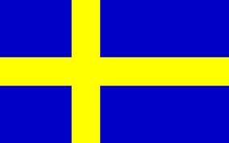  Sweden | Metodija Beshirovski |  | ext.108 | Metodija.beshirovski@mfa.gov.mk
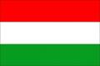 | Anastasija Spasevska |  | ext.221 | volonter.ded@mfa.gov.mk

VI ANNUAL MEETING OF THE REGIONAL COOPERATION COUNCIL

Ohrid, 30 May 2013

Programme

10:00 – 11:30 Regional Cooperation Council (RCC) Annual Meeting
Venue: Hotel Inex Gorica
Conference room Diamond Hall

11:30 – 12:00 Coffee break/ Family photo
Venue: Hotel Inex Gorica

12:00 – 13:30 Continuation of the Meeting

13:30 – 15:00 Buffet lunch for the participants of the RCC Annual Meeting hosted by the RCC Secretary General, Mr. Goran Svilanović
Venue: Hotel Inex Gorica

Draft Agenda

- Adoption of the Agenda

- Introductory remarks by the Minister of Foreign Affairs of the Chairmanship-in-Office of the South East Europe Cooperation Process 2012 - 2013 and by the Secretary General of the RCC

- Exchange of views on the developments in regional cooperation in South East Europe

- RCC Strategy and Work Programme 2014-2016 – presentation and endorsement

- Annual Report of the Secretary General of the RCC on regional cooperation in South East Europe for the period 15 May 2012 – 25 April 2013 – presentation and endorsement

- Any other business

Useful Information

Application/ Registration
The RCC Participants are kindly requested to fill in the enclosed registration forms and return them to the Regional Cooperation Council Secretariat (contact bellow) at the latest by 10 May 2013.
Contact

Ms. Ana DEREBAN BLAZHESKA  SEECP Chairmanship-in-Office  Tel: +389 2 3110 333 ext. 183  Fax. + 389 2 3233 958  e-mail: ana.dereban@mfa.gov.mk | Ms. Nataša MITROVIĆ  Regional Cooperation Council Secretariat  Tel: +387 33 561 708  Fax: +387 33 561 725  e-mail: front.office@rcc.int

Accommodation
The SEECP Chairmanship-in-Office recommends hotel Drim in Struga (transportation from the hotel to the venue of the RCC Annual meeting and back will be provided by the hotel). Special rate has been agreed for the participants of the RCC Annual meeting. The accommodation arrangements shall be made directly with the hotel. Accomodation costs should be covered by the participants of the RCC Annual meeting. Please find bellow contact details of the hotel including facilities and price:

Hotel Drim ****
Location: Kej Boris Kidric 51, 6330 Struga
Capacity: minimum 70 rooms
Price: 55EUR; Single superior room; BB
The price includes: breakfast, parking slot, WiFi, VAT (5% on hotel services), tax fee, and transportation from Hotel Drim to Hotel Inex Gorica and back.
Web page: www.drim.com.mk

Arrival/ Transportation

Arrivals can be made at the Airport Alexander the Great in Skopje (http://www.airports.com.mk/)
Group transfers from the airport in Skopje to hotel Drim in Struga and back for the participants of the RCC Annual Meeting will be provided for all delegations arriving to Skopje on 29 May2013 to the airport in Skopje (departure by bus scheduled for 16:00 hours) and departing on 31 May 2013 from hotel Drim in Struga (departure by bus scheduled for 8:00 hours)
Each delegation are requested to indicate their travel details in the RCC Annual Meeting Registration form and send it back to the RCC and the SEECP CiO Secretariat by the deadline written on the registration form in order to be able to arrange airport pick up.
For arrivals of special planes, respective Embassies are kindly asked to submit over flight requests to the relevant authorities of the host country. The crew members are kindly requested to organize their own lodging and visas if necessary.

Conference Center
The RCC Annual Meeting will be held at Hotel Inex Gorica in Ohrid (http://www.inexgorica.com.mk/) in the conference room Diamond Hall.

Conference passes (accreditation)
The RCC will provide conference passes (badges) for the participants. Each participant of the Meeting will be issued a badge granting access to the Meeting Hall. Registration desk will be opened at the enterence of the meeting room on 30 May 2013 at 9:00 hours.
Language and Interpretation

The working language of the RCC Annual Meeting is English.
Interventions of the Participants

Participants are invited to submit their requests to address the Annual Meeting by 24 May 2013 noon at front.office@rcc.int. Due to the number of participants, interventions should not exceed four minutes. All Participants are welcomed to submit their interventions in written form at front.office@rcc.int. The requests for interventions could also be addressed to the representatives of the RCC Secretariat directly at the Meeting.

Press Centre
For information related to the RCC Annual Meeting please contact Dinka Zivalj, Spokesperson, Regional Cooperation Council, tel: +387 33 561 700, fax: +387 33 561 725, mob: +387 62 341 881, e-mail: dinka.zivalj@rcc.int, press@rcc.int.

Visa requirements
Members of the delegations, accompanying personnel and journalists coming from countries requiring entry visas should contact relevant diplomatic representations in their countries.

Security

The Security measures will be taken by the competent authorities of the host country.

REGISTRATION FORM | Deadline:  10 May 2013

- Country *
- Organisation
Name
Position/Function
Head of Delegation
Address:
Phone:
e-mail:
* Be reminded to Please check for Visa Requirements!

1+2
ATTENTION: delegation format: (t (to be coordinated with your respective National Coordinator)

Arrival and departure arrangements:
Date of arrival: |  | Flight Number: |  | Time:
Date of departure: |  | Flight Number: |  | Time:
Remarks:

PLEASE RETURN THIS FORM BY FAX OR E-MAIL UNTIL 10 May 2013 TO BOTH:
Regional Cooperation Council Secretariat  Sarajevo, Bosnia and Herzegovina | Fax:  e-mail: | +387 33 561 725  front.office@rcc.int
Secretariat of the SEECP CiO  2012-2013 | Fax :  e-mail: | +389 2 3233 958  ana.dereban@mfa.gov.mk

