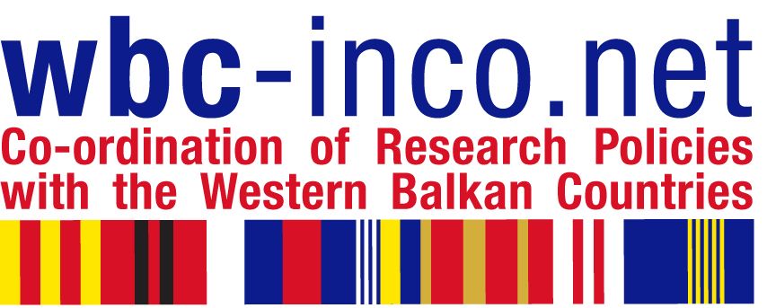
Financial Workshop “Surviving the EC Audit” – Pitfalls and Problems, Survival and Success Stories

Workpackage 4, Task 4.2

Time and Location:

Date: 10 September 2013
Time: 09:00 – 17:30
Location: Institute of Chemistry, Technology and Metallurgy
Njegoseva 12, 2nd floor
Belgrade, Serbia

Participants: Project Managers and Financial Project Managers with at least one FP7 project experience People

Trainers:

Bedanna Bapuly, Austrian Academy of Science
Vladimir Crnojevic, University of Novi Sad, DEET – FTN, Serbia
Claudia Kögler, KPMG Austria
Nevena Sicevic, KPMG Serbia
Katarina Rohsmann, FFG Austrian Research Promotion Agency

Agenda:

9.00-9.15 | Registration
9.15-9.30 | Opening session  Introduction and Welcome by MSTD and FFG
9.30-13.00 | Morning session  09:30 - 10.15  Katarina Rohsmann  Introduction on audits (types, regulations), Funding Regimes, Funding Rates, Activities  10:15- 11.00  Nevena Sicevic  “Practical issues and challenges relating to cost claims – Experience from other FP7 audits in Serbia“-Challenges related to Lump Sum, Flat Rates, Personnel Costs, Average Personnel costs (Employment issues, Students), Receipts, related to Eligible & Ineligible costs  11:00 - 11:30  Coffee Break  11:30 - 12:15  Claudia Kögler  Overheads, Methods (Direct/Indirect Costs), Bookkeeping, Accounting Records, Time sheets, Cost Recording, Financial Reporting, Certificate on Financial Statement  12:15 - 13:00  Dicussion
13.00-14.00 | Lunch break
14.00-16.30 | Afternoon session  14:00 - 15:00  Bedanna Bapuly, Vladimir Crnojevic - Survivor Experiences  15:00 - 15:15  Break (participants who don't need any consultation may leave the workshop)  15:15 - 16.30  Consultations  “Tables of Interest” where main lecturers sit together with trainees and talk on good and bad practices; on real examples and even talk with them about their projects

PRACTICAL INFORMATION

Location of the Institute of Chemistry, Technology and Metallurgy (IHTM), Njegoseva 12, Belgrade

http://www.ihtm.bg.ac.rs/ENG/index2_e.htm

Travel arrangements:

Travel budget (400 euro) per participant is allocated to local organizer Ministry of Education, Science and Tech. Development-MSTD, Serbia. All nominated participants are kindly requested to sent desirably flight details to travel agency Miross, which is hired by MSTD for travel arrangements. Contact person in Miross agency is Ms Silva Cvetković silva@miross.rs (Tel/fax: +381 11 3033225, 3033226), and c.c. zeljka.dukic@mpn.gov.rs If you would like to use any other mean of traveling you can arange it also with Miross agency. Once when you arrange travel to Belgrade with Miross agency, they will send invoices to MSTD which will pay all of it.

Suggested hotels:

Rooms for nominated participants are pre-booked at Hotel Park, Njegoseva 2, Belgrade. Rooms are pre-booked for the two nights 9-11.9.2013. and will be paid by the local organizer Ministry of Education, Science and Tech. Development, Serbia.

http://www.hotelparkbeograd.rs/en

Transport from Belgrade airport ‘’Nikola Tesla’’ to hotel Park:

We recommend to take bus (Line A1) from the airport to hotel. Bus goes to Slavia square which is only 5 minutes walk from hotel Park.
http://www.beg.aero/passengers/to_and_from_the_airport/bus_transport.326.html

Should you have any questions please contact person in charge for organizing this workshop Ms Zeljka Dukic (zeljka.dukic@mpn.gov.rs ), phone: +381 3616 529, mob: +381 64 8166 005.

