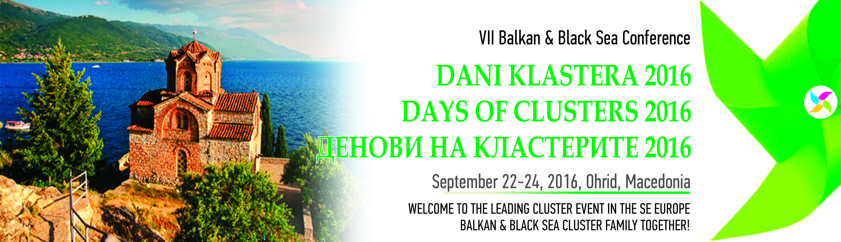

Conference Topic

Creating Cluster-Based Economic Development for a Sustainable Region

Welcome cocktail | Wednesday 21st September 2016
Venue: Hotel Inex Gorica | Ohrid | Macedonia

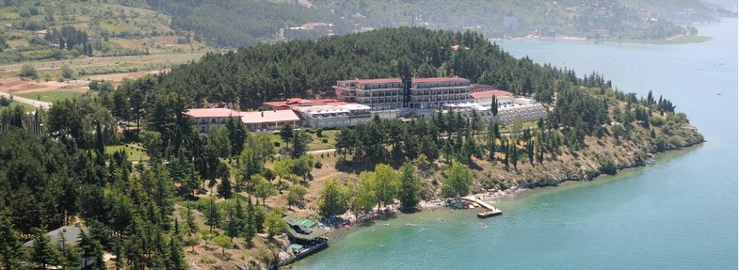
http://www.hotelinexgorica.com.mk/

Registration of participants 15:00 – 20:00

Organizational meeting 18:00 – 19:30
Organizing and scientific conference committees meetings (closed session)

Welcome cocktail with traditional live folk music 20:00 – 21:30

CONFERENCE DAY 1 | Thursday, 22nd September 2016
Venue: Hotel Inex Gorica | Ohrid | Macedonia

Registration 08:00 – 09:00
Registration of participants
OPENING CEREMONY 09:00 – 10:00
- Mr. Gjorge Ivanov, President of the Republic of Macedonia (TBC)
- Academician Taki Fiti, President, Macedonian Academy of Science and Arts, Skopje, Macedonia
- Minister of the Ministry of economy of the Republic of Macedonia, Skopje Macedonia (TBC)
- Rector of the Ss. Cyril and Methodius University, Skopje, Macedonia (TBC)
Co-chairmen of the conference:
- Prof. Dr. Radmil Polenakovik, President, National Centre for Development of Innovation and Entrepreneurial Learning, Skopje, Macedonia
- Dr. Danka Milojkovic, Director, Cluster House, Nis, Serbia & Director, Global TCI BoD, Barcelona, Spain

First Conference Session 10:00 – 11:30
Theme:
CLUSTER-BASED ECONOMIC DEVELOPMENT POLICES FOR IMPROVING
PRODUCTIVITY AND ATTRACTING INVESTITORS IN THE REGION
- Mr. Lars Albæk, Head of Department, Væksthus Hovedstadsregionen, Rønne, Denmark
- Dr. Nikolina Trajanovska, Head of Unit for Industrial policy, Ministry of economy of the Republic of Macedonia, Skopje Macedonia
- Mr. Geunwoo Ryu, Professor of e-Trade and Finance, Dean of Social Science, Keimyung University, Daegu, South Korea
- Mr. Jagat Shah, Representative of Government of Manitoba, Canada in India, Founder & Chief Mentor: www.globalnetworkindia.com , www.clusterpulse.org ,www.mentoronroad.com (TBC)
- Mrs. Gabriela Parvu, High Counsellor, MECT – DPIM, Bucharest, Romania
- Dr. Gerd Meier zu Köcker , Head of European Cluster Observatory, Berlin, Germany, topic: CLUSTER BASED ECONOMIC DEVELOPMENT POLICES FOR IMPROVING - PRODUCTIVITY AND ATTRACTING INVESTITORS IN THE REGION
- Prof. Dr. Radovan Pejanovic and Doc. Dr. Mirjana Kranjac, University of Novi Sad, Serbia, topic: Development of clusters in the region of Vojvodina
Discussion
Moderator: Mr. Carsten Lund, President, LEDIB Cluster House Union Assembly, Copenhagen, Denmark

Coffee break 11:30 – 12:00
Second Conference Session 12:00 –13:30
Theme:
CLUSTER MANAGEMENT SKILL UPGRADING PROGRAMMES TO SUPPLEMENT
THE CURRENT POLICES FOR INCREASING JOB OPORTUNITIES
- Mr. Ifor Ffowcs-Williams, CEO, Cluster Navigators, New Zealand
- Representative of the TRAKYAKA, Tekirdag, Turkey, topic: Dairy, Wine and Agriculture Clusters in Trakya Region
- Mr. Tue David Bak, Director at Region Sjælland and Founder at Lamont Street Advisors, Copenhagen, Denmark
- Mr. Daniel Cosnita, President, ClusteRO, Bucharest, Romania
- Dr. Pavla Bruskova, President, National Cluster Association, Ostrava, Czech Republic
- Mr. Gal Kormendy, President, Hungarian National Alliance for Innovative Clusters, Budapest, Hungary
Discussion:
Moderator: Mr. Bojan Jovanovski, Co-founder of NCDIEL & Teaching Assistant at the Faculty of Mechanical Engineering, Ss. Cyril and Methodius University, Skopje, Macedonia
cluster family photo session 13:30 – 13:45
Cluster BROKERAGE EVENT & Lunch 13:45 – 14:30
Third Conference Session 14:30 – 16:00
Theme:
KEY PILLARS OF A CLUSTER-BASED ECONOMIC POLICY APPROACH
- Mr. Pierluigi Ghione, Plant Manager Site Serbia, PMS Seat covers, GRAMMER SYSTEM Ltd. Aleksinac, SERBIA (TBC)
- Ms. Lucia Seel, European Cluster Collaboration Platform
- Mr. Vedat Kunt, VEGO Consulting and UNIDO Cluster Expert, Izmir, Turkey
- Ms. Joanna Podgorska, Deputy director, Enterprise and Innovation Department, Polish Agency for Enterprise Development, Warsaw, Poland, topic: Cluster policy and cluster development – Polish experiences
- Mr. Enric Pedrós, Cluster Manager at FEMAC, The Catalan Cluster of Agricultural Machinery in Lleida, Catalonia, Spain (TBC)
- Mr. Michael Guth, Consultant, Inno Consult, Germany

Discussion
Moderator: Mr. Paul Ravn Jepsen, international business development expert, CPH, Denmark or Mr. Julien Schmitt, Strategy and Development Consultant, Eticus Consulting, Spain

CLUSTER DEVELOPMENT WORKSHOPS (parallel, up to 20 participants) 16:30 – 18:30
Workshop on ….  VEGO Consulting, Expert, Izmir, Turkey  Mr. Vedat Kunt, Mr. Gökçe Yalçın | Workshop on ….  Cluster Navigators, New Zeland  Mr. Ifor Ffowcs-Williams
Official dinner on the boat and Lake Ohrid Sightseeing Boat 20:00 – 23:30
Transfer to the port and boat. Cockatiel dinner and Lake Ohrid Sightseeing. Party on the boat.

CONFERENCE DAY 2 | Friday, 23rd September 2016
Venue: Hotel Inex Gorica | Ohrid | Macedonia
Registration of participants 08:30 – 09:00
Parallel conference sessions
Practitioners track | Academic track
4.P. SESSION…………………….…………09:00 – 10:30  CLUSTER DEVELOPMENT BEST PRACTICE – CROSS SECTORS NETWORKING – AGRO+TOURISM  - Mr. Ilija Mugosa, Fresh water fish cluster, olive oil cluster and wine cluster, Podgorica, Montenegro  - Mr. Szymon Lach, Business Development, Global Entrepreneurship Week Foundation, Poland, topic: Deriving benefits from cooperation, knowledge and human capital exchange between hotels  - Ms. Tamara Hoegler, Head of Innovations & International Affairs, CyberForum e.V., Karlsruhe Germany  - Cluster Development from Turkey (TBC)  - Mr. Ivica Velkovski, Macedonıa Wine Cluster, Skopje Macedonia (TBC)  - Mr. Tomi Pikuli, AGRINET, Korçë ALBANIA  Moderator: Dr. Nikolina Trajanovska, Head of Unit for Industrial policy, MofE Skopje Macedonia | 4.A. SESSION……………………………………09:00 – 10:30  Experiences with Triple Helix Partnerships in South East Europe 5-7 speakers  - Alan Paic, OECD – Intro speech and moderator A - Session

Coffee break 10:30 – 11:00

Practitioners track | Academic track
5.P. SESSION…………………….………….11:00 – 12:30  CLUSTER DEVELOPMENT BEST PRACTICE - CROSS SECTORS NETWORKING – TEXTILE+CREATIVE INDUSTRIES  - Mrs. Sara Wechsler, president, Romanian Textile Concept  - Ms. Slađana Milojevic, cluster manager, Fashion apparel Cluster FACTS Belgrade, Serbia  - Mrs. Natasa Sivevska, executive director, Textile Trade Association of Macedonia  - Mr. Nermin Balija, cluster manager, Asstex Textile Cluster Novi Pazar Serbia  - Mrs. Mirela Bogyo, Transylvania Textile & Fashion cluster, Romania  - Mr. Yordan Belovodski, cluster manager, Textile and Clothes Branch Organization, Kyustendil, Bulgaria  Moderator: Mr. Gökçe Yalçın, VEGO Consulting, Izmir, Turkey | 5.A. SESSION………………………………….11:00 – 12:30  How can clusters contribute for economic policy?  - 5-7 speakers  - Moderator

Cluster BROKERAGE EVENT & Lunch 12:30 – 13:30

Practitioners track | Academic track
6.P. SESSION…………………….………..13:30 – 16:00  CLUSTER DEVELOPMENT BEST PRACTICE SME DEVELOPMENT TOOLS – INCUBATORS, INDUSTRIAL PARKS…  - Mrs. Tatjana Kalezic, Founder Institute / Creative Industries Cluster of Vojvodina – Novi Sad, Serbia  - Mr. Roland BOGYÓ, Management consultant, BUSINESS INCUBATOR of SFÎNTU GHEORGHE, Romania  - Prof. Dr. Bülent Eker, Namık Kemal University, General Manager of Techno Park, Tekirdag, Turkey (TBC)  - Mr. Franci Bratkovič, Development Center Novo Mesto, Slovenia  - Dr. Svetoslav Novkov, Director, Strategic Planning at JAR Cluster and Mr. Dimitar Dimitrov, director, Foundation “Don’t stop” - Bulgaria, Sofia, Bulgaria  - Mr. János Keresnyei, President, Cultural Innovation Competence Centre Association, Pecs Hungary  - Mr. Ionut Tata, Alt Brasov Clusterr for Innovation and Technology, Brasov, Romania  Moderator: Dr. Milan Vemic, Chairman, Council of HEI “Dositej”, Belgrade, Serbia | 6.A. SESSION………………………….………..13:30 – 16:00  What is the role of different stakeholders in the cluster-based economic development?  - Prof. dr Marko Koscak, Faculty of Tourism University of Maribor – Slovenia, topic: TOURISM ENTREPRENEURSHIP IN ACTION AND STAKEHOLDER’S RELATIONSHIP  ….  ….  Moderator

Closing Remarks – co-chairmen of the conference 16:00 – 16:30
- Dr. Nikolina Trajanovska, Head of Unit for Industrial policy, Ministry of economy of the Republic of Macedonia, Skopje Macedonia;
- Prof. Dr. Radmil Polenakovik, President, National Centre for Development of Innovation and Entrepreneurial Learning, Skopje, Macedonia
- Dr. Danka Milojkovic, Director of the Cluster House, Nis, Serbia & Director of the Global TCI BoD, Barcelona, Spain

Social Programme – City of Ohrid Sightseeing 17:30 – 19:30
Transfer to Ohrid downtown. Ohrid guided tour by professionally qualified guides. Free time or joint dinner in national restaurant.

CONFERENCE DAY 3 | Saturday, 24th September 2016
Check-out and departure from Ohrid.
Wine Cluster Learning Trip | Tikves Region | Tikves – Stobi – Popova Kula 10:00 – 15:00
Transfer to Airport Skopje
NOTES:
- Transfers from Skopje Airport „Alexander the Great" - Ohrid - Skopje Airport „Alexander the Great" will be organized according to the flight scheduler of the conference participants 21st -22nd of September and 24th -25th of September.
- The DAYS OF CLUSTERS 2016 Agenda is a subject to change till the beginning of the Conference.

Co-organizers:
- AGROHELIKS - Veles
- Association EDEN - Tourism Cluster of South West Macedonia – Ohrid
- Fashion Cluster - Association of fashion – Skopje
- Textile Trade Association - Textile cluster – Macedonia
- CENET – Center for Education and NEtworking in Tourism – Demir Kapija
- Kreativa - Creative Industry Cluster – Stip
- MAMEI – Macedonian association of metal and electrical industry – Skopje
- MASIT – Macedonian Chamber of Information and Communication Technologies – Skopje
- SHARRI – Tourism Cluster in Polog – Tetovo

Official Conference tour operator:

 | DMC " VIS POJ "  Makedonski Prosvetiteli 1  6000 Ohrid, R.Macedonia  tel./fax: +389(0)46 255 600  office@vispoj.com.mk  www.vispoj.com.mk

Conference hotels:
1. Hotel Inex Gorica 5* (http://www.hotelinexgorica.com.mk/)
2. Hotel Belvedere 4* (http://hotelbelvedere.com.mk/)

