Call for Applications

Intermediate Evaluation of the Project
“Multidimensional Project for the Implementation of an Institutionalised Partnership between Austria and Kosovo in the Field of Higher Education, Research and Innovation”
(acronym: KAIP)

Austrian Development Cooperation – Contract No: 8116-00/2005

Terms of Reference

Background
The KAIP project aims to reform and stabilise the public higher education system in Kosovo along the principles of the Bologna Process, thus, contributing to the overall objective of establishing a good governance system in Kosovo along European values and standards.

Its content descends from several meetings, field and desk research and exchanges of communication between Austrian and Kosovar stakeholders. The observable outcome of this participatory co-ordination process is a Memorandum of Understanding between Austria and Kosovo signed by the Federal Ministry for Foreign Affairs of the Republic of Austria and the Federal Ministry of Education, Science and Culture on one side and UNMIK/MEST on the other (Annex). All signatory parties agreed to support this multidimensional project by contributing financial input and by allocating adequate knowledge and institutional resources. The signatory parties plus ADA constitute a Steering Committee which oversees, discusses and steers the implementation of the KAIP-project and its several components.

Eight major project components of the KAIP-project reflect the thematic orientation laid down in the MoU. They target on
- institutional development, capacity building, policy advice and community-centred operations of the Kosovo Accreditation Agency (KAA)
- institutional development, capacity building, awareness raising and subsequent community-centred operations of the Centre for Innovation Support and Technology Transfer (CITT)
- institutional development, capacity building, awareness raising and subsequent community-centred operations of the Kosovo Centre for International Higher Education, Research and Technology Co-operation (K-CIRT)
- capacity building for the Kosovar ENIC/NARIC
- institutional development, capacity building, policy advice and community-centred operations of the Kosovo Council of Research and Technology
- promotion of collaborative research and technological development
- capacity building for academic employees from Kosovar public higher education institutions and
- capacity building and subsequent community-centred operations of selected University of Prishtina faculties in terms of upgrading managerial, teaching and research qualifications of its staff.

As a ninth component, however horizontal in its nature, generic capacity building support for the MEST in terms of sector programming is taking place.

This multidimensional project has a strong institutional development component, aiming to influence in part the entire set-up of the higher education system in Kosovo (e.g. by KAA or the Kosovo Council of Research and Technology). Thus, in many cases, the direct recipients are intermediaries for delivering the benefits of the several components which should accrue to the intended beneficiaries. The direct recipients subsume for instance the KAA, the CITT, the K-CIRT as well as the MEST staff in general and the Minister for Education, Science and Technology in particular. The intended beneficiaries are differing by the targeted component. Overall, however, the intended beneficiaries subsume around 45,000 students from public and private universities (profiting from the KAA and ENIC/NARIC operations), out of which around one fourth of the 33,000 students of the UP gain additional profit from better trained academic staff and more efficient and effective management operations. Among the intended beneficiaries, also the headcount of up to 80 professors ready to engage in research has to be subsumed. Moreover, at least 50 Kosovar companies will make profit from technology audits and/or successful technology transfers.

More information about the KAIP project can be found under http://www.aei-austria-kosovo.com/ and in the Annex.

Purpose
The evaluation is an interim evaluation conducted in compliance with the Austrian Development Agency’s evaluation policy. As for any other independent evaluation, its purpose is to determine as systematically and objectively as possible the relevance, efficiency, effectiveness and achievements (outputs, outcomes and likely sustainability and impact of the project). The evaluation will assess the achievements of the project against its key objectives, as set in the project document, including re-examining the relevance of the objectives and the design as well as additional activities conducted under the KAIP-project. It also identifies factors that have facilitated or impeded the achievement of the objectives.
The clients of this evaluation are:
- the Ministry of Education, Science and Technology (MEST) (main client of the KAIP-project)
- the University of Prishtina
- the Austrian Agency for European Integration and Economic Development (AEI) (implementing agency of the KAIP-project)
- the Steering Committee (SC) of the KAIP-project consisting of representatives from the MEST, the Austrian Ministry of European and International Affairs, the Austrian Ministry of Science and Research and the Austrian Development Agency (who chairs the SC).

The purpose of the evaluation is to (a) support the learning dimension. Therefore, specific recommendations and suggestions will be made in order to improve the overall performance of the project in future. The recommendations should also refer to the likely sustainability of the interventions. However, in addition also (b) the effectiveness (accountability) dimension will be included to assess the overall project’s progress towards its objectives (including a detailed assessment of the progress on module level) and by assessing the produced output vis-à-vis the planned output. The available Logframe (Annex) for the KAIP-project should be used for this end. Furthermore, also (c) the efficiency of the project management processes and its interventions need to be assessed. In general, aspects of transparency, participatory processes, ownership and gender sensitivity should be taken into account under this evaluation. Recommendations should be made with regards to alternative processes/strategies for project implementation.

Scope
The evaluation will assess the entire project’s development from its inception until mid 2009. Besides the desk analysis of the documents of the project, the evaluation contains at least two onsite-visits in Kosovo and one in Austria and interviews with the main Kosovar and Austrian stakeholders. The AEI will support the evaluator logistically in terms of travelling and interview arrangements.

Main Questions
The following main questions should be answered under this evaluation:

Relevance

- Is the overall project objective and its specific modular division relevant respectively in compliance with the Strategy for Development of Higher Education in Kosova 2005-2015 (see Annexes) as well as the ADC Country Programme for Kosovo 20082011?
- How do donors coordinate in the field of higher education in Kosovo and in particular in the KAIP project (if relevant)?
- Are the modifications to the initial planned work and add-on activities relevant in terms of the overall project’s objective?
- How important are the interventions for the target groups and how well do they correspond with their needs and interests?
- To what extent has the Austrian/international knowledge provided through the project been considered transformable to the Kosovar context? How successful was the project in adapting the knowledge transfer to Kosovar needs, if necessary?

Efficiency (production of outputs)
- Was the implementation of the overall project and the nine modules carried out efficiently in terms of time and resources (cost-benefit / input-output ratio)?
- To what extent was the project structure supportive to the achievement of the expected outputs?
- How transparent and efficient was the co-funding from the side of the MEST (staffing, tasks and responsibility)? Where were differences vis-à-vis the original plan and where is the need for improvement?

Effectiveness (use of outputs)
- To what extent have the immediate objective and expected results of the project been met?
- Were all the results/outputs of the nine project components achieved? If not, why?
- What factors were decisive for the achievement / failure of the project’s objective and its outputs on the level of all nine components (please indicate strengths and weaknesses)?
- Was the project, differentiated on the level of all nine components, properly managed and implemented with a view to effectiveness?
- To what extent was Kosovar ownership – differentiated at the module levels and the overall project level – achieved (supportive and adverse factors)? What was the role of MEST and what is the future potential?
- To what extent were KAIP results taken up by the concerned target groups and authorities in Kosovo? A differentiation at the module level on this question has to be provided.
- How far have changes in local absorption capacities determined foreseen outputs?
- To what extent did the beneficiaries (identified for each of the nine project component) benefit from the project (numbers of beneficiaries reached per component are to be provided)?

Likely Sustainability and Impact (effects outside the KAIP intervention logic)
- To what extent were the capacity development measures implemented in such a way, that autonomous sustainable follow-up activities are feasible? What were success factors?
- To what extent have other development organizations established relations with those institutions that were newly established as a result of the project?
- Which non-intended effects have been triggered by the KAIP project? Particularly, to what extent were also counter-“good governance” effects produced respectively supported?
- What was the (positive, neutral or negative) influence of these non-intended effects on the social fabric (acceptance, structure) of the wider system of higher education and research in Kosovo? What is the status of the relationships between different institutional actors (MEST vs. University of Pristina; various structures within MEST; public vs. private universities etc.)?
- To what extent did the non-intended effects influence the KAIP project itself?

Consistence with ADC programming principles
- In how far have gender equality principles been successfully integrated in project activities (e.g. concerning decision-making in boards in the various institutions etc.) and recommendations regarding gender equality been followed up during project implementation?
- Reference should be made to the integration of the other ADC programming principles, as relevant for the Kosovar context (esp. Preventing conflict and stimulating interethnic cooperation as outlined in the ADC Country Programme for Kosovo 2008-2011

Methodological Approach

The evaluation team should provide a comprehensive assessment which should be based on

- document analysis
- a wide range of structured interviews with persons engaged, targeted or concerned by the KAIP-project
- at least one onsite visit in Kosovo and one in Austria to verify the produced outputs

Although not demanded, further methodological approaches can be proposed by the evaluator (e.g. focus group discussion in addition to single interviews; policy design analysis etc). The OECD DAC Evaluation Quality Standards have to be respected.

Among the interview partners, the opinion of the following stakeholders should be recorded (not a taxative list):
- Minister of Education, Science and Technology
- Head(s) of Unit(s) for Research and Higher Education at the MEST
- Rector of the University of Prishtina (UP)
- Deans of the Faculties for Philosophy, Law, Medicine, Agriculture and Forestry of the UP
- Board members of the Kosovo Accreditation Agency (KAA)
- the executive management of the KAA
- Board members of the K-CIRT
- Board members of the CITT
- the executive manager of the K-CIRT and the CITT
- staff of the Kosovar NARIC office
- Chairman of the National Research Council (NRC)
- General Secretary of the NRC
- Kosovar PhD students granted under the fellowship programme of the ÖAD (Austrian Agency for International Cooperation in Education and Research)
- Kosovar project leaders granted under the research calls for proposal implemented by the Austrian Science and Research Liaison Offices (ASO)
- and others

On the Austrian side, interviews should be conducted with
- the overall project manager, Prof. Günther from the AEI
- the executive management of the AEI (including Austrian Ministry of European and International Affairs; Austrian Federal Ministry of Science and Research; Austrian Development Agency)
- the Austrian members of the Steering Committee
- Prof. Dr. Konrad from the University of Graz
- Prof. DI Horvat
- Prof. Dr. Höllinger
- Dr. Kasparovsky from the Austrian NARIC
- Dr. Ramoser from the Austrian Ministry of Science and Research
- Dr. Stoklaska from the Austrian Ministry of Science and Research
- the executive management of the ÖAD
- the executive management of the ASO

In addition, the representatives in Kosovo of the following international and other organizations dealing with higher education issues should be contacted:
- European Commission
- SIDA (Swedish International Development Cooperation Agency)
- USAID
- OSCE
- Norway
- Netherlands
- Switzerland
- Austrian Development Cooperation - Technical Cooperation Office

Timing
The evaluation should start on 15 May 2009 and be finalized until 15 November 2009. The draft report should be delivered to the AEI until 31 August 2009. Feedback on the report should eventually be taken-up until 15 September 2009. The final draft evaluation report should be ready by 30 September 2009. The evaluator should earmark another four to five working days and travel costs to Kosovo in order to present his/her main findings, conclusions and recommendations in October 2009 (eventually in connectivity with a Steering Committee meeting) and to guide and draft the lessons (to be) learned chapter with the client, the donors and the AEI until 31 October 2009. The final report, including the lessons learned chapter is due until 15 November 2009.

Main dates:
- kick-off-meeting with AEI in Vienna between 15 and 20 May 2009
- desk study and inception report until 15 June 2009. The Inception report must be presented in a structured manner and according to the ADC standard format
- field visit incl. surveys and interviews: mid June until end July: The field visit must include a briefing and de-briefing with main project stakeholders in Pristina, Kosovo
- draft report delivered to AEI and the Steering Committee until 31 August 2009: the Evaluation report must answer all above cited questions in a structured manner and according to the ADC standard format
- final draft report delivered to AEI and the Steering Committee until 30 September 2009
- presentation of the main findings, conclusions and recommendations in October 2009
- guiding and drafting the lessons (to be) learned chapter in October 2009
- submission of the final report (including the lessons learned chapter) by 15 November 2009.

Reporting language will be English.

The report should provide answers to the questions indicated above and orient itself on the following structure:

I. Executive summary (Not more than three pages focusing on the most important findings and recommendations)
- Must be self-explanatory

II. Introduction (Not more than three pages)
- Information on the evaluation: why, when, by whom, etc
- Information sources and availability of information
- Methodological remarks and validity of the findings

III. Project history, approach and planning (Not more than three pages)

- Brief description including history and related earlier activities
- Description and assessment of the project approach and planning

IV. Implementation of the project (Not more than five pages)

- Description of the activities and outputs of the project

V. Project assessment (Not less than 15 and not more than 20 pages)

- Description and results of analysis (desk study, surveys, interviews, etc)
- Assessment of project results (Level of achievements of project results must be presented in narrative form as well as in a tabular overview against each expected result and corresponding indicators)
  - Relevance
  - Efficiency
  - Effectiveness
  - Likely sustainability and impact
- Conclusions

VI. Recommendations (Not more than five pages)
- Must be specific and should indicate who they address for further take-up

VII. Lessons learned*
*Under the guidance of the evaluator, the client (i.e. MEST; for certain fields also the UP), the donors (including the Austrian Development Agency) and the AEI will add a final chapter on “Lessons (to be) Learnt” until 30 September 2009. This chapter will be drafted by the evaluator on behalf of the before mentioned parties.

Evaluation Team
The evaluation requires in-depth and inter-disciplinary knowledge and experience in evaluation of development projects with a focus on higher education and research.

The evaluation shall be carried out by two independent international or – not necessarily – a team of more than two independent evaluators with the required qualifications and experience. Preference is given to a tandem of two experienced evaluators. Members of the evaluation team must not have been directly involved in the design and/or implementation of the programme/projects.

The AEI will be responsible for the quality control of the evaluation process and report. It will provide inputs and logistical support and verify the evaluation process and report against these terms of reference.

The qualifications of the applying evaluator(s) should be demonstrated by comprehensive CV(s) showing the professional record, providing a list of relevant reference projects in the field under scrutiny by the given format and providing a record on previous evaluation experiences. Fluency in English language is expected. Experience in Southeast Europe in the thematic field under scrutiny is a pre-condition. Each evaluator has to provide a sworn statement that he/she is available to execute the evaluation with an indicated resource estimation in days (statement of availability). The key evaluator should have at least 10 relevant working years in the field of higher education/research/evaluation. If a team applies, the division of labour among the team members has to be clearly indicated and the resource input assigned to each evaluator transparently shown.

The application also has to include a concept (not more than 5 pages) how the evaluation will be conducted (timing, methodology, communication and reporting).

The maximum budget earmarked for this evaluation is € 35.000,00. This amount includes transportation costs, daily allowances, all other costs (including overheads) and taxes.

A minimum of 40 working days is expected to be delivered!

Contact and Application Procedures
The applications (including CVs, statement of availability, reference projects, description of the proposed methodology and price-effort grid) have to be made available in the office of the AEI until 30 April 2009 (no post stamp date!).

Contact: Mag. Stefan Meingast

Address: AEI Project Office
FAA Holding G. m. b. H.
Heiligenstädter Lände 29
1190 Wien
Österreich

E-Mail: stefan.meingast@faa.at

Annexes:
- Project Logframe
- Umbrella Memorandum of Understanding

Annexes (which will be made available to the Evaluator upon contract signature):
- Project document
- all annexes to the project document
- All narrative progress reports incl. annexes, financial reports
- Other relevant project documents
- Strategy for Development of Higher Education in Kosova 2005-2015: http://www.see-educoop.net/education_in/pdf/str-develop-high-educ-kos-enl-t02.pdf
- ADC Country Programme for Kosovo 2008-2011:
- http://www.entwicklung.at/en/countries-and-regions/south-eastern-europewestern-balkans/kosovo.html
- ADC Guidelines on Evaluation:
- http://www.entwicklung.at/en/activities/evaluation.html

Annexes

Project logframe (as of 22 October 2006)

Intervention Logic |  | Objectively Verifiable Indicators | Sources of Verification | Assumptions
The development (overall) objective: | The autonomous governance structures in Kosovo in support of a democratic, sustainable, market-driven albeit social economic development are improved along European values and standards.
The immediate objective (purpose): | At the end of the project the system of public higher education in Kosovo is stabilised and reformed along the principles of the Bologna Declaration and its follow-ups and connected to an established basic institutional set-up serving the emerging knowledge economy in the country. | The standardised set of indicators used in the Bologna stocktaking and reporting is applied. | Bologna Stocktaking Report and National Country Report (biennial basis). | Assumptions:  Irrespectively of the status negotiations MEST will undertake the effort to participate on a voluntarily basis in the biennial Bologna process stocktaking exercise.
Results: | 1.: KAA – Kosovo Accreditation Agency  Only higher education institutions operate in Kosovo which have been thoroughly evaluated and accredited by international standards. | Indicators:  - KAA will be established until mid of 2007 latest as functioning institution with board and office, statutes, rules and procedures.  - All universities established in Kosovo will have been subjected under a thorough accreditation process by mid 2009. | Sources of Verification:  - Approved statutes by the ministry (ministerial decision) until mid of 2007. Steering board with international members and office infrastructure with trained local staff available until mid of 2007. Operations based upon a yearly work programme, rules of procedure, code of conduct and standardised, internationally comparable accreditation and quality assurance rules and regulations (specific project deliverables).  - Until mid 2009 standardised expert assessments for all universities are at hand indicating the accreditation results (approved, provisional, not-approved), suggestions for improvement with clear OVIs and a provision of further steps to be undertaken by the concerned parties (specific project deliverables) | Assumptions:  - The board members (incl. 3 internationals) endowed with the necessary competencies and resources will be engaged until Autumn 2006. Qualified staff can and will be recruited and an office infrastructure provided by the MEST until the end of 2006.  - MEST will re-dimension the existing offer of higher education in Kosovo irrespectively of personal or professional affiliations of the MEST and board staff.
 | 2.: CITT – Centre for Innovation Support and Technology Transfer  Technology transfer between the higher education sector and the local economy is organised and increased. | Indicators:  - CITT will be established until September 2007 as functional department within the MEST.  - Until the end of 2007, 10 successful knowledge and technology transfer processes have been facilitated by the CITT. There is a yearly increase of 20 % of successful technology demands/supply matches until 2009. | Sources of Verification:  - The CITT department at the MEST is fully functional with at least three experts working in it as of February 2007. A business plan for the CITT as a specific project deliverable is available until September 2007.  - Yearly performance report of the CITT. | Assumptions:  - Qualified staff can and will be recruited and an office infrastructure provided by the MEST as of February 2007.
 | 3.: K-CIRT – Kosovo Centre for International Higher Education, Research and Technology Co-operation  Researchers from Kosovo are submitting projects under the 7th European Framework Programme for RTD. | Indicators:  - K-CIRT will be established until September 2007 as unit within the CITT.  - In 2008, 50 project proposals are advised by K-CIRT and 10 participations funded by the EC. There is an increase by 20 % in 2009. | Sources of Verification:  - The K-CIRT unit at the MEST is fully functional with at least two experts working in it as of February 2007. A business plan for the K-CIRT as a specific project deliverable is available until September 2007.  - Yearly performance reports of K-CIRT. EC-statistics inform about Kosovar participation in FP7 on an aggregate level (after clear status assignment). | Assumptions:  - Qualified staff can and will be recruited and an office infrastructure provided by the MEST as of February 2007. Dedicated MEST staff will be fully committed to work for the K-CIRT.  - Kosovar researcher can apply under FP7 under a specific status assignment (e.g. UNMIK/Kosovo).
 | 4.: ENIC/NARIC (National Academic Recognition Information Centre)  Diploma recognition processes in Kosovo are comparable to average European performance. | Indicators:  - The average length of successful treatment of inquires will be reduced by 30 % until the end of 2008.  - The rate of being unable to comply with specific inquiries drops below 3 % until the end of 2008 (of all inquiries treated per year). | Sources of Verification:  - Yearly performance reports document the cases treated by ENIC/NARIC including effort assessments. | Assumptions:  - The employed ENIC/NARIC staff will not be reduced.  - The Austrian ENIC/NARIC office can continue to provide international advisory.
 | 5.: Council of Research and Technology  Legal and institutional prerequisites for the conduct of RTDI in Kosovo are established. | Indicators:  - The Council of Research and Technology will be established until mid 2007 as functioning advisory board to the minister.  - A RTDI strategy for the Kosovo is established and approved by the minister until the end of 2007.  - Two full-fledged RTDI programmes are drafted by the mid 2008. | Sources of Verification:  - Approved statutes by the minister (ministerial decision) until mid of 2007. Established Council of Research and Technology with international members established until mid of 2007 with specified rules of procedure and a code of conduct (specific project deliverables).  - The published RTDI strategy for the Kosovo as a specific project deliverable.  - The internal layout of two full-fledged RTDI programmes as a specific project deliverable. | Assumptions:  - The Council members (incl. two internationals) are endowed with the necessary competencies and resources and can be identified until spring 2007.  - There is political intention to invest in a transparent RTD programme as of 2008.
 | 6.: Collaborative Research Promotion  Internationally visible research outputs on society-driven problems in Southeast Europe are available. | Indicators:  - A minimum of 10 successfully evaluated research projects subsuming researchers from Kosovo and Austria will be selected for funding at the latest until mid 2008.  - A minimum of 80% of the funded research projects will complete their suggested work successfully. | Sources of Verification:  6.1. Evaluation report of the ASOs as a specific project deliverable.  6.2. Monitoring report of the ASOs as a specific project deliverable. | Assumptions:  - A quantitatively and qualitatively high response rate can be stimulated in Kosovo and abroad by the call(s) for proposals.  - International RTD co-operation is not severely hampered by ethnical tensions, visa problems a.s.o.
 | 7.: Fellowship programme  The teaching and/or research skills of around 15 to 20 academic employees of the UP are improved according to international standards. | Indicators:  - A minimum of 15 successfully evaluated postgraduate researchers from Kosovo will be selected for funding at the latest until the end of 2007.  - A minimum of 80% of the funded fellows will complete their postgraduate studies successfully and return to the UP. | Sources of Verification:  - Evaluation results as specific project deliverables.  - Staff lists of the UP. | Assumptions:  - Enough absorption capacities (for hosting and training) are available at the Austrian universities.
 | 8.: University Twinnings  The managerial, teaching and research quality of three selected UP faculties is improved until mid of 2009. | Indicators:  - Standardised indicators are used to assess the UP faculties in terms of management, teaching and research. There is a first assessment no later than end of 2007 (baseline) and a quality improvement review no later than mid 2009. | Sources of Verification:  - External evaluation reports covering all three UP faculties are established (start- and end of project) as specific project deliverables. | Assumptions:  - The selected UP faculties are ready to undergo a transparent evaluation procedure.
 | 9.: Sector Programming  The MEST has build up own capacities to fully plan, organise and implement sector strategies in the field of higher education, research and innovation. | Indicators:  9.1. The follow-up programme is designed and proposed by the MEST. | Sources of Verification:  9.1. A new sector programme for higher education, research and innovation. | Assumptions:  9.1. The capacity trained under this initiative remains available to the MEST.

ACTIVITIES
1.: KAA – Kosovo Accreditation Agency | Calculation basics: | Resources (material and immaterial) needed (only Austria):
- Nomination of experts into the board. | Austria will nominate one expert (Prof. Konrad) and remunerate his efforts.  MEST will remunerate the efforts of the local experts and seek funding for the other two international experts. | - Austrian senior expert  - assistance to the Austrian senior expert  - AQA as resource available
- Constitution of the board (establishment of statutes, rules of procedure and code of conduct), adoption by the ministry. | Austria will remunerate the efforts of the Austrian delegate.  MEST will remunerate the efforts of the local experts and seek funding for the other two international experts. | - two meetings: € 6.600,--  - additional work load: € 3.500,-- (5d)
- Elaboration of ToR for office staff, recruitment of office staff and provision of office infrastructure. | MEST will pay the salaries for the director of the office (full-time post), one expert (full-time post) and one secretary (part-time post) as of Autumn 2006 until the end of 2009.  MEST will cover the operational expenses of the office (incl. Travel costs) until the end of 2009. | - 2d work contribution: € 1.400,--
- Establishment of a yearly work programme, setting of accreditation and quality assurance priorities. | Austria will remunerate the efforts of the Austrian delegate.  MEST will remunerate the efforts of the local experts and seek funding for the other two international experts. | - two meetings: € 9.800,--  - additional work load: € 3.500,-- (5d)
- Training of office staff. | Austria will provide training and staff placement for the director and expert of the office. | - 2 travels for 2 Kosovar experts (each 3 days): € 6.400,--  - AQA efforts: in-kind contribution (14d)
- Office assists the board and conducts the daily work operations as regards accreditation and quality assurance management under supervision of the board. It conducts PR (incl. Website), provides information and advices the universities. | MEST will pay the salaries for the director of the office (full-time post), one expert (full-time post) and one secretary (part-time post) as of Autumn 2006 until the end of 2009.  MEST will cover the operational expenses of the office (incl. Travel costs) until the end of 2009.
- Standardised, internationally comparable accreditation and quality assurance rules and regulations will be decided upon on which the accreditation and QA processes will be based upon. | Austria will remunerate the efforts of the Austrian delegate. | - two meetings: € 9.800,--  - additional work load: € 3.500,-- (5d)
- Until mid 2009 accreditation procedures for all universities established in Kosovo will have been conducted and reports indicating decisions for accreditation, suggestions for improvement etc. delivered. | Austria will remunerate the efforts of the Austrian delegate. | - six meetings: € 29.400,--  - additional work load: € 35.000,-- (50d)
- As a horizontal measure a communication and documentation interface with the overall project management is established throughout the entire process. | Austria will remunerate the efforts of the Austrian delegate. The MEST is responsible for the Kosovar side. | - work load: € 7.000,-- (10d)
Preconditions:
MEST has sufficient budget provision to remunerate the efforts of the local board experts, to pay the salaries of the office staff and to pay the running costs of the office (including travel costs).
MEST will secure funding for the other two (non-Austrian) international board members.
Bm:bwk and AQA are ready to assist training and staff placements for the director and expert of the KAA office as an in-kind contribution.
The Austrian partners are aware and agree to the fact that they perform a part in a larger project and are, thus, ready to co-ordinate with the central project management and the other project components.
The entire communication is in English. Otherwise translation has to be provided by the MEST.
2.: CITT – Centre for Innovation Support and Technology Transfer: | Calculation basics: | Resources (material and immaterial) needed (only Austria):
2.1. Hiring of staff and provision of office infrastructure. | MEST will pay the salaries for the director of the office (full-time post), one expert (full-time post) and one secretary (part-time post) as of February 2007 until the end of 2009.  MEST will cover the operational expenses of the office (incl. Travel costs) until the end of 2009 and will seek funding to secure the C-IRT operations beyond the project’s lifetime.
- Establishment of the business plan together with Austrian experts. | Austria will remunerate the costs of the Austrian experts (incl. Travel costs). | Austrian TT experts with OD and training background  - 3 meetings (1 expert): € 14.700,--  - additional work load: € 7.000,-- (10 d)
- Training of Kosovar experts. | Austria will provide staff placement for the director and expert of the office and training for them as well as for other 10 technology focal points (e.g. from the UP). | - 2 travels for 2 Kosovar experts (each 5 days): € 6.400,--  - organisational effort (14d): € 9.800,--  - 3 training sessions in Kosovo (2 experts; each 5 d): € 29.400,--  - additional work load (preparation and follow-up): € 14.000,-- (20 d)
- Technology audits will be carried out in at least 50 Kosovar companies and in all technical and engineering faculties of the UP and up to five non-university research centres. | Work is conducted by the MEST staff working in the CITT and supervised and supported by Austrian experts. | - supervision: € 3.500,-- (5 d)  - 2 meetings (1 expert): € 6.600,--
- A catalogue on demands, needs, potentials and opportunities for knowledge and technology transfer of the local economy will be produced in Albanian and English language. | Work is carried out by the MEST staff working in the CITT.  Austrian experts advice on the structure. The printing costs are covered by the Austrian grant. | - advisory: € 2.100,-- (3 d)  - 1 meeting (1 expert): € 3.300,--  - layout/printing: € 10.000,--
- The CITT conducts the daily work operations as regards knowledge and technology transfer. It conducts PR (incl. Website), provides information and advices the companies and universities. | MEST will pay the salaries for the CITT staff as of February 2007 until the end of 2009.  MEST will cover the operational expenses of the office (incl. Travel costs) until the end of 2009.
- As a horizontal measure a communication and documentation interface with the overall project management is established throughout the entire process. | Austria will renumerate the costs of the Austrian experts. The MEST is responsible for the Kosovar side. | - work load: € 4.900,-- (7d)
Preconditions:
MEST has sufficient budget provision to pay the salaries of the CITT staff and to pay the running costs (including travel costs).
The identified Austrian service providers for the CITT are aware and agree to the fact that they perform a part in a larger project and are, thus, ready to co-ordinate with the central project management and the other project components.
K-CIRT – Kosovo Centre for International Higher Education, Research and Technology Co-operation | Calculation basics: | Resources (material and immaterial) needed (only Austria):
- Preparation of the ToR for staff, hiring of staff and provision of office infrastructure. | MEST will pay the salaries for the head of the office (full-time post), one expert (full-time post) and one secretary as of February 2007 until the end of 2009.  MEST will cover the operational expenses of the office (incl. Travel costs) until the end of 2009 and will seek funding until the end of FP7.  Austrian experts advice on ToR for staff. | Austrian senior expert with experience in European RTD  - advisory: € 700,-- (1 d)  - 1 meeting (1 expert): € 4.900,--
- Establishment of the business plan together with Austrian experts. | Austria will remunerate the costs of the Austrian experts (incl. Travel costs). | - 2 meetings (1 expert): € 9.800,--  - 1 meeting (3 experts): € 9.900,--  - additional work load: € 4.200,-- (6 d)
- Training of Kosovar experts. | Austria will provide staff placement for the K-CIRT staff and training for them as well as for around 10 other focal points (e.g. from the UP). | - 2 travels for 2 Kosovar experts (each 5 days): € 6.400,--  - organisational effort (14d): € 9.800,--  - 3 training sessions in Kosovo (2 experts; each 5 d): € 29.400,--  - additional work load (preparation and follow-up): € 14.000,-- (20 d)
- Production of a directory of at least 500 Kosovar researchers from industry and academia with their specific offer and need profiles until the end of 2007. | Work is carried out by the MEST staff working in the K-CIRT.  Austrian experts advice on the structure. The printing costs are covered by the Austrian grant. | - advisory: € 1.400,-- (2 d)  - 1 meeting (1 expert): € 3.300,--  - layout/printing: € 5.000,--
- Implementation of a targeted electronic CRM-system at the K-CIRT which is continuously updated with new entries by the K-CIRT staff. | Work is carried out by the MEST staff working in the K-CIRT.  The CRM-development costs are covered by the Austrian grant | - CRM-System: € 10.000,--  - 3 meetings (1 expert; technical implementation, servicing and training): € 9.900,--  - hardware and licences: € 10.000,--  - additional workload: € 7.000,-- (10d)
- Two large information events on FP7, proposer days, and around 15 public information and advice sessions on specific calls for proposals launched under FP7 are carried out until mid of 2009. | Work is carried out by the MEST staff working in the K-CIRT.  Austrian expert is engaged in the two large information events on FP7. | - 2 information events (1 expert): € 6.600,--
- K-CIRT provides on a daily basis information and advice on FP7 participation opportunities and assists in international partner search inquiries. Personal (e.g. face-to-face meetings) and mediated information means (e.g. web-site, folders) are employed to this end. | Work is carried out by the MEST staff working in the K-CIRT.
- As a horizontal measure a communication and documentation interface with the overall project management is established throughout the entire process. | Austria will remunerate the costs of the Austrian experts. The MEST is responsible for the Kosovar side. | - work load: € 4.900,-- (7d)
Preconditions:
MEST has sufficient budget provision to pay the salaries of the K-CIRT staff and to pay the running costs (including travel costs).
The identified Austrian service providers for K-CIRT are aware and agree to the fact that they perform a part in a larger project and are, thus, ready to co-ordinate with the central project management and the other project components.
4.: ENIC/NARIC (National Academic Recognition Information Centre) | Calculation basics: | Resources (material and immaterial) needed (only Austria):
- Training of Kosovar experts. | Austria will provide staff placement for the ENIC/NARIC staff and training for them as well as for around 10 other focal points (e.g. from the UP).  MEST will cover the salaries and operational expenses of ENIC/NARIC (incl. Travel costs) until the end of 2009. | Austrian ENIC/NARIC as resource available  - 2 travels for 2 Kosovar experts (each 3 days): € 6.400,--  - organisation and training effort (14d): in-kind contribution  - 3 training sessions in Kosovo (1 expert; each 3 d): € 3.600,-- (plus in-kind contribution of 9 days)  - additional work load (preparation and follow-up): in-kind contribution (6d)
- Delivery of detailed information about university and applied university studies from Austria by the Austrian experts. | Austria will remunerate the costs of the Austrian experts | in-kind contribution (5d)
- Assistance of Kosovar staff by Austrian experts as regards the treatment of complex cases (30 until the end of 2008). | Austria will remunerate the costs of the Austrian experts (incl. Travel costs). | - 2 travels for 1 expert (each 3 days): € 2.400,-- (plus in-kind contribution of 6 days)  - additional workload: in-kind (4d)
- A clearly structured case repository, which includes the 30 cases under 4.3., will be established in Albanian language and enlarged by the Kosovar ENIC/NARIC staff to the amount of 100 cases until the end of 2008. | MEST will cover the salaries and operational expenses of ENIC/NARIC (incl. Travel costs) until the end of 2009.
- As a horizontal measure a communication and documentation interface with the overall project management is established throughout the entire process. | Austria will remunerate the costs of the Austrian experts. The MEST is responsible for the Kosovar side. | in-kind contribution (2d)
Preconditions:
MEST has sufficient budget provision to pay the salaries of the Kosovar ENIC/NARIC staff and to pay the running costs (including travel costs).
The Austrian ENIC/NARIC office is ready to assist training and staff placements for the Kosovar ENIC/NARIC office as an in-kind contribution. ENIC/NARIC is aware and agrees to the fact that she performs a part in a larger project and is, thus, ready to co-ordinate with the central project management and the other project components.
5.: Council of Research and Technology | Calculation basics: | Resources (material and immaterial) needed (only Austria):
- Nomination of Council members. | Austria will recommend one expert and remunerate his/her efforts.  MEST will remunerate the efforts of the local experts and seek successfully funding for the other international expert. | - Austrian senior expert
- Constitution of the Council (establishment of statutes, rules of procedure and code of conduct) and adoption by the Minister. | Austria will remunerate the efforts of the Austrian delegate.  MEST will remunerate the efforts of the local experts and seek successfully funding for the other international expert. | - three meetings: € 9.900,--  - additional work load: € 3.500,-- (5d)
- Conducting a study-visit to Austria (including in-situ seminars and meetings with Austrian RTDI programme makers). | Austria will remunerate the efforts of the Austrian delegate.  Austria will cover the study-visit costs (up to 9 persons). | - study visit for 9 Kosovar experts (5 days): € 14.400,--  - workload (10d): 7.000,--
- Benchmarking RTD capacities in Kosovo. | Austria will remunerate the efforts of the Austrian delegate who supervises the benchmarking exercise.  MEST will remunerate the efforts of the local experts and seek successfully funding for the other international expert. | - two meetings: € 9.800,--  - methodological input and supervision: € 10.500,-- (15d)
- Advising the senior levels of the ministry and the minister on the Kosovar RTDI agenda and establishment of an approved Kosovar RTDI strategy until the end of 2007. | Austria will remunerate the efforts of the Austrian delegate.  Austria will cover the publication costs.  MEST will remunerate the efforts of the local experts and seek successfully funding for the other international expert. | - four meetings: € 13.200,--  - workload: € 14.000,-- (20d)  - layout/printing: € 10.000,--
- Drafting of the layout of two full-fledged RTDI programmes until mid 2008. | Austria will remunerate the efforts of the Austrian delegate.  MEST will remunerate the efforts of the local experts and seek successfully funding for the other international expert. | - four meetings: € 13.200,--  - workload: € 10.500,-- (15 d)
- As a horizontal measure a communication and documentation interface with the overall project management is established throughout the entire process. | Austria will remunerate the costs of the Austrian experts. The MEST is responsible for the Kosovar side. | work load: € 4.900,-- (7d)
Preconditions:
MEST has sufficient budget provision to remunerate the efforts of the local Council experts (including travel costs).
MEST will successfully secure funding for the other (non-Austrian) international Council member.
Bm:bwk is ready to assist contacting the relevant Austrian stakeholders (Austrian Research Council, Austrian Science Council) and RTDI programme managers (FFG, FWF etc.) as an in-kind contribution.
The Austrian stakeholders and RTDI programme managers are ready to engage themselves in way of an in-kind contribution. They are aware and agree to the fact that they perform a part in a larger project and are, thus, ready to co-ordinate with the central project management and the other project components.
6.: Collaborative Research Promotion | Calculation basics: | Resources (material and immaterial) needed (only Austria):
- The ASO will unilaterally prepare, promote and launch a call for proposals (including application forms; evaluation criteria etc.) thematically co-ordinated with the Kosovo Council of Research and Technology and the bm:bwk. | Austria will cover the efforts of the ASO staff (including travel costs). | Austrian ASO as resource available  - two meetings: € 6.600,--  - additional work load: € 7.000,-- (10d)  - research funding (provided by bm:bwk): € 300.000,--
- An independent evaluation group will evaluate the proposals upon a transparent set of criteria and propose a minimum of 10 projects for funding documented in an evaluation report. | Austria will cover the operational costs of the evaluation process and remunerate the efforts of the evaluation panel. | - honoraries of evaluators (+ logistics): € 5.000,--  - additional work load (advice to applicants, preparation of evaluation meeting) : € 10.500,-- (15d)
- The research grants will be disbursed in instalments by the ASO staff and the progress monitored and documented in a monitoring report. | Austria will contribute 300.000,-- € to fund the research projects and cover the monitoring costs of the ASO staff (including travel costs). | - 2 monitoring visits (1 expert, each 5d): € 9.800,--  - financial administration and desk research: € 28.000,-- (40d)
- As a horizontal measure a communication and documentation interface with the overall project management is established throughout the entire process. | Austria will remunerate the costs of the Austrian experts. | work load: € 3.500,-- (5d)
Preconditions:
All researchers, independently of their national or ethical origin, age, sex, religion, institutional affiliation etc. are free to participate under the call(s) for proposals. A society-driven research problem, excellent scientific approach and methodology, expected impact, dissemination measures and cost-benefit ratio are the only applicable criteria for the selection of proposals.
The ASO operations are secured by the bm:bwk until the end of 2009 and the call budget of € 300.000,-- available.
The ASO is aware and agrees to the fact that she performs a part in a larger project and is, thus, ready to co-ordinate with the central project management and the other project components.
7.: Fellowship Programme | Calculation basics: | Resources (material and immaterial) needed (only Austria):
7.1. The bm:bwk will prepare the programme, which will be promoted and launched by the ÖAD. | The bm:bwk efforts are an in-kind contribution. Logistical support (e.g. for promotion) will be financed by Austria.  Around 15 to 20 fellowships will be funded. | - Austrian ÖAD as resource available  - two meetings: € 6.600,-- (plus in-kind contribution of the bm:bwk at the amount of € 6.600,-- for participation in these two meetings in Kosovo)  - additional work load: € 7.000,-- (7d) plus 3d in-kind contribution of the bm:bwk  - fellowship grants (provided by bm:bwk): € 250.000,--
7.2. The Austrian universities will evaluate the applications, provide an adequate supervision and/or training course and select the best candidates which match best with the available absorptive capacities in Austria (in terms of hosting and training). | The universities will evaluate the applications and will seek supervision as an in-kind contribution. | in-kind contribution of the universities
7.3. The fellowships are disbursed and the trainings are carried out. | Austria will contribute 250.000,-- € as fellowship grants. Training and supervision is an in-kind contribution of the Austrian universities. | - logistical support for fellows by ÖAD: € 42.000,-- (60d)  - financial administration: € 28.000,-- (40d)  training is an in-kind contribution of the universities
7.4. As a horizontal measure a communication and documentation interface with the overall project management is established throughout the entire process. | Austria will remunerate the costs of the Austrian experts. | work load: € 3.500,-- (5d)
Preconditions:
University staff working at the UP (teaching and/or research) below 40 years of age with a completed university education, independently of their national or ethical origin, sex, religion, etc. are free to participate under the call(s) for fellowships. Availability of training capacities in Austria and the quality of the applications are the only evaluation criteria.
The university twinnings have to be established first (s. pt. 8).
The Austrian universities engaged in the selected twinning arrangements are ready to implement the fellowship programme and are aware and agree to the fact that they perform a part in a larger project and are, thus, ready to co-ordinate with the central project management and the other project components.
The ÖAD operations are secured by the bm:bwk until the end of 2009 and the fellowship budget of € 250.000,-- available.
8.: University Twinnings | Calculation basics: | Resources (material and immaterial) needed (only Austria):
8.1. Appropriate UP faculties and fitting Austrian partners are invited by the overall project management to establish joint twinning agreements (call for expression of interest) | The efforts of the overall project management and the efforts of the Austrian universities (incl. travel costs) will be paid by Austria.  The efforts of the UP have to be covered by the UP as in-kind contribution. | - preparation of the call and decision on 3 faculty twinnings: € 10.500,-- (15d)  - university staff from different spheres and competencies (management, teaching, research)
8.2. Three joint twinning agreements are negotiated and approved at the latest by mid 2007 indicating the thematic details of the knowledge exchange seminars and workshops and respective operational implementation plans. | The efforts of the participating Austrian universities (incl. travel costs) will be paid by Austria.  The efforts of the UP have to be covered by the UP as in-kind contribution. | - 2 meetings in Kosovo for each of the 3 faculty twinning under preparation (each 3 Austrian experts) in Kosovo: € 59.400,--  - 1 meeting in Austria for each of the 3 faculty twinnings under preparation (each 3 Kosovar experts) in Austria: € 14.400,--  - additional work load: € 21.000,-- (30 d)
8.3. The daily implementation of the twinning agreements is thoroughly organised, administered and documented by the Austrian university based sub-project managers (incl. travel arrangements, seminar organisation, partner communication etc.). | The efforts of the participating Austrian universities (incl. travel and logistic costs) will be paid by Austria. | - 1 part-time assistant at each participating faculty: € 146.880,-  - 4 meetings of assistant per faculty twinning: € 16.800,---
8.4. In total 3 seminars on quality control, QA, TQM and on internal and external evaluations are conducted under each faculty twinning. | The efforts of the participating Austrian universities (incl. travel and logistic costs) will be paid by Austria | - 3 seminars per faculty twinning (each 2 persons, 4 days): € 73.800,--  - preparation and follow-up workload: € 37.800,-- (54d)
8.5. The two external peer reviews carried out under each twinning agreement (one at the start of the twinning and one at the end) are prepared (including harmonisation of checking lists and evaluation criteria), conducted, documented and communicated and completed by further assessment methods (self-evaluation reports, SWOT-Analysis etc.). | The efforts of the participating Austrian universities (incl. travel and logistic costs) will be paid by Austria.  The efforts of the UP have to be covered by the UP as in-kind contribution. | - 2 preparation meetings for each of the 3 faculty twinning under preparation (each 1 Austrian expert) in Kosovo: € 29.400,--  - 2 external peer review visits per faculty twinning (each 4 persons, 4 days): € 98.400,--  - preparation and follow-up workload: € 67.200,-- (96d)
8.6. A minimum of five knowledge transfer seminars/workshops on management, teaching and/or research issues are prepared, conducted and documented under each twinning agreement. | The efforts of the participating Austrian universities (incl. travel and logistic costs) will be paid by Austria.  The efforts of the UP have to be covered by the UP as in-kind contribution. | - 5 seminars per faculty twinning (each 2 persons, 3 days): € 99.000,--  - preparation and follow-up workload: € 63.000,-- (90d)
8.7. As a horizontal measure a communication and documentation interface with the overall project management is established throughout the entire process. | Austria will remunerate the costs of the Austrian experts. The UP is responsible for the Kosovar side. | - work load (5d per twinning): € 10.500,-- (15d)
Preconditions:
The UP has a fully functioning and duly authorised governance structure which is both backing and actively supervising the twinning processes at the faculty level.
The faculty twinnings should not contribute to a further separation of UP faculties from the central university management.
The twinning partners are aware and agree to the fact that they perform a part in a larger project and are, thus, ready to co-ordinate with the central project management and the other project components.
Sector Programming | Calculation basics: | Resources (material and immaterial) needed (only Austria):
9.1. Engagement of a local project officer who supports the overall project manager throughout the entire work and who will be guided by the overall project manager throughout the entire work (learning by doing and training on the job) | 1 full time person paid by ADA for 3 years. Fully equipped office infrastructure for two persons (local project officer plus project manager) provided as an in-kind contribution by the MEST. | - office: in-kind contribution by the MEST  - 36*€ 900,--: € 32.400,--
9.2. Project management seminars | The participation of the local project officer in two project management seminars will be covered by Austria. | - 2 seminar participations for one person including international travel and subsistence: € 7.400,--
9.3. Certified Program on Higher Education and Science Management | The participation of the local project officer in the certified program on Higher Education and Science Management provided by the Danube University Krems (or equivalent) will be covered by Austria. | - Course costs: € 3.700,--  - travel and subsistence for 4 moduls each 3d: € 6.400,--
9.4. Travel to meetings in Austria and participation in field trips to AQA, FFG, ENIC/NARIC, Austrian Research Council, ADA, bm:bwk, technology transfer centres etc. | The participation of the local project officer in the majority of field trips will be covered by Austria. | - 9 field trips (4 days): € 13.050,--
9.5. Organisation of two workshop on programming and designing sector programmes in the field of higher education, research and innovation | The workshop logistics (incl. accommodation and meals of Kosovar participants in a seminar centre) will be borne by Austria. Also the salaries and travel costs of the Austrian experts will be covered by Austria. | - 2x travel costs of four Austrian experts (4 days): € 32.800,--  - logistic costs for the two workshops incl. accommodation of Kosovo experts in a seminar centre, catering and stationary: € 12.000,--
Preconditions:
MEST engages a competent local project officer on basis of an approval of the SC. MEST provides office space for two persons in its premises.
MEST is committed to employ this trained person for its future operations in the field of higher education, research and innovation.

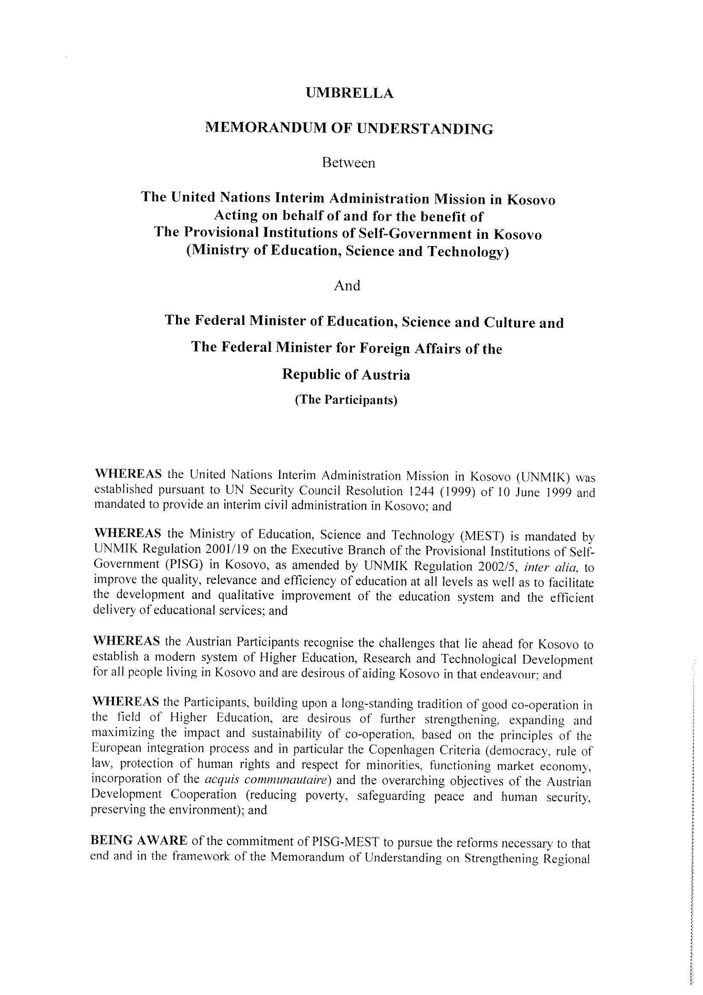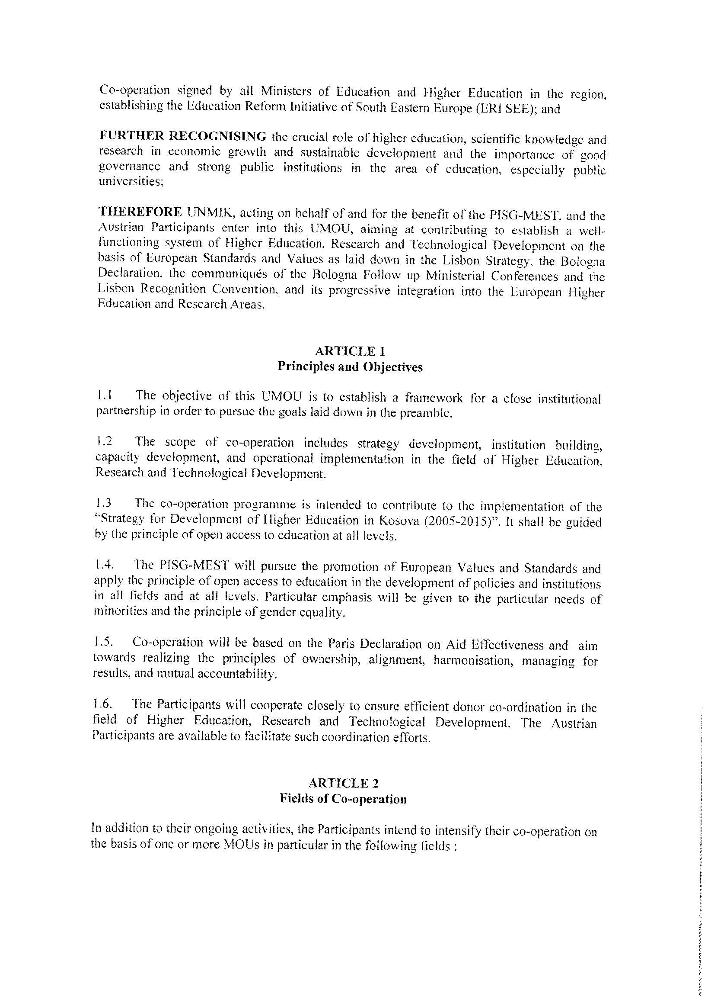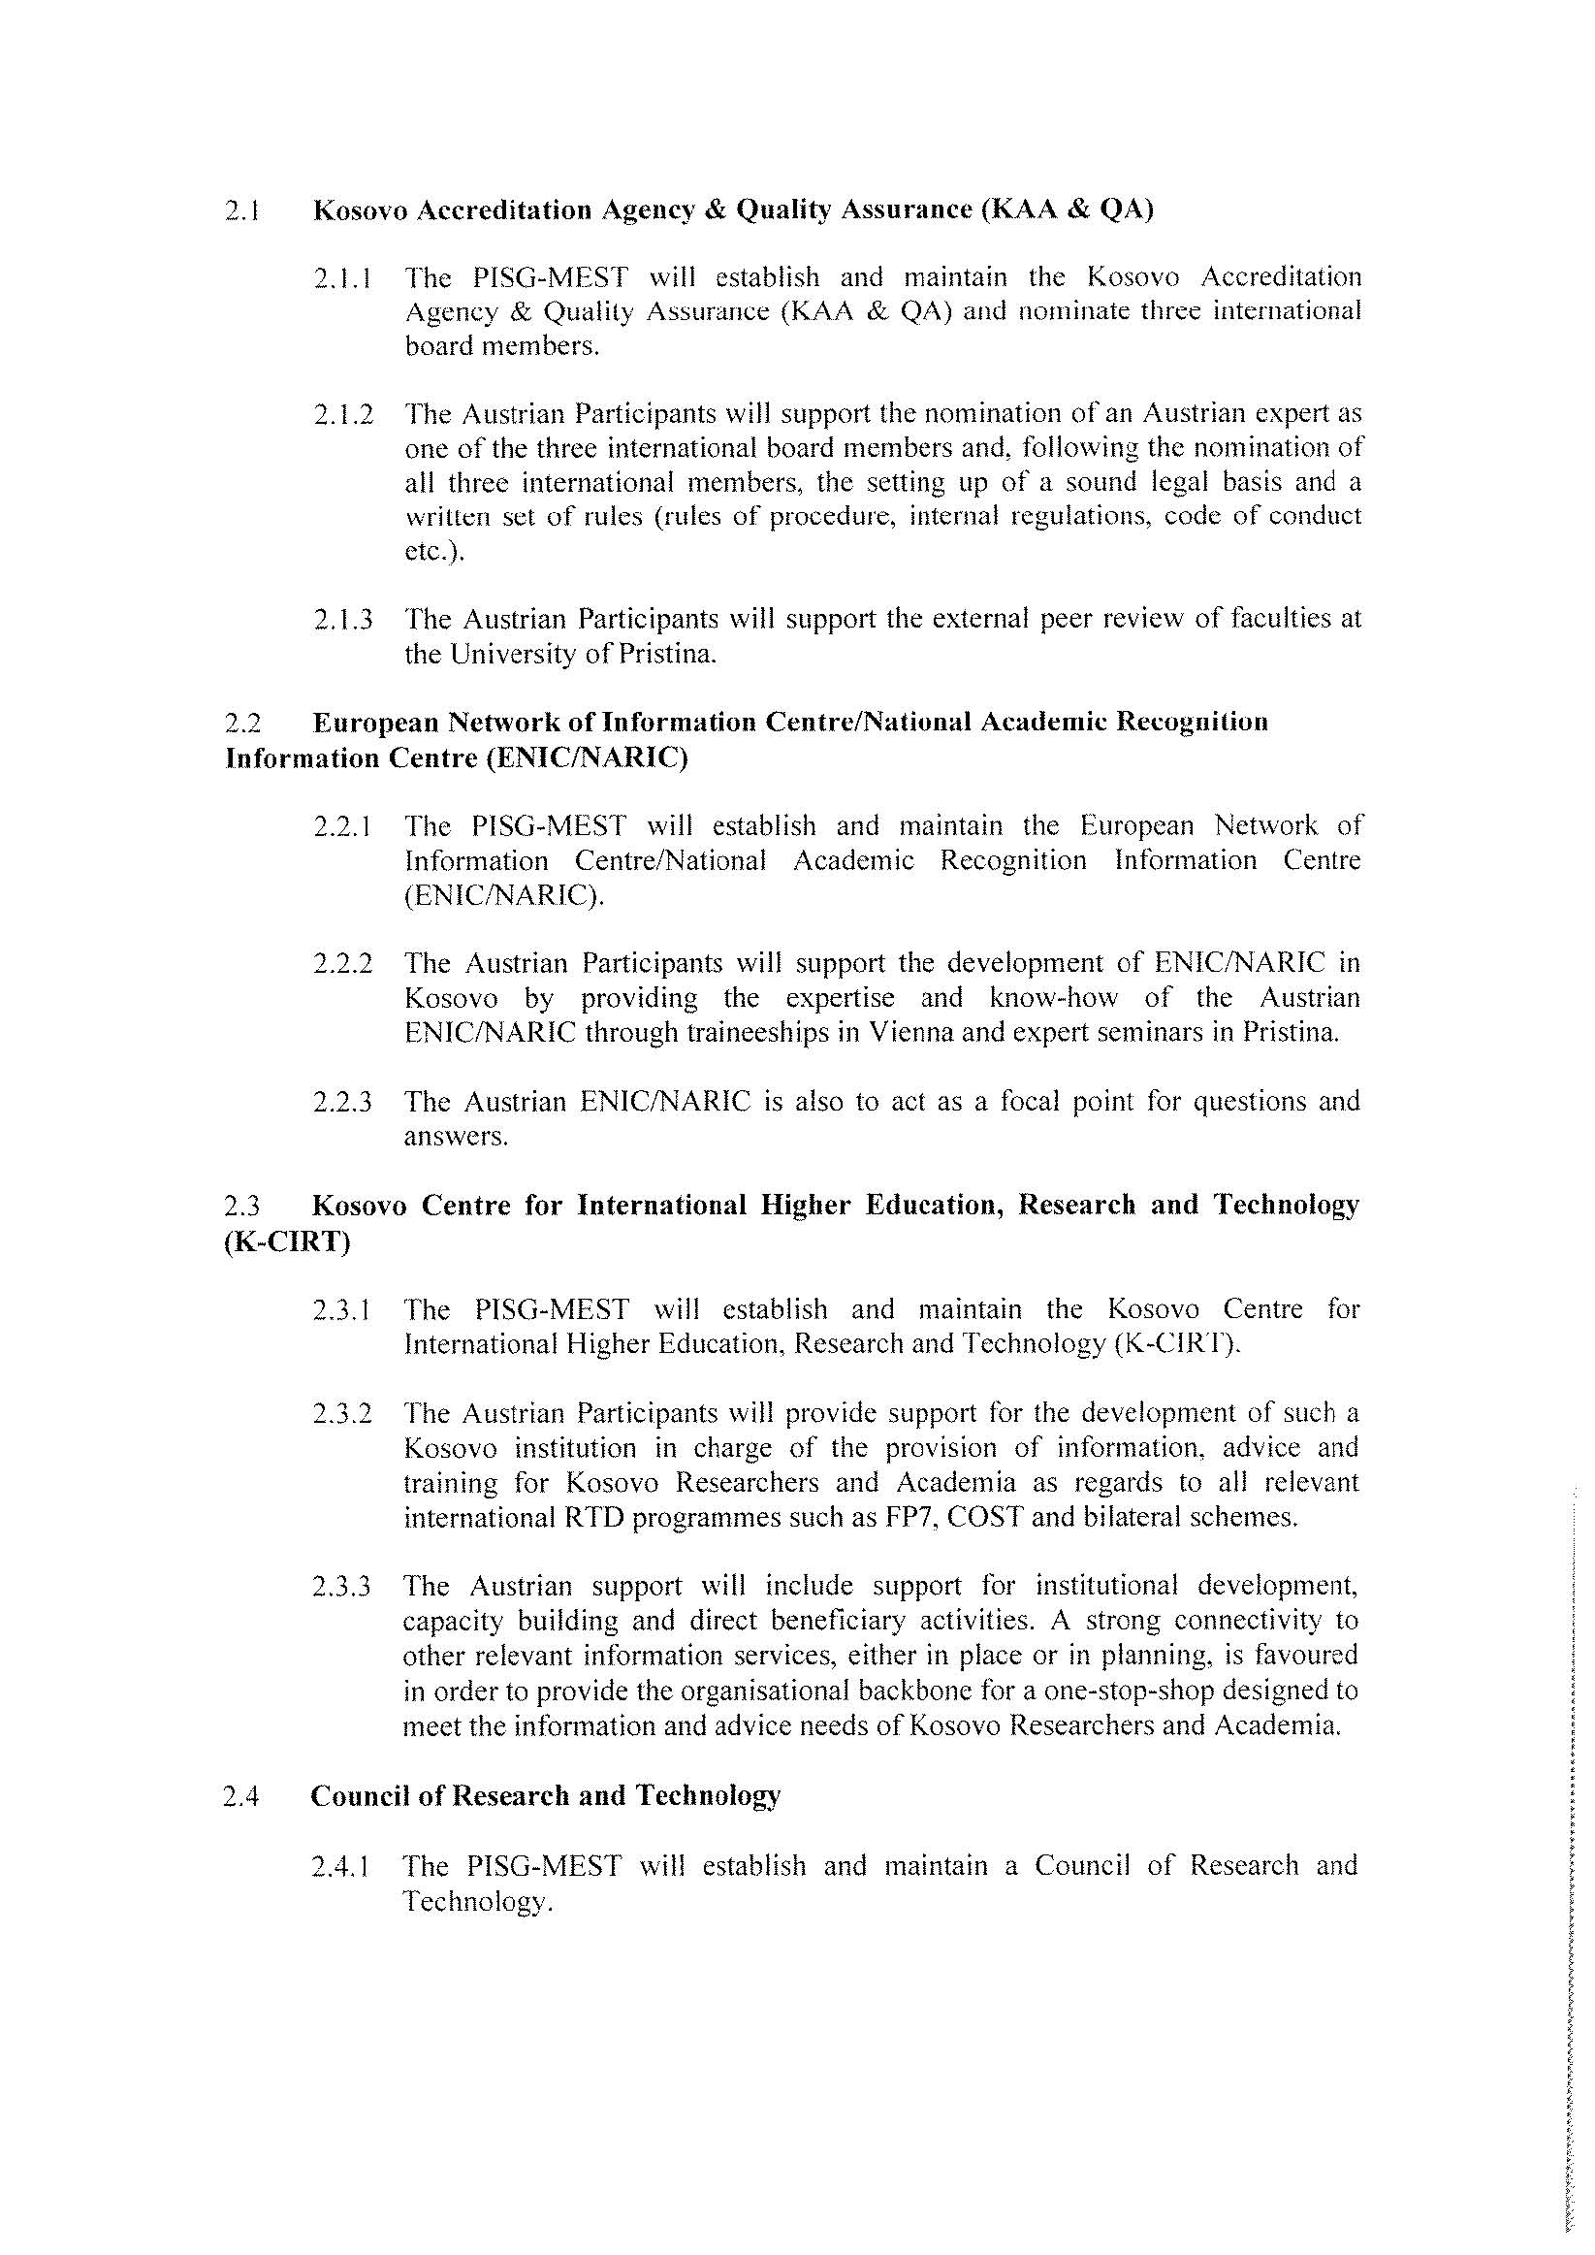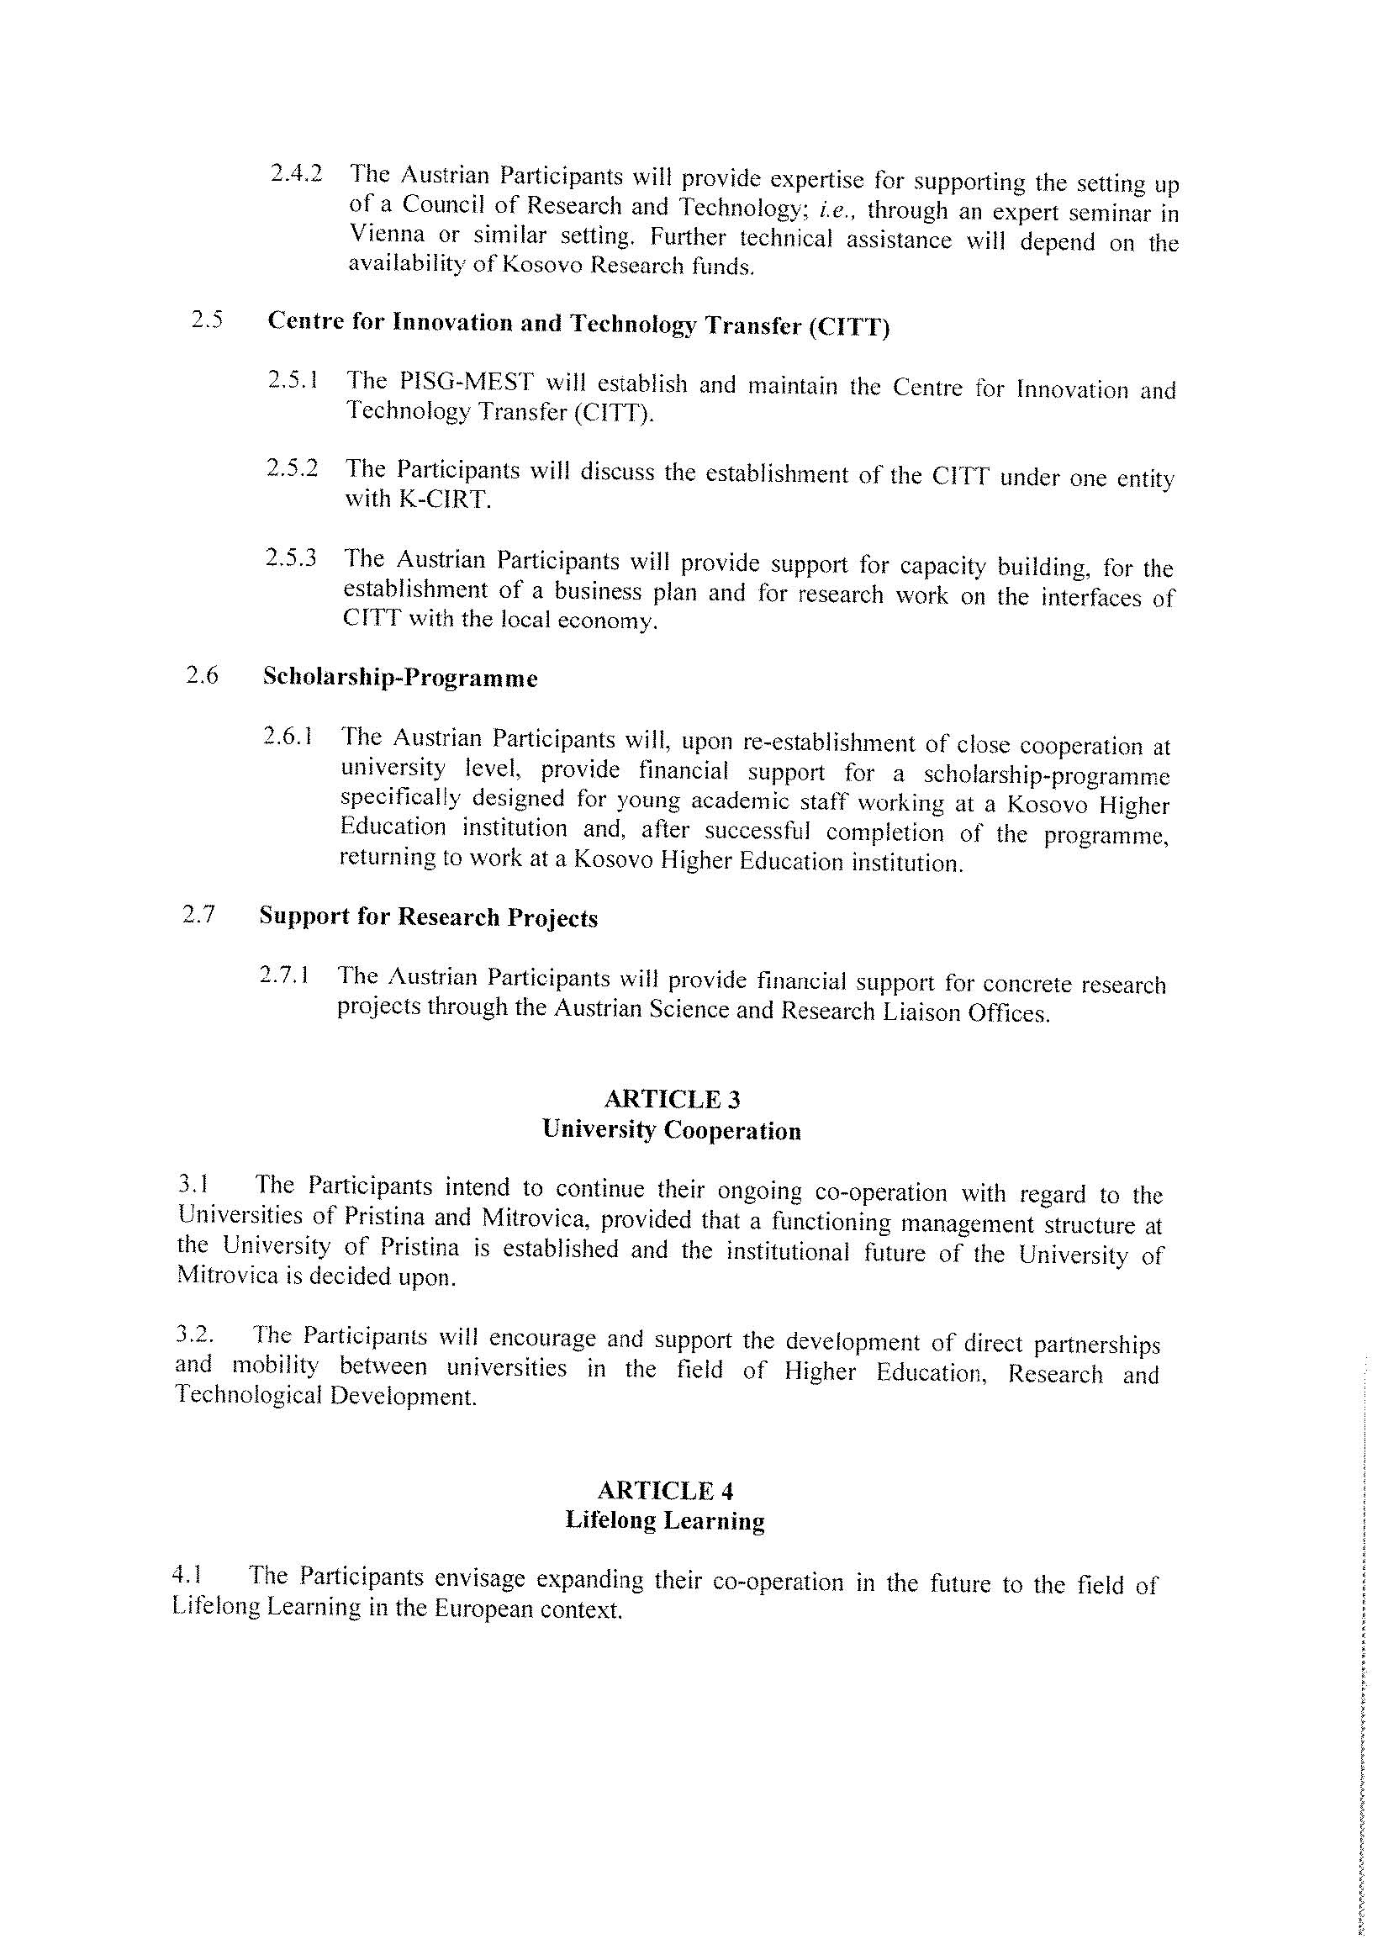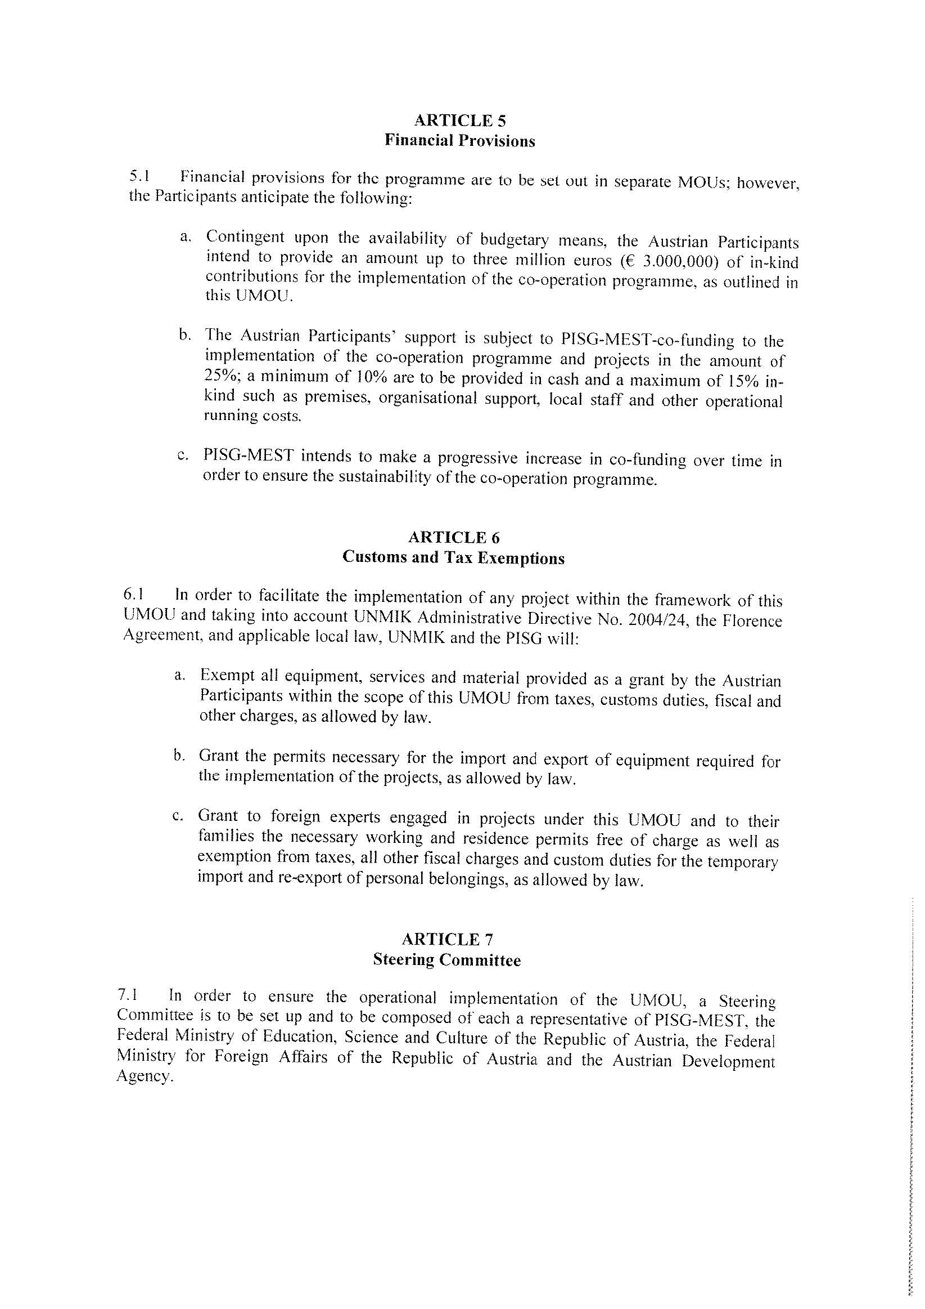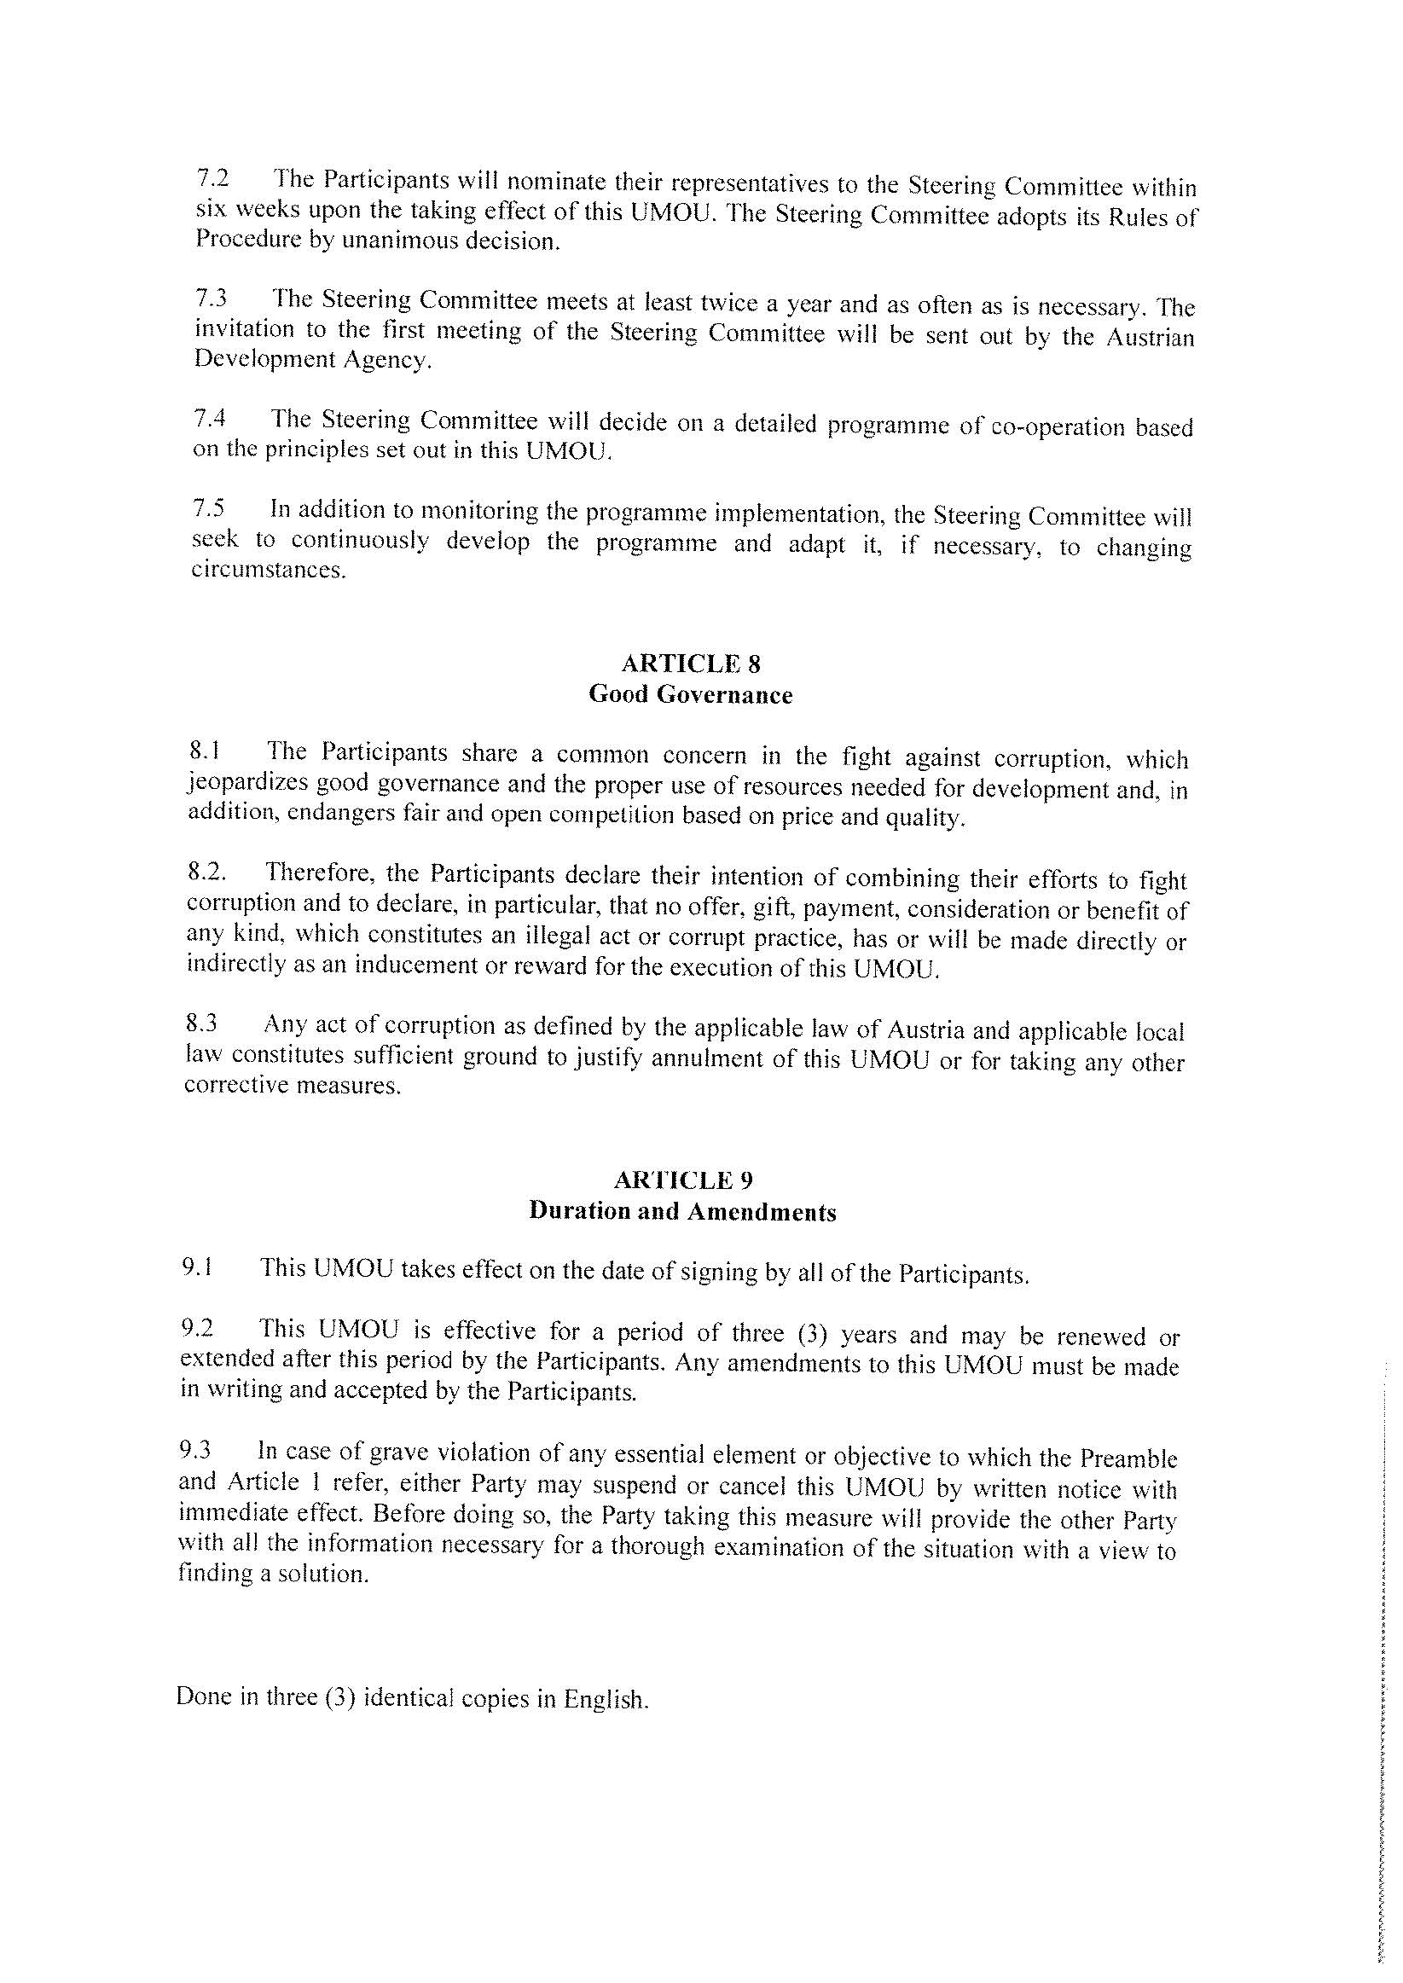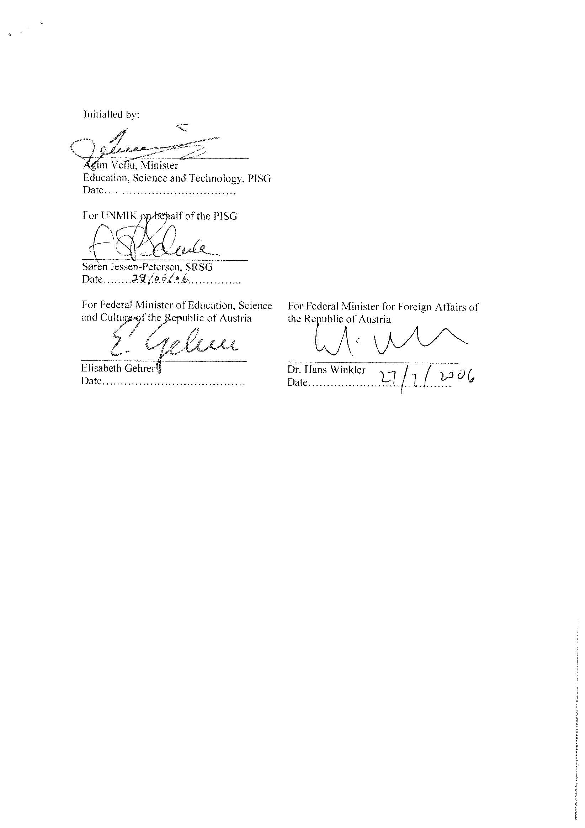

Financed by the Austrian Development Agency (ADC Contract No 8116-00/2005, starting from 1st December 2006) as well as the Austrian Ministry of Science and Research.
http://www.entwicklung.at/en/countries-and-regions/south-eastern-europewestern-balkans/kosovo.html
See: http://www.entwicklung.at/uploads/media/Muster_für_die_Gliederung_eines_Zwischenberichts__Inception_Report.pdf
See: http://www.entwicklung.at/uploads/media/Muster_für_die_Gliederung_eines_Evaluierungberichts.pdf
Please make sure this corresponds the ADC format under: http://www.entwicklung.at/uploads/media/Muster_für_die_Gliederung_eines_Evaluierungberichts.pdf

