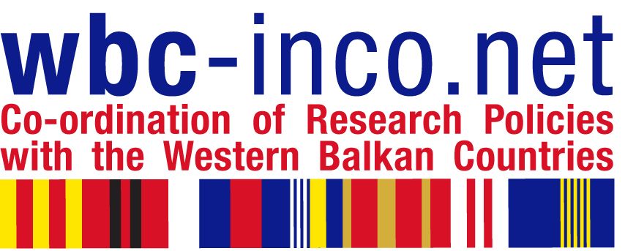

R E G I S T R A T I O N F O R M

for

TRAINING WORKSHOP FOR RESEARCH MANAGERS

Friday 19 November 2010

Economic Chamber of Macedonia

13 Dimitrije Čupovski, Skopje

POBox: 324, tel.+389 2 118 088

Name:
Organization:
Position/function:
Address:
Telephone:
E-mail:
Date and Signature:

PLEASE SEND THE FILLED-OUT FORM TO info@sbra.be.

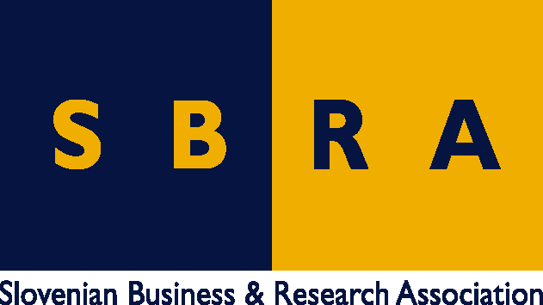

in collaboration with:

  EUROPEAN CENTER FOR PEACE AND DEVELOPMENT  of the University for Peace established by the United Nations  ECPD Regional Institute for development studies,  Skopje | 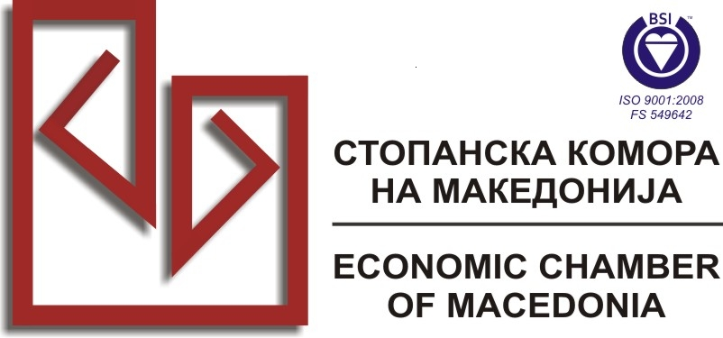  Economic Chamber of Macedonia (FYRoM), Skopje

