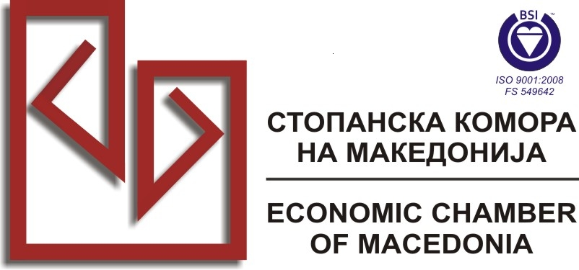

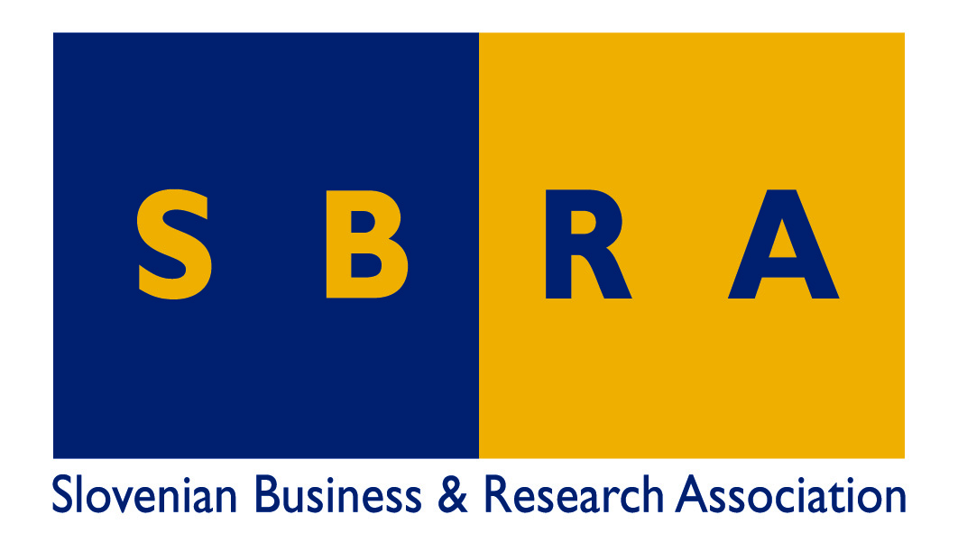
EUROPEAN CENTER FOR PEACE AND DEVELOPMENT
of the University for Peace established by the United Nations

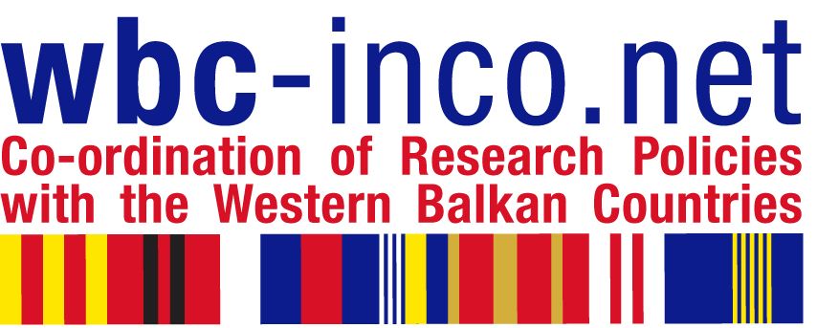

Training Workshop on

»Successful participation in Framework Programme 7 (FP7)«

Skopje, Friday 19 November 2010

As part of its activities in the WBC-INCO.NET project, SBRA is organising in the month of November a training seminar on successful participation in FP7. In line with the terms of reference, the workshop is to be freely offered to representatives of business, academic institutions, local communities, and NGOs, from countries of South Eastern Europe – beneficiaries of the EU-funded project mentioned above.

The event is co-organized by ECPD Regional Institute for development studies in Skopje, and the Economic Chamber of Macedonia, which is also hosting the event at its premises in Skopje at Dimitrije Čupovski 13. The working language will be English. As organisers, we recommend that primarily people with solid command of English language take part in the workshop for the sake of terminology which they need to be able to prepare a successful project submission.

Draft Agenda:

09.00 Registration
10.00 Welcome speech by President of Economic Chamber of Macedonia
10.10 Introduction by Prof.dr.Boris Cizelj
10.30 Briefing on how to participate successfully in Framework Programme 7
Mrs.Maja Ferlinc, Economic Advisor, SBRA
11.10 Coffee break
11.30 Lessons learnt – Observations and comments by Ministry of Education and Science, Rep.of Macedonia (FYRoM), Mrs.Marina Nikolovska, JRC and Health NCP for Macedonia
Presentation of experience in FP7 projects – Ilina Hristova, RR&Co
Presentations of good practice case: Mrs.Kristina Jakimovska, Assistant Professor, Faculty of Mechanical Engeneering, University of Skopje
  - Questions and answers
  - Closing remarks by panelists
13.00 Networking buffet lunch and close of the Workshop

All interested are kindly invited to register with attached form, to be returned to info@sbra.be. Registrations will be confirmed on a first/come/first/served basis.

Brussels, 3 November 2010 prof.dr.Boris Cizelj, SBRA

Attachment: Registration Form

