Evaluation of Research Activities and Strategic Planning of Research at the University of Montenegro
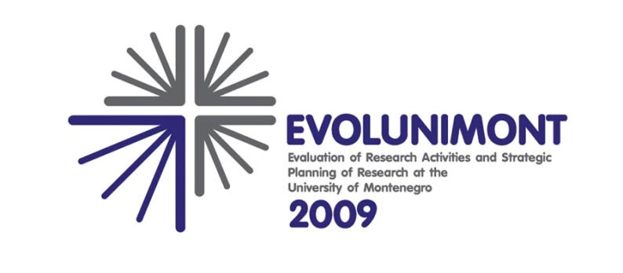

INVITATION TO A
THREE-DAY WORKSHOP ON EVALUATION OF RESEARCH AND UNIVERSITIES

Workshop provider:
MANCHESTER INSTITUTE FOR INNOVATION RESEARCH
Prof. dr Katherine Barker
Prof. dr Maria Nedeva

Kotor - Montenegro, July 6 – 8, 2009

Considering the fact that evaluation of research is still not a well established practice in the Western Balkan region, and that awareness raising and education on the topic are required for institution managers, the University of Montenegro is organizing a regional workshop on evaluation of research.
Ten places are available for participants from partner institutions – Universities and research institutes from the region of the Western Balkans. The project will cover the training, accommodation and reimbursement of up to 250 eur for travel costs for each participant.

Interested participants should send completed registration forms below, until June 25. Information on acceptance will be sent back on June 26.

Venue of the Workshop: Hotel Vardar, Kotor Old Town
Subsidiary accommodation: Hotel Marija and Hotel Cattaro

WP 2: GAINING KNOWLEDGE ON EVALUATION
AND RESEARCH MANAGEMENT
Task 2.1 Workshop on evaluation of research
Kotor – Montenegro, July 6 – 8, 2009

REGISTRATION FORM

Please fill out this form and send it to: mirjana@ac.me or by fax: +382 20 242 301
within 25 June, 2009.

Name and Surname

Title
Position
Institution
Address
Tel/Fax/Mobile
E-mail

DETAILS ON ARRIVAL
Arrival Date: | Time: | Number of nights:
Departure Date: | Time: | Number of nights:

Note that closest airports to Kotor are Tivat, Podgorica and Dubrovnik

