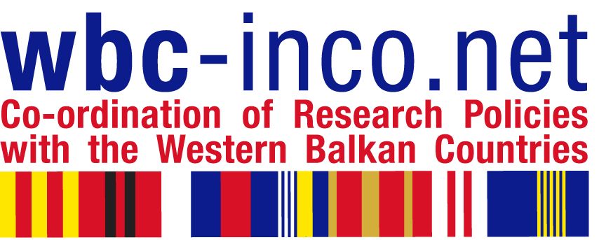

WORKSHOP

ENHANCE INFORMATION ON RTD CAPABILITIES IN WBC

Maribor, Slovenia, 12 November 2009

LIST OF EXPERTS

Country | Name and surname | Organization
BIH | Mr. Denis Mušić | Faculty of Information Sciences , University "Džemal Bijedić", Mostar
BIH | Mr. Djordje Markez | Ministry of Science and Technology of Republic of Srpska (International S&T cooperation)
MACEDONIA  (fyr of) | Mr. Miodrag Dadašević | National and University Library: "Sv. KLiment Ohridski", Skopje
MACEDONIA  (fyr of) | Ms. Stanka Petkovska | Advised for Database in Ministry of Education and Science
ALBANIA | Prof.Dr. Salvator  Bushati | Scientific Secretary of Academy of Science Tirana, Albania
ALBANIA | Prof. As. Evan Rroco | Agriculture University of Tirana, Albania
SERBIA | Mr. Pero Šipka | University of Novi Sad, Faculty of Philosophy and  Centre for Evaluation in Education and Science
SERBIA | Mr Djuro Kutlača | Mihailo Pupin Institute, Belgrade
KOSOVO  (as defined by UN SC Resolution 1244) | Mr. Hysen Bytyqi | Head of the University RTD Cooperation Office University of Prishtina
KOSOVO  (as defined by UN SC Resolution 1244) | Ms. Linda Grapci | Assistant Proffesor at the University of Prishtina
MONTENEGRO | Mr. Saša Ivanović | Ministry of Education and Science of Montenegro
MONTENEGRO | Ms. Branka Bošnjak | Adviser for science  Rectorate of University of Montenegro
CROATIA | Ms. Vesna Kotarski | Office of International Projects Institut Ruđer Bošković, Zagreb

