 | 
REPUBLIKA E KOSOVËS
REPUBLIKA KOSOVO
REPUBLIC OF KOSOVO
KËSHILLI KOMBËTAR I SHKENCËS |  | NACIONALNI SAVET ZA NAUKU | NATIONAL RESEARCH COUNCIL

National Research Program 2010-2015

National Conference

Grand Hotel Prishtina, 3 March 2010, 9:30-15:30 h

09:00-09:30 | Registration of participants
09:30-10:00 | Openning of the Conference  (Chair: Prof.Dr. Suzana Manxhuka-Kërliu, member of the NRC)  Welcome address  Academician Rexhep Ismajli, NRC President  Dr. Jakup Krasniqi, Speaker of the Kosovo Assembly  Dr. Enver Hoxhaj, Minister of Education, Science and Technology  Academician Besim Bokshi. President of the ASAK  Dr. Johann Guenther, KAIP Project
10:00-11:00 | Plenary Session  (Chair: Prof.Dr. Suzana Manxhuka-Kërliu, member of the NRC)  Presentation of the National Research Program  Dr. Dukagjin Pupovci, NRC Secretary  Comments from Expert  Dr. Klaus Schuch, Austrian Expert  Q&A Session  Instructions for Group Work
11:00-11:30 | Coffee Break
11:30-13:00 | Group Work  Participants will be divided into six groups  - Environment, Energy and Natural Resources  - Agricultural Production and Food Safety  - Medical Research  - Development of a Knowledge Based Society & ICT  - Linguistic, Historic and Cultural Studies  - Program objectives and targets
13:00-14:.00 | Lunch
14:00-15:30 | Plenary Session  (Chair: Prof.Dr. Fetah Podvorica, member of the NRC)  Group Presentations  Closing of the Conference

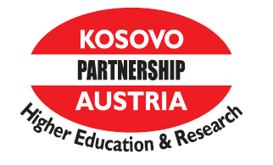
Supported by:

