S&T Policy Coordination with Western Balkans: New Project Supports Integration

The Western Balkan Countries INCO-NET (WBC-INCO.NET) is one of six new projects on international cooperation funded by the European Union to support bi-regional dialogues in the area of science and technology (S&T). A consortium of 26 partners, which includes relevant ministries from the Western Balkan countries (WBC), will work in the next four years intensively on the integration of the region into European research networks.
Success of this project can be measured for example through increased involvement of scientists from the region in the European Framework Programme and other programmes for cooperative research.

FP7 is the current EU programme for research and technological development, running from 2007 until 2013. FP7 supports research in a range of areas including health, information technology, energy, security, food, agriculture and biotechnology as well as environment and climate change, etc. - topics which are also of high interest in and for the Western Balkan countries. WBC-INCO.NET is dedicated to strategically support the cooperation between the European Commission, countries involved in FP7 and the Western Balkan countries in the field of S&T. It aims to sustain the relationship already in place as a result of the Steering Platform on Research between the EU and the WBC and to encourage the participation of researchers and research institutions from the WBC in FP7 projects by making the process of involvement as straightforward and rewarding as possible.

The WBC-INCO.NET project targets several different aspects, including European and Regional Dialogue, Priority Setting to Structure Participation in FP7, Monitoring and Analysis of S&T Cooperation and Facilitating Networking and Increasing Participation in FP7. These will be conducted through Steering Platform Meetings, regional S&T policy meetings, meetings with European Commission Directorate Generals, expert seminars, brokerage events, training seminars, the support of online databases and an information portal, and the publication of information newsletters, to name just a few of the exercises that will be funded.

Currently, one of the main difficulties for the WBC is the lack of awareness of the research being funded in FP7 and the lack of contacts with other scientists and researchers throughout Europe. WBC-INCO.NET seeks to ease this difficulty so that the existing potential for cooperation will be internationally recognised, setting an example for other areas of cooperation and integration.

February 1, 2008 saw the kickoff meeting for WBC-INCO.NET in Ljubljana, Slovenia. Further information can be found on this website: http://www.wbc-inco.net/ or by contacting Ms. Elke Dall (contact details below).

Centre for Social Innovation (ZSI) Phone: +43 1 495 04 42 62
Linke Wienzeile 246 Fax: +43 1 495 04 42 40
A-1150 Vienna dall@zsi.at

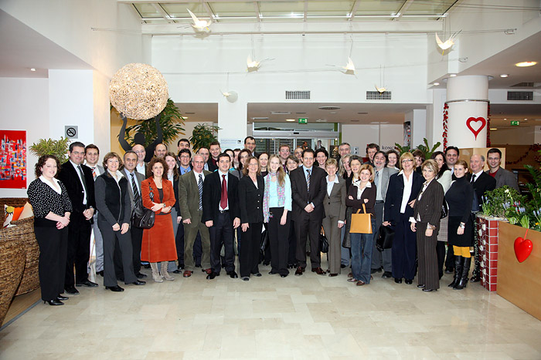
Kick off meeting in Ljubljana February 1, 2008 with participants from Albania, Austria, Belgium, Bosnia and Herzegovina, Bulgaria, Croatia, FYR of Macedonia, Germany, Greece, Italy, Montenegro, the Netherlands, Serbia, Slovenia, Spain, and Turkey.

