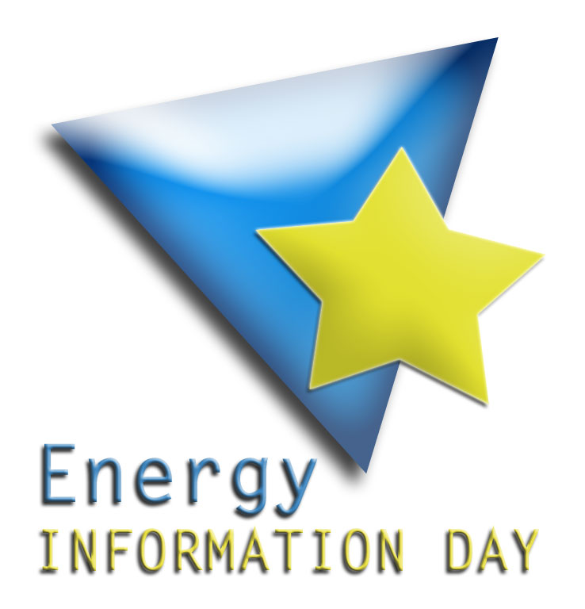
PROJECT CORNER FORUM
PROJECT PROPOSALS

Topic and/or project idea I would like to discuss with other participants at the Energy Information Day” - 9th May 2008, Pula:

Short description of the topic/project idea:

I am willing to speak briefly about this idea in one of the Three thematic groups during the PCF:

YES
NO

Please indicate in which of the 3 thematic themes the topic/project idea is
most relevant:

FP7
Interreg
IEE, Eco Innovation

If you already have more information about a project proposal please fill in the following:

Title of the project:

Estimated budget:

Project objectives:

Leader:

Partnership collaboration with:

Other comments:

YOUR NAME:

ORGANISATION:

ADDRESS AND PHONE NUMBER:

EMAIL:

Contacts
Fundación Comunidad Valenciana-Región Europea
Manuel Irún: mirun@delcomval.be
Cristina Bonafé: cbonafe@delcomval.be
Laura Prieto: lprieto@delcomval.be
Region of Istria
Patrizia Bosich: patrizia.bosich@istra-istria.hr
Maja Lazar: maja.lazar@istra-istria.hr
Dino Babić: dino.babic@istra-istria.hr
Please return this form by e-mail before 5st May 2008.

Appendix: Only an example of the feedback form that will be used at the event

PROJECT CORNER FORUM Feedback Form
Participants:

What was discussed:

Important comments/recommendations:

Conclusions and next steps:

