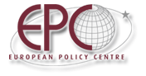
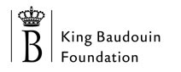

In strategic partnership with the King Baudouin Foundation and the Compagnia di San Paolo

Tuesday 17 June 2008

POLICY DIALOGUE

Résidence Palace – Polak room
155 Rue de la Loi, 1040 Brussels

The Balkans in Europe:
containment or transformation?

PROGRAMME

09.30 Registration

10.00 Welcome by the Chairman
Graham Avery, Senior Adviser, European Policy Centre

10.05 Introductory remarks
Fabrice de Kerchove, Project Manager, King Baudouin Foundation
Borut Grgic, Director, Institute for Strategic Studies, Slovenia

10.15 Presentation of the Working Paper The Balkans in Europe: containment or transformation? Twelve ideas for action
Rosa Balfour, Senior Policy Analyst, European Policy Centre

10.25 Panel discussion

Jelica Minic, Deputy Secretary General, Regional Cooperation Council, Sarajevo
Dragana Radulovic, Deputy Foreign Minister for EU and NATO, Montenegro
Ivan Vejvoda, President, Balkan Trust for Democracy, Belgrade

11.10 Open discussion

12.00 End of Dialogue

