INSTRUCTIONS FOR THE PREPARATION OF PAPERS
FOR THE UKIM FOF IN SKOPJE FORESTRY REVIEW XLIII

Author(s)
University(ies) / Institute(s)
Address(es)

ABSTRACT: These notes provide important information on how to prepare and submit your paper. Read the notes carefully and follow them as precisely as possible. Any inaccuracy will cause delay at the Technical Editors and in the publication of the Forestry Review. Your paper must be written in English (UK) and the layout should be exactly the same as this master document. In order to prepare your layout, save this document with a new name and use it as a guide. Replace the text of this document with the text of your paper without changing the layout, font type and size, line spacing, page margins and structure of this template (see section 3). Do not insert page numbers or page headers/footers. If you have any question, please do not hesitate to contact us (see section 7.3).
Keywords: select 3 to 6 keywords.

1 DEADLINES AND DELIVERY

Papers will be published in the UKiM FoF in Skopje Forestry Review XLIII only if correctly submitted.
The electronic version of your paper must be submitted to the Technical Editors by e-mail according to the dates (see section 5, note 3), by one of the authors, together with two suggested reviewers (see section 11), and the Copyright Transfer Agreement Form duly filled-in and signed (this will be available and sent to the corresponding author before Review print).

Your original manuscript must be delivered in the following formats:

- Microsoft Word (97/2003, .docx), and Adobe Acrobat PDF by e-mail.

Please make sure that the paper you submit is the final version with all numberings in the correct order. Do not submit the paper more than once.

2 PREPARING THE MANUSCRIPT

2.1 Volume and length of the paper
Please consider that the complete paper in pdf format, including illustrations, may not exceed 10 A4 pages. This is a very good proven capacity for final papers.

2.2 Organisation of the paper
The title of the paper should be informative and concise. It must be followed by the author(s) name(s) – listing the principal author first, organisation, complete address, telephone, fax and e-mail address.
No logos may appear in the title.
The abstract preceding the body of your paper should give a brief account of the most relevant aspects of your paper, in 200/250 words. Please avoid using symbols, graphics and text formatting (bold, italic, underline) in this part of the document.
Next, in order of importance, select three to six of the most relevant keywords and include them in your paper. The keywords should be separated with commas. The keywords must correspond exactly as they appear on our list.
The body of the text must be in two columns. Number each heading using decimal numbering. Follow the layout specifications in section 3 below.

3 LAYOUT SPECIFICATIONS

The layout of your paper should have exactly the same format as this master document.

Before you start working on your paper, if you use Adobe Acrobat, select the printer option “Acrobat Distiller” (version 5.0) or Adobe pdf (version 6.0), in order to avoid accidental misplacement of layout elements afterwards when converting the Word file into PDF format.

3.1 Font type and size
Font type: Times New Roman. Font size: 9pt. Line spacing: single. Text alignment: justified left and right.
Captions should have the same font and size as the typeface used for the text. Make sure that illustrations are clear and easy to read. Please do not use any other font than Times New Roman.

3.2 Page size
Page size must be A4 (210 mm x 297 mm).
Margins: top: 32mm; bottom: 19 mm; left and right: 25mm.
The body of the text must be in two equal columns of 73,6mm each. All written parts and images must fit inside these margins (for further details see subsection 4.1 about figures, and subsection 4.2 about tables).

3.3 Typing the text
Begin at the top of the first page with the title of the paper in bold capital letters and centered.
Leave one blank line between the title and the name of the author(s).
List the surname preceded by the initial of the first name; when several authors prepare a paper, the name of the main one should appear first. On the following lines, give the name of the company or institute, wherever applicable, with the full address; the name of each organisation should be easy to depict. This paragraph must be centered and without any blank space.
Next, leave two blank lines and then type an abstract of no more than 250 words (keep the indent of this block on both sides, as shown on this document). At the end of the abstract give your 3/6 keywords on the last line.
Leave two blank lines between the abstract and the body of the text of your paper, which must be in two columns.

3.4 Headings
Leave two blank lines before each section and one blank line before the heading of each sub-section. Headings and sub-headings should be numbered (e.g. 3, 3.1, 3.2). Separate the numbers from the text of the heading with two spaces.
There should be no blank line after the title of the sub-sections but only an indentation to indicate the beginning of a paragraph. Section headings should be in capital letters. Sub-section headings should be in upper and lower case. Headings should be normal text – not underlined or in bold.

4 ADDITIONAL COMPONENTS

4.1 Illustrations
Illustrations (photographs, drawings, graphs, charts, etc.) should not exceed 50% of the whole paper and should be placed as near as possible their citation. Illustrations must not be taken from previously-printed materials.
Illustrations should have a resolution of 300 dpi using simple colors (Standard+RGB) and be placed at 100% scale (i.e. if an illustration covers the full column width, it should be of approx. 860 pixel).
Illustrations should have the layout in line with the text (right click on the object – Format object – Layout – in line with the text, which should be the left-most option in the layout dialogue window).
All illustrations must be numbered progressively in bold decimals (e.g. Figure 1:) and have a reference in the text (e.g. Fig. 1). Captions should be as clear as possible, to allow comprehension of the illustration without reference to the text.
Graphs and charts must not be imported from Excel, but should be inserted as a picture (.jpg, .bmp or .gif). Please, use simple contrasting colors and effects instead of fill patterns. See Fig. 1 for good/bad example.
Illustrations must be clear also when printed in black and white.

Good example with contrasting colors:

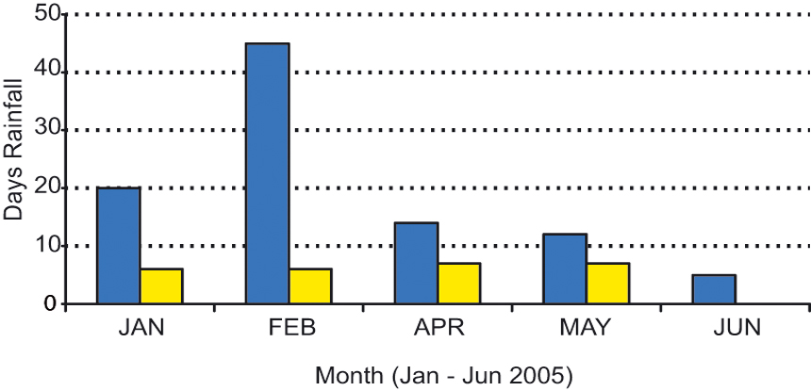

Bad example with fill patterns:

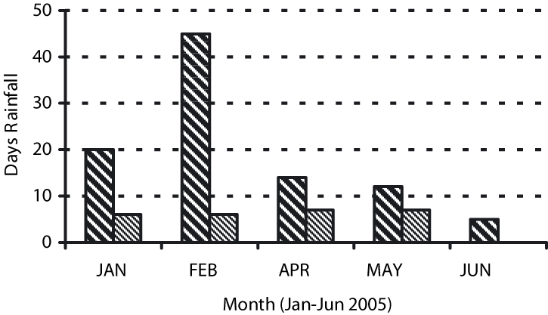

Figure 1: Clear line drawings are essential

4.2 Tables
Tabular presentation of data is an easy way to condense many items. Tables must be numbered in bold Roman numerals (e.g. Table I), and have a reference in the text. Captions should be as clear as possible, for an easy comprehension of the tables.

Table I: Overview of biomass resources available

Biomass Sources Quantity Moisture Residue
Sewage Sludge 1.86 1.73 1.40
Septage 0.32 0.28 0.16
Fruit Pulp 3.78 3.89 4.02

4.3 References and notes
References and notes must not appear as footnotes in the pages, but should be listed together at the end of the text, in the dedicated sections.
When referring to them in the text, please type the corresponding reference number in brackets. Use round brackets for the notes (1) and square brackets for the references [1].
To make them easier to find, indent your notes and references from the second line, as in the examples (see sections 5 and 6).

4.4 Acknowledgements
Any acknowledgement should be added at the very end of the paper, in a dedicated section, as in the example (see section 8).

5 NOTES

  - This section should have the progressive number before the title, exactly as for the previous ones.
  - Do not add any unnecessary space between the listed numbers of your notes.
  - Important dates of the UKiM FoF in Skopje Forestry Review XLIII are:
Abstract submission March 15th
Abstract acceptance March 30th
Paper submission May 15th
Paper acceptance June 15th
Forestry Review Print October 15th

6 REFERENCES

[1] This section should have the progressive number before the title, exactly as for the previous ones.
[2] Do not add any unnecessary space between the listed numbers of your references.
[3] G. Campolmi, Proceedings of the 3rd World Biomass Conference – Biomass for Energy, Industry and Climate Protection, III Vol. (2005), pag. 981.
[4] D. Reed, Evaluation of Biomass Resources in the southern regions in Nigeria, (2007), pag. 124.
[5] O. Vecchi, Biofuel Production in central Italy, (2008), pag 45.

7 OTHER POINTS

7.1 Permissions
Authors are fully responsible for their manuscripts. They must take the necessary steps to obtain permission for using any material that might be protected by copyright.

7.2 Copyright
Please be aware that on delivery of your manuscript, you transfer the copyright to University Ss. Cyril and Methodius in Skopje, Faculty of Forestry in Skopje, publishers of the Forestry Review.

7.3 Further information
We are available to assist you. Please, do not hesitate to contact us for any query; please address your e-mails to bsimovski@sf.ukim.edu.mk and bokaco@gmail.com or call Bojan Simovski MSc ++389 70 595 321.

8 IMPORTANT SPECIFICATIONS FOR THE PDF

8.1 Printer
If you are using Adobe Acrobat, please select Acrobat Distiller (version 5.0) or Adobe Pdf (version 6.0) as printer option to convert your Word file into pdf format. Go to Printer Properties and click on “Acrobat pdf settings”; in Conversion Settings select “Press” quality.
If you are using special fonts make sure that the checkbox “Do not send fonts to distiller (“adobe pdf” for version 6.0)” is not selected.

8.2 Password / Security
Please do not use any Password / Security when making the Pdf file. As the header and page numbers will be added by us, we need to ensure that you pdf file is not password protected.

9 ACKNOWLEDGEMENTS

- We thank you for successfully following these instructions. This will make the Reviewers easier to read and avoid queues at the Technical Editors!
- The Authors are grateful to the students- members of DREN - NGO of students of Forestry at the Faculty of Forestry in Skopje for their helpful cooperation.
- …….

10 LOGO SPACE

If you wish, you may add your logos (e.g. Organisations, Project Partners, Supporters, Brands etc) at the end of the paper.

11 important notice for the submission

To ensure a convenient publication process, the authors are requested to follow these instructions. Submission of a paper implies that it reports unpublished work and that it is not under consideration for publication elsewhere. If previously published tables, illustrations or more than 200 words of text are to be included, then the copyright holder's written permission must be obtained. Copies of any such permission letters should be scanned and attached with the paper.
A condition of submission (with the abstract submission) is that the author nominates two people who are qualified to act as reviewers and who have not previously been involved with the paper in any way. Both of the nominated reviewers must be working in a different country to the first named author.
Before the publication, the paper will be reviewed by the members of the Editorial Board and a notification of acceptance will be send to the corresponding author. Editors may request that authors submit a revised version of their paper before it can be accepted for publication. The Editor's decision on all submissions is final.
Finally, the authors will receive Copyright Transfer Agreement Form which they need to fill-in and sign for the publication to be complete.

