


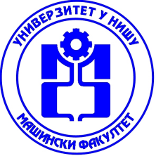
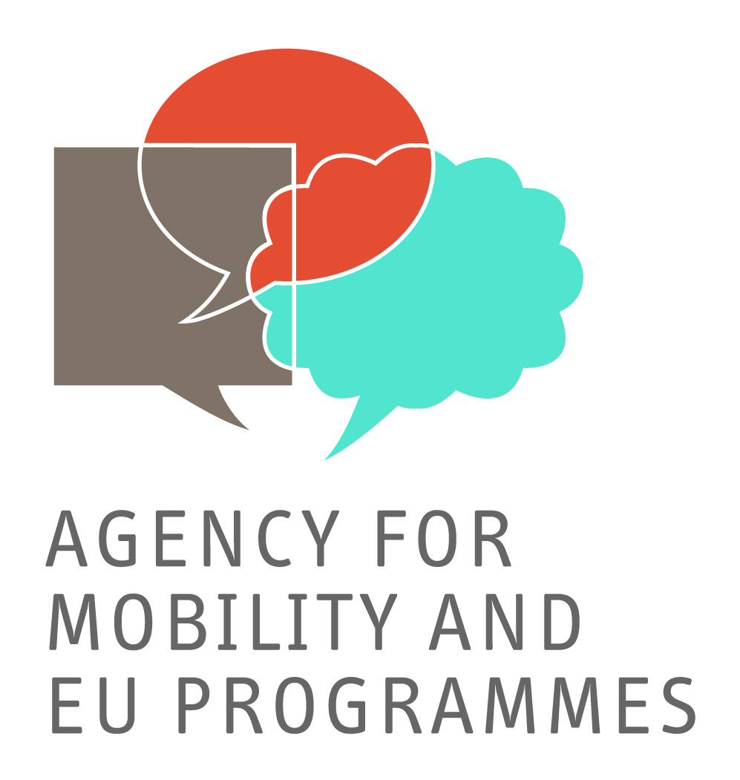



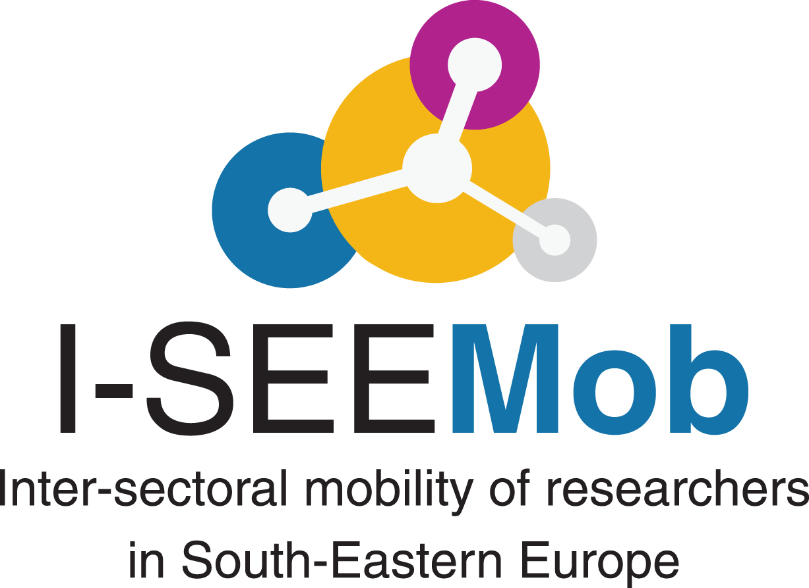

I-SEEMob is a FP7-CAPACITIES funded project aiming at developing a set of policy recommendations to the national governments for improving and supporting the inter-sectoral (academia-industry and vice versa) mobility of R&D personnel and, thus, enhancing their career development. The consortium is consisted of 9 organisations from 8 SEE countries. The partners are: the General Secretariat for Research and Technology (GR/Coordinator), the Centre for Research and Technology-Hellas (GR), the Scientific and Technological Research Council of Turkey (TR), Sofia University “St. Kliment Ohridski” (BG), University of Nis/Mechanical Engineering Faculty (RS), Agency for Mobility and EU Programmes (HR), Macedonian Academy of Sciences and Arts (MK), Ministry of Civil Affairs (BA), Executive Agency for Higher Education, Research Development & Innovation Funding (RO).

On Friday, 16 March 2012, the I-SEEMob project consortium organized the Conference titled “Fostering inter-sectoral mobility of researchers in SEE: Challenges and driving forces” at the premises of the Centre for Research and Technology-Hellas in Thessaloniki, Greece.

The topic industry-academia collaboration comes again and again at several forums and EU policy documents as an ever-green issue for Member States. Inter-sectoral mobility is not seen as a goal in itself, but as an instrument that can effectively contribute to eradicating the so-called "European Paradox", i.e. that Europe is unable to sufficiently turn research results into globally competitive products. As such, it fits with the Community policy on boosting research and innovation. At the same time, inter-sectoral mobility adds to the employability and diverse career development of researchers. Increasing knowledge transfer between academia and industry is a key goal of the Commission’s innovation plan, and a vital component of the debates for the future of the European Research Area.

The aim of the event was to foster a policy dialogue between policy representatives from eight (8) Southeastern European (SEE) countries (Greece, Turkey, Bulgaria, Former Yugoslav Republic of Macedonia, Republic of Serbia, Croatia, Bosnia-Herzegovina, and Romania) so as to provide recommendations and guidelines to the respective governments for enhancing industry-academia collaboration and promoting inter-sectoral mobility of researchers at the respective countries.

During the first part of the Conference, Prof. Fulvio Esposito, Chair of ERA Steering Group on Human Resources and Mobility, former Dean of the University of Camerino- Italy, elaborated on the importance of mobility for the career development of researchers in the framework of EUROPE 2020 strategy. Additionally, Dr. Vasiliki Pletsa, officer at the International S&T Cooperation Directorate, General Secretariat for Research & Technology/Greece, talked about the significant role that industry-academia cooperation plays for Innovation and Development and the Horizon 2020 strategy on the topic. Following, Dr. Stella Bezergianni, researcher at the Laboratory of Environmental Fuels & Hydrocarbons- CPERI/CERTH, presented the point of view of academia for the cooperation with the private sector, the problems and challenges faced. On the other side, Mr. Alexandros Litinas, Research, Development and Quality Control Manager of Elin Biofuels S.A, described industry’s perspective on the topic of industry-academia collaboration and the factors inhibiting this collaboration. Finally, during the first part of the Conference, the results of the I-SEEMob survey on remaining inter-sectoral mobility obstacles in the eight (8) countries of the consortium, and the results of the current legal framework analysis and its impact on the topic of intersectoral mobility of researchers were, also, presented.

During the second part of the Conference, representatives from Ministries, research institutions, business associations and other agencies from the countries participating in the consortium engaged in an interesting discussion about the remaining intersectoral mobility obstacles and the problems causing the limited levels of intersectoral cooperation in the region.

